**RHINE LANDS**

The term Rhine lands refers to the region in Europe that is drained by the Rhine River and its tributaries. The region is sometimes called the Rhine basin. There are five (5) countries making up the Rhine lands and these include:

* Switzerland
* Germany
* The Netherlands
* Belgium
* Luxembourg

**THE EXTENT OF THE RHINELANDS**

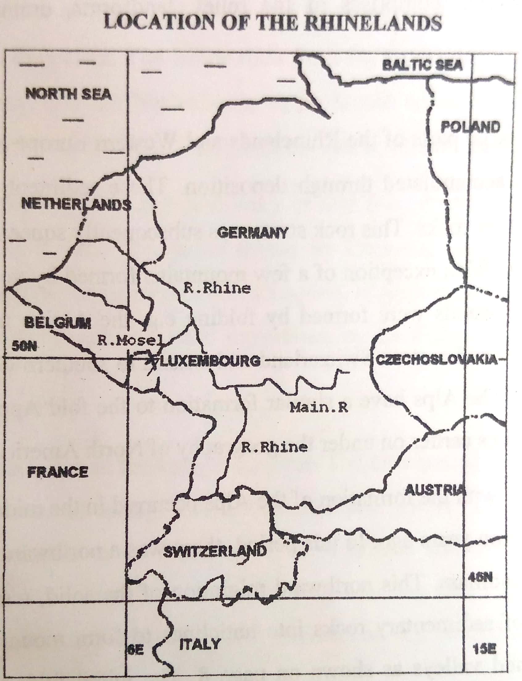

**Comparison between the Rhine lands and East Africa**

1. **Land area/ size**

The Rhine lands is smaller than East Africa. In fact, it is smaller than Tanzania and smaller than Kenya. Germany which is the biggest country in the Rhine lands is slightly bigger than Uganda.

1. **Population**

East Africa’s population is slightly bigger than the Rhine lands. Rhine lands have a population of about 120 million while East Africa has a population of about 135 million. The Rhine lands have a high population density than East Africa has a low population density.

1. **Topography/ relief**

East Africa is generally plateau area, with volcanic and other mountains while the Rhine lands is generally a low land punctuated with fold, volcanic and other mountains. Most of the land is East Africa is above 1000 ma above sea level while most of the Rhine lands is below this height above sea level.

Both regions have rift valleys. In East Africa, there is a great rift valley. There is also a rift valley in the Rhine lands extending from Basel in Switzerland to Mainz in Germany. However, the East African rift valley is much longer and more complex than the Rhine Rift Valley.

1. **Climate.**

East Africa experiences a tropical climate while the Rhine lands experience a temperate climate. East Africa experiences two distinct wet and dry seasons while the Rhine lands experience four seasons of spring, summer, autumn, and winter based on changes in temperature. East Africa is located astride the equator while the Rhine lands lie far North of the equator.

1. **River navigation**

Most of the Rivers in East Africa are not good for navigation while most of the Rivers in the Rhine lands are good for navigation.

1. **Economy**

East Africa relies mainly on agriculture while the Rhine lands rely mainly on industry. East Africa largely exports unprocessed or semi-processed products while the Rhine lands mainly export manufactured goods with high value added.

1. **Economic productivity**

East Africa is less productive with under developed technology while the Rhine lands are highly productive with advanced technology.

1. **Urbanization**

Most of the people in East Africa live in the villages while most of the people in the Rhine lands live in urban areas.

**SWITZERLAND**

Switzerland is a small landlocked country located in central Europe. It is strategically located; bordered by Germany in the North, France in the west and North West, and Austria in the East. It covers a total land area of 42,000km2.

The country is not well endowed with natural resources especially minerals, but it is one of the industrialized countries of Western Europe.

**Q’**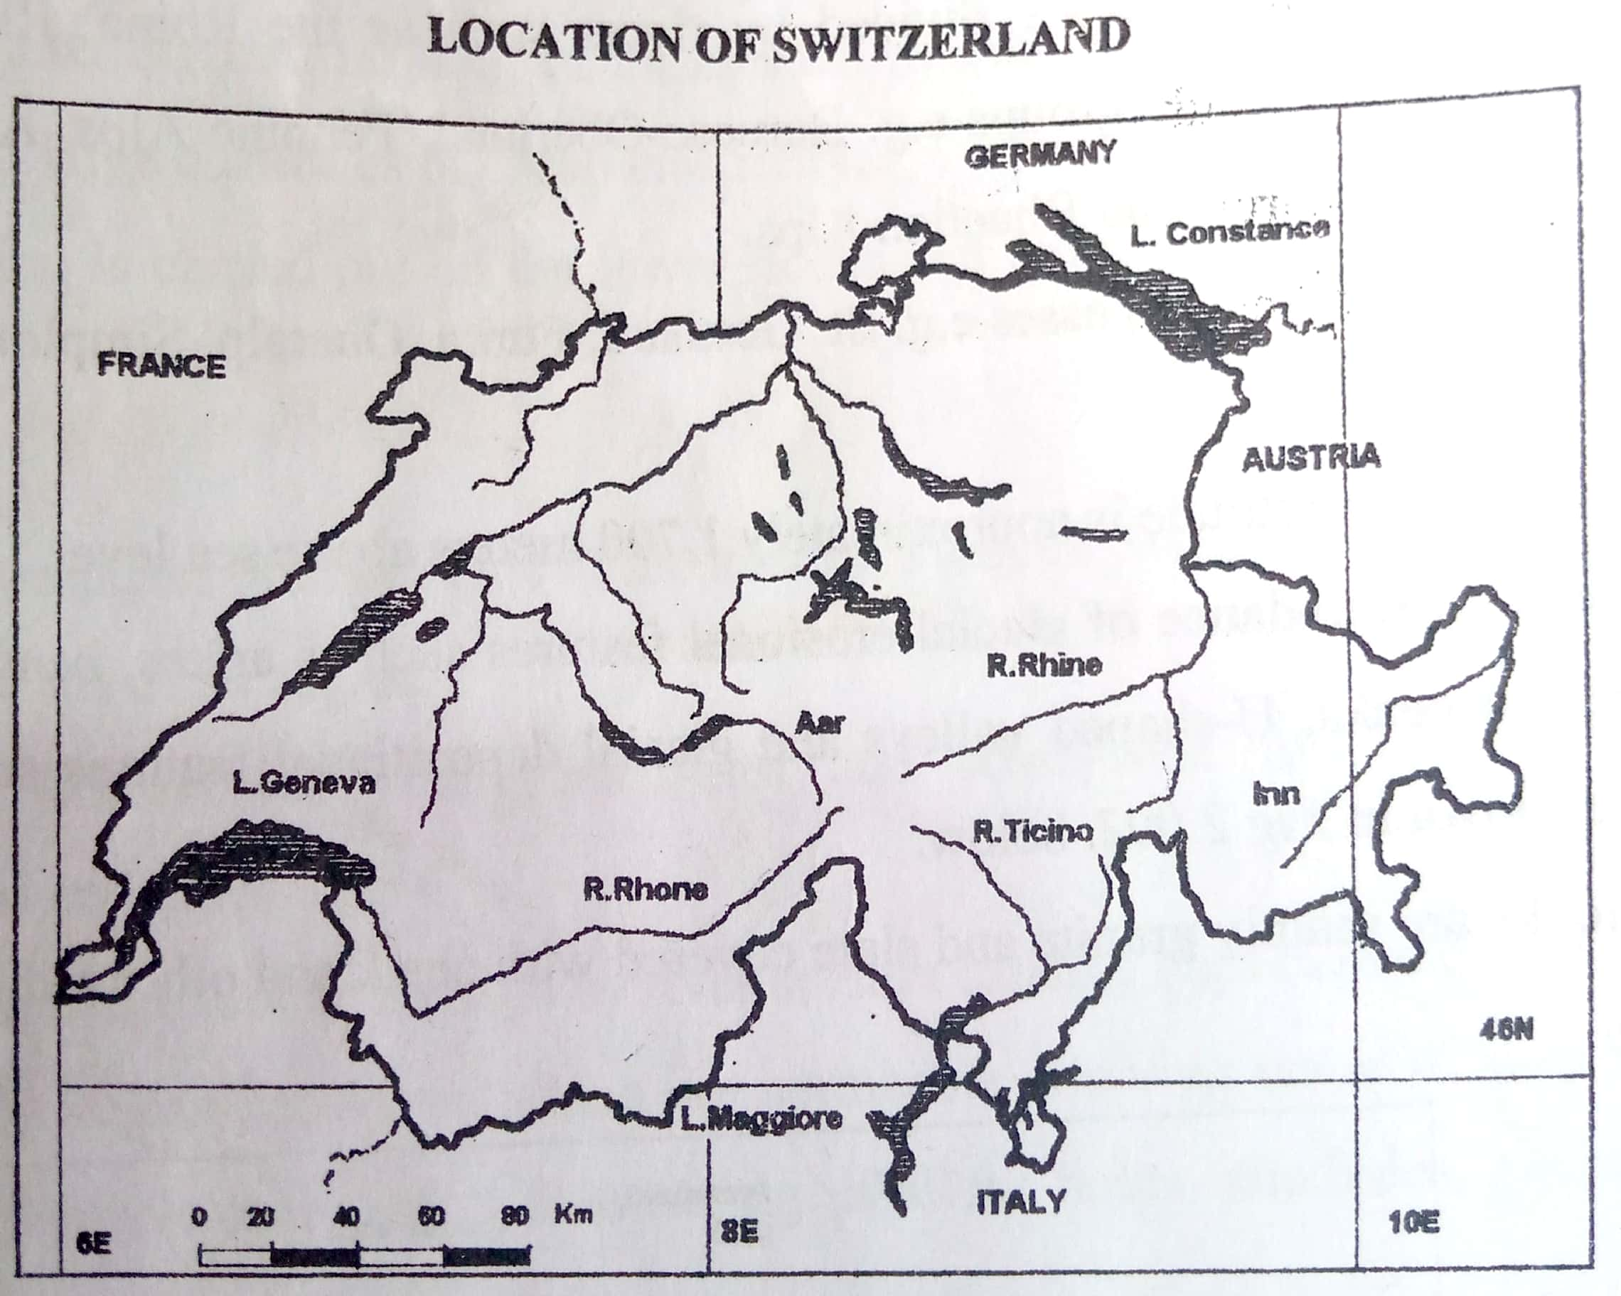

**Physical regions of Switzerland**

Switzerland is divided into three main relief/ physical regions, which include:

1. The Jura
2. The Central plateau/ Swiss plateau
3. The Alps

***A sketch map showing the physical regions and drainage of Switzerland***

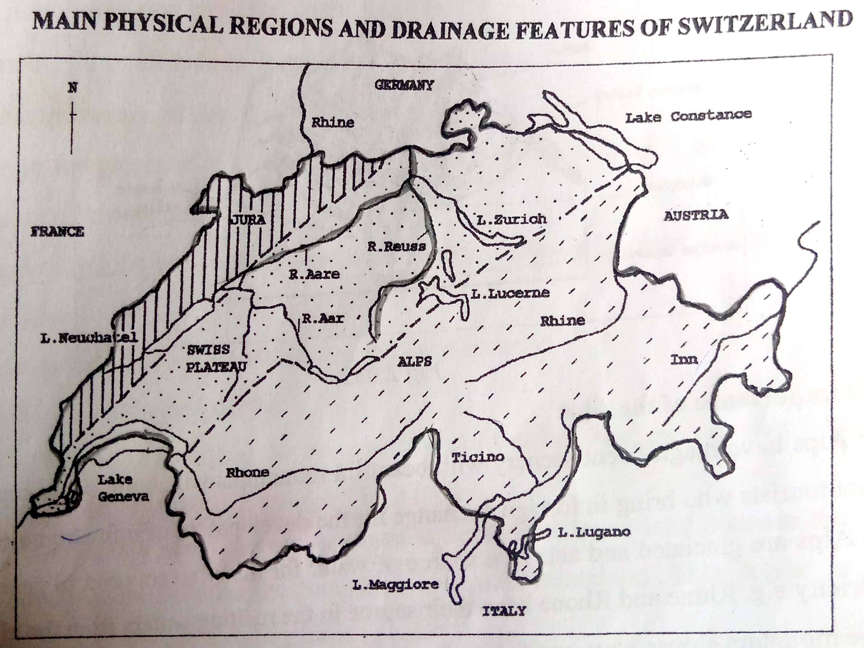

**The Swiss Jura**

The Jura region comprises of about 10% of the total land area of Switzerland.

**Characteristics**

1. The region consists of young fold mountain ranges with parallel synclines and anticlines
2. The fold ranges are punctuated/ dissected by Rivers causing gaps called cluses.
3. The rocks are mainly limestone, which are permeable (allow water to seep through).
4. There are many limestone/ karst features like shallow holes, caves, gorges, dry valleys, steep rocky cliffs, grykes etc
5. The Northern region has a flat-topped plateau.
6. The average/ mean altitude / height is about 750 m above sea level.

**Economic activities in the Jura region**

1. Animal rearing is the most important activity for dairy and beef products due to the presence of limestone rocks that lead to infertile soils. (However, on the higher slopes, the pastures are poor and only suitable for rearing sheep and goats).
2. The lower slopes are covered with forests especially pines and this leads to the development of lumbering activities.
3. Mining is also carried out especially salt in the valleys and limestone.
4. Tourism industry is also developed due to limestone features such as caves, clints.
5. Manufacturing industry such as watch making industry and textiles.

**The central plateau/ Swiss plateau**

The Swiss plateau is a North East to south west corridor of lower land between the Jura and the Alps. The Swiss plateau covers a total land area of about 30% in Switzerland.

**Characteristics**

1. The region slopes downwards towards the North East
2. The region is made up of sediments which piled up from the Alps, Jura and Black forest mountains.
3. Much of the plateau is undulating and is covered by fertile moraine material.
4. The average altitude is about 580m above sea level.
5. It contains large lakes such as Constance, and Lake Geneva
6. The region has the highest population total in the country.

**Economic activities of the Swiss plateau region**

* Urbanization and trade since the largest percentage of the population is found in the Swiss plateau. Urban centres are Bern, Zurich, Geneva
* Industry due to large population offering labour and market.
* Arable farming due to the low altitude and flat landscape that enables mechanization and cultivation. The crops include maize, wheat, barley, fodder crops, apples, pears, cherries etc
* Animal rearing due to rich pastures and fodder crops that support large herds for beef and dairy products.
* Fishing due to presence of lakes such as Constance, Geneva

**The Swiss Alps**

The alpine region makes up about 60% of the total land area of Switzerland and stretches from Lake Geneva to Italy in the south and Austria in the East.

**Characteristics**

* The region is dominated by complex fold mountain ranges running NorthEast and southwest.
* The mountains are dissected by Rivers such as Rhine, Rhone, Ticino etc into about 6 sub-divisions like Bernese, Oberland, Alps, Pennine, Adula Alps etc
* The average altitude is 1700m above sea level.
* Presence of many glacial erosional features such as arêtes, hanging valleys, pyramidal peaks, U-shaped valleys etc
* Presence of glacial depositional features such as moraines, outwash plains, drumlins, erratic etc
* The rocks are mainly granite and slate covered with chalk and other sedimentary in the North.
* The region has the lowest population density.

**Economic activities of the Alps**

1. Tourism due to the presence of the Alps with a beautiful/ magnificent scenery that attracts tourists and this generates foreign exchange.
2. The Alps are glaciated and act as a source of Rivers (from melt waters) such as Rhine, Rhone etc. the Rivers also act as a source of hydroelectricity.
3. Forestry and lumbering since the mountain slopes have coniferous forests.
4. Industry for example centres for smelting and refining of metals (like aluminium) due to presence of cheap electricity.
5. Animal rearing particularly cattle grazing –where transhumance is practiced. Transhumance is the seasonal movement of animals to the highlands where there is absence of pasture in the lowlands and back to the lowlands when there is absence of pasture in the highlands. This has promoted dairy farming.
6. Arable farming carried out on the lower slopes and crops grown include orchards, vines/ grapes.

**Glaciers and glaciated scenery in Switzerland**

Glaciation is the process through which the landscape is changed/ modified by the work of moving ice or glacier. The work of glaciers involves glacial erosion and glacial deposition.

The precipitation that falls in the Alps is conserved in form of snow and ice on the high mountains. Moving ice is called glacier and flows from high mountains into the valleys. As a glacier moves it erodes, transports and deposits material to the lower slopes to form moraine.

**Glacial erosional features**

Glacial erosion involves the reduction of the earth’s surface as a result of the presence or passage of a glacier. The glacial erosional features include cirques/ corries, arêtes, pyramidal peak/ horn, U-shaped valley / glacial trough, hanging valleys etc

1. **Cirque/ corrie/ cwm/ coomb**

A cirque is semi-circular steep sided basin cut into the side of a glaciated mountain. It is formed when a glacier moves from the side of a mountain leaving depression that is armchair-like. When this depression is filled with water to form a **cirque lake or tarn**.

***Diagram showing a cirque, arêtes, and pyramidal peak***

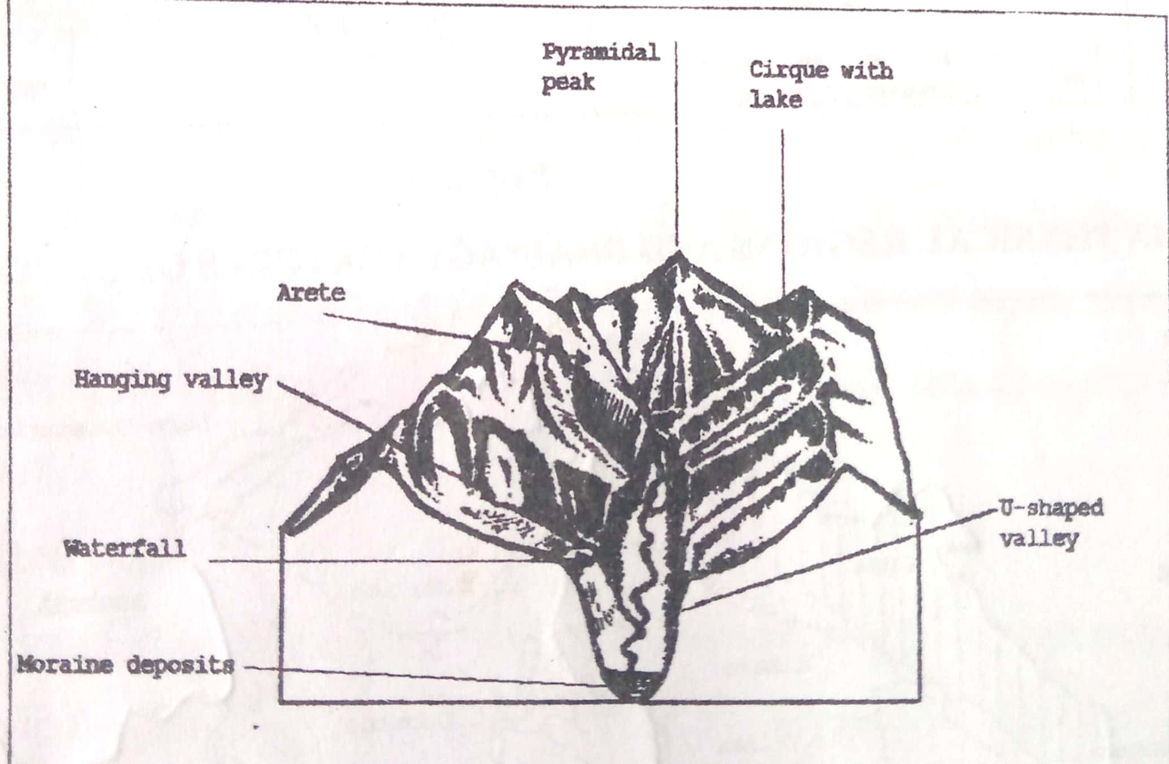

1. **Arêtes**

These are sharp knife-like / steep sided ridges separating two adjacent cirques. Arêtes are formed when the backwalls of two adjacent cirques are cut back by headward erosion (glacial erosion) forming a narrow knife-like ridge between the cirques.

1. **Pyramidal peaks/ horn**

This is a very sharp high-pointed mountain peak and it is surrounded by radiating arêtes. It is formed when a resistant rock remains on top of a mountain after the weak rocks on the sides have been eroded by glaciers. *(It is formed when two or more cirques are cutting back into the original upland).*

1. **U-shaped valley/ glacial trough**

A glacial trough is a broad/ wide, flat bottomed, steep sided valley. It is formed by deepening and widening/ straightening of the River valley, changing the cross-profile of a V-shaped valley into a U-shaped valley.

The valley glacier wears down the interlocking spurs of the pre-existing River valley. The sides of the U-shaped valley are steepened and are called **truncated spurs.**

***Illustration of a U-shaped valley***

1. **Hanging valleys**

These are tributary valleys left high above the main valley. They are formed when the main valley is over deepened by glacial erosion, such that the tributary valley is left high above the main valley.

If a River occupies the hanging valley, it forms a waterfall to the floor of the main valley.

***Illustration of a hanging valley***

**Glacial depositional features**

Deposition occurs mainly on the lowland from the steep slopes of the highland. This is where the speed of the transported load is reducing and hence deposited. The glacial deposition features include moraine/ till plain, outwash plains, drumlins, erratic, kames etc

* **Moraine**

Moraine involves rock fragments / rock debris of all sizes that a glacier carries *(material transported and deposited by a glacier).* Moraine is of several types:

1. **Lateral moraine**. This is formed at the sides of a glacier.
2. **Terminal moraine**. This formed at the end of the glacier i.e. along the front of the glacier.
3. **Medial moraine**. This moraine forming in the middle of a glacier. It is formed when two glaciers join / meet.
4. **Ground moraine**. This is moraine that is deposited at the bottom of the glacier.

* **Outwash plain**

This is a gently sloping plain composed of mainly gravel and sand. It is formed out of material deposited by terminal moraine.

* **Drumlins**

These are long rounded hills (oval-shaped) made of boulder clay/ deposited material. They may be about 1 km long and about 25-100m high. The upstream sides are steeper than downstream sides.

* **Erratics**

These are large boulders transported and deposited by a glacier. The boulders (blocks of rock) may vary in size.

* Other depositional features include: kames and eskers.

**Importance of glacial features**

1. Tourism development due to the attractive features like U-shaped valleys, cirques etc; hence generating foreign exchange.
2. The waterfalls from the hanging valleys are suitable for the development of hydroelectricity dams, which supports various economic activities like running machines in industry.
3. U-shaped valleys form natural route ways in the highland regions, which improves accessibility.
4. The Alps during summer have good pastures that favour animal rearing
5. The glaciers act as reservoirs for water during the dry months. That is, snow and glaciers provide water to the Rivers and streams for domestic and industrial use.
6. Glacial lakes may form fishing grounds, which increases incomes/ improves the diet.
7. Glaciers promote sporting activities such as ice-skating, and ice skiing.

**Negatives / disadvantages of glaciation**

* Glaciers lead to the formation of a rugged landscape which hinders the development of transport routes
* Glacial erosion erodes away the top soils and this discourages crop growing
* Some outwash plains contain infertile soils leading to wastelands
* Avalanches (downward movement of massive snow) are potential natural hazards which destroys farmlands or settlements.
* The deposited material in Rivers may result into flooding which destroys farmlands and transport routes.
* Glaciated regions are too cold in winter hence discouraging settlement.

**What causes a glacier to move?**

1. Gravitational pull from the top of the mountain to the bottom of the valley.
2. Development of pressure exerted by the overlying mass of ice causing lubrication within thus forcing the outer layer of ice to move down slope.

The speed of a glacier is affected by:

1. Nature of the slope. The steeper the slope, the faster the movement of glacier.
2. Thickness of the glacier. The thicker the glacier, the slower the movement.
3. The type of the glacier. Valley glaciers tend to move faster than ice sheets.

**Forms of glacier erosion**

A glacier erodes in three major ways:

1. **Plucking.** This is a process where a glacier tears away large pieces of rock underneath it, or it’s the tearing away of blocks of rock which have become frozen into the sides or bottom of a glacier. (The rock fragments are removed as the glacier moves).
2. **Abrasion**. This is the wearing or scouring of the rocks embedded in the glacier on the land. i.e. the grinding process in which rock particles such as pebbles and boulders are used as ‘grinding tools’ on the channel.
3. **Basal sapping/ frost action**. This is rock disintegration due to the alternate freezing and melting/ thawing of water that collects in jointed rocks beneath the glacier. When the water freezes and expands later the crack is widened and the rock particles tend to break away and they are transported by the glacier.

**Drainage of Switzerland**

Switzerland is the source of four major Rivers of Europe. River Rhine is the biggest River and its main tributaries are Reuss and Aare. The Rhine flows into the North Sea and it is the main River through which exports and imports are transported through the port of Basel.

River Rhone flows westwards into Lake Geneva; River Ticino flows southwards into Lake Maggiore; River Inn flows North Eastwards to join River Danube into the Black sea. These Rivers have their sources in the heavy precipitation and melt waters of the Alps Mountains. The lakes in Switzerland include Lake Geneva, lake Zurich, Lake Constance, Lake Neuchâtel, Lake Lugano etc.

These Rivers and lakes are viable for transport particularly Rhine, irrigation water, modifying the microclimate, sites for fishing, and as tourist attractions.

***A sketch map showing rivers and lakes in Switzerland***

***Climate of Switzerland***

Switzerland has varying climates. The west has a modified climate influenced by winds blowing from the Atlantic Ocean, the central and east have a continental climate highly influenced by altitude. The south of the Alps has almost Mediterranean climate due to the influence of the Mediterranean Sea.

The country experiences four seasons. Winter comes in December to February and is is cold and dry characterized by snow fall. Snow covers in most of the country. Spring comes in March to May, and it is generally a wet and cool season.

Summer comes in June to august and it is warm and wet with temperatures ranging between 16 to 220c. Autumn comes in September to November and it is dry and cool season.

However there are local climates influenced by altitude such as sub-alpine, alpine and glacial climatic zones. (For example snow always covers the mountain tops).

***A sketch map of Switzerland showing the climatic regions***

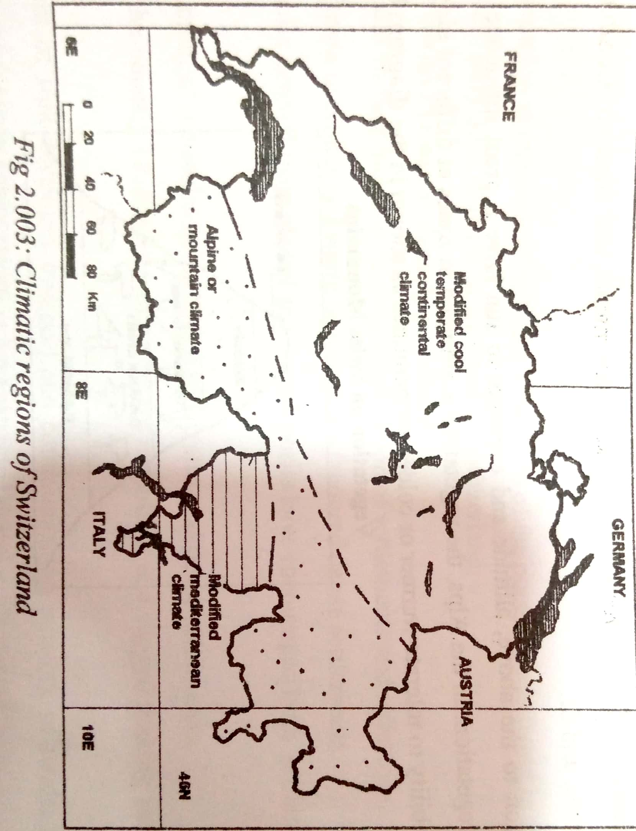

**Factors influencing the climate of Switzerland**

* **Latitudinal location (distance from the equator)**

The country lies far north of the equator and beyond the tropic of cancer making it a temperate country. At this latitude, heat from the sun is much less than near the equator and it fluctuates periodically caused by the apparent movement of the overhead sun. This results into a four-season pattern (winter, spring, summer and autumn). For example, summer comes in June to august when the overhead sun is around the tropic of cancer (Switzerland feels much sun heat because the sun is near).

Winter comes in December to February when the overhead sun is around the tropic of Capricorn (cool to cold conditions since the sun is far away).

There is precipitation throughout the year in Switzerland, having maximum rainfall in summers (120-180mm) while in winters rainfall is in form of snow (especially in the Alps). (In the valleys summer temperatures in July are between 16-210c while in winter (Jan) temperatures fall to -50c).

* **Aspect**

Due to the latitudinal location, the south facing slopes of mountains are warmer than north facing slopes. This is due to the influence of aspect. This leads to more settlement to the south facing slopes than the north facing slopes. Even natural vegetation distribution is affected, where in the alpine region, there is much tree coverage on the south facing slopes than the north facing slopes.

* **Influence of air masses/ prevailing winds**

The westerly winds blowing towards the country (summer westerly winds from France) due to a low-pressure zone developing in central Europe around July lead to warm and rainy weather. The easterly winds (winter easterly from Germany) which blow from central Europe around January bring in col conditions.

* **Variation in altitude (height of land above sea level)**

The high Alps region experiences cooler weather than the lower central/ Swiss plateau region. This is because temperatures decrease with increase in altitude. This also explains why the tops of the Alps are permanently covered by snow and the whole Alps gets covered in snow in winter.

* **Temperature inversion**

This is a situation where dense cold air descends to the valley bottoms as the light warm air rises. This affects the valleys of the alpine region. It makes the valley bottoms colder than valley sides (directly opposite of the lapse rate principle). This temperature inversion has influenced settlement in the region. Settlements are located upon the valley sides avoiding the coldness of the valley bottoms.

**Population in Switzerland**

Switzerland has a population which is unevenly distributed. Over 70% of the population if found in the Swiss plateau, which covers only 30% of the total land area of the country. The Alps has a low population density.

**The Swiss plateau is densely populated due to the following:**

1. Presence of generally flat landscape makes construction of buildings easy and thus dense settlement.
2. The mild climate in winter and warm summers have favoured settlement, leading to dense population.
3. Presence of fertile soils from glacial and river deposition have encouraged crop farming and dense settlement
4. The presence of many industries in the region which offers many employment opportunities and thus attracts dense settlement.
5. Presence of Well-developed transport routes such as roads, railways, air transport which makes accessibility easy and thus attracts more people, hence dense population.
6. Favourable government policy of developing infrastructure such as roads and railways hence attracting many activities and dense population.
7. The rest of the country (Jura and Alps) are mountainous and rugged which limits construction of structures and thus discourage settlement.

**Reasons why the Swiss Alps has a low population density**

1. Harsh/ very cold winter climate especially in winter with temperatures falling below 60c and thus low population density.
2. Presence of rugged mountainous relief which makes construction of structures and mechanization of farming difficult and thus sparse population.
3. Presence of thin, stony infertile soils which discourages crop farming and hence leading to sparse population.
4. Presence of forests on the lower slopes which harbor dangerous wild animals and hence discouraging settlement.
5. Presence of few industries and thus limited employment opportunities created, hence low population density.
6. Natural calamities such as avalanches and mudslides which destroy farmlands and settlements, leading to sparse population.

**Mineral resources**

Switzerland is almost totally lacking in viable mineral resources. The only reliable mineral is salt got from the Rhine valley above Basel and the Rhone valley. Other minerals only exist in very small quantities such as anthracite coal in Valais, peat coal, iron ore.

**Power resources**

Switzerland is endowed/ blessed with various power/ energy resources that is, hydroelectricity, nuclear power, and natural gas.

Hydroelectric power is the most important power source. This is due to the presence of many Rivers flowing from the Alps and Jura into the central plateau. In Switzerland, there are over 434 power stations.

The main users of electricity in Switzerland include:

|  |  |
| --- | --- |
| **User** | **Percentage** |
| Private homes, business, trade, agriculture | 50.5 |
| Railways | 6.5 |
| Industry in general | 22.0 |
| Electro-chemical & metallurgical industry | 14.7 |
| Others | 6.3 |
| **Total** | **100** |

Power sources have led to a high standard of living in the country such as the widespread use of electric appliances –dryers, refrigerators, cookers, television, washing machines etc. It is also noted that about 99 % of the Swiss railway system is electrified including cable cars and ski-lifts.

**Reasons why there are more HEP stations in the south than in the North**

1. Most of the major Rivers are found in the south such as Rhine, Rhone, Ticino etc. these Rivers have their sources in the melt waters of glacial Alps mountains
2. Constant flow of Rivers. The Rivers have a lot of water stored in frozen form i.e. the glacier acts as a reservoir during the dry months
3. Presence of many waterfalls in the south created by glaciers. Through over deepening of the main valley hanging valleys have been created resulting into cascading waterfalls which have been used to generate hydroelectricity.
4. The Northern part consists of the Swiss plateau which is generally flat without waterfalls.
5. The Jura region in the North west consists of mainly limestone rocks which are permeable. Water seeps through easily coming out at the foot of the mountains and thus less surface drainage to generate hydroelectric power.

**Note:** Apart from hydroelectric power, there are sources of power in Switzerland such as nuclear power and geothermal power.

**Tourism in Switzerland**

Switzerland has one of the most developed tourism industry in the world and tourism is the leading source of foreign exchange and a dominant employer. Switzerland’s tourism started in the 18th century when Europeans admired the diversity of scenery and beauty of the Alps. The first were the British, followed by German visitors and later other people. The Swiss tourist industry today commands a global image and the country receives millions of tourists each year.

**Tourist attractions and tourist resorts**

1. **The Alps** have magnificent mountain scenery which is also snow-capped with many glacial features such as hanging valleys, U-shaped valleys, pyramidal peaks, arêtes, corries/cirques, cirque lakes/tarns.
2. **Water bodies**. The Alps are dissected by Rivers such as the Rhine River, Rhone River, Ticino River, and River Inn. Lakes include Lucerne, Geneva, Constance, Lugano, Maggiore, Neuchatel and Lake Zurich.
3. **Wildlife** including plant and animal life. Vegetation includes a mix of deciduous trees and coniferous trees. The animal species such as the deer, fox, graceful chamois, ibex (wild goat); and many bird species such as wood peckers, peregrine falcons, golden eagles, jay etc
4. **Climate**-which provides both summer and winter attractions
5. In summer, the warm sunny days enable tourists to view the magnificent scenery of the snowcapped peaks, clear blue lakes, and cascading waterfalls. In addition, there is swimming, sunbathing, and boat racing and other activities.
6. During winter, the big attraction is the abundance of snow on mountain slopes enabling ice skiing and ice-skating.
7. **Industrial centres and urban centres** such as Zurich, Basel, Bern, Geneva, Blenna, Vevey, Interlaken, St.Moritz, Le Locle, and St.Gallen. The main industries are engineering, watch making, textiles, and chemical industries.
8. **Culture and tradition** especially paintings, music and architecture are of great interest to tourists. There are many Roman monuments, numerous cathedrals, Swiss museums. The National Museum in Zurich houses many historical collections.

**The main tourist resorts**

***A Tourist resort*** is a place which attracts large numbers of holiday makers and having special facilities to look after them. In Switzerland, there are both summer and winter resorts.

In summer, the greatest activity is in the towns of the Swiss plateau such as Lausanne, Geneva, Bern, Zurich, St.Gallen and the shores of Lake Lucerne. In the part bordering Italy towns like Locarino and Lugano are also important tourist centres.

In winter, the well-known resorts are Grindelwald, Kandersteg, Murren, and St.Moritz. Other important winter resorts are Davos, Klosters, Arosa, Zermatt, Champery. St.Moritz has the second largest number of hotels to Geneva.

***A sketch map of Switzerland showing the major tourist resorts***

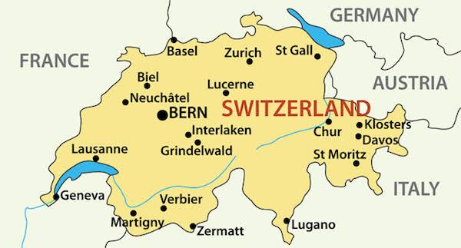

**Factors favouring the development of the Swiss tourist industry**

**Physical**

1. Magnificent/attractive landform scenery which includes the Alps Mountain ranges, snowcapped peaks, U-shaped valleys, and pyramidal peaks. Many people are attracted for mountaineering/ mountain climbing and mountain viewing.
2. Climatic changes/ variations which have given Switzerland a tourism opportunity throughout the year. There are summer attractions such as sunbathing, swimming as well as winter attractions to various tourists such as skiing and ice-skating.
3. Presence of a Variety of drainage features for example Rhine River, Rhone, Ticino; Lakes like Geneva, Constance, Zurich; which promote swimming, sunbathing, boat racing, blue water viewing, and sport fishing.
4. Presence of various fauna potentials. The animal species like the deer, fox and many species of birds like the wood pecker, peregrine falcons, golden eagle and jay which attract many tourists for animal and bird viewing and study tours.
5. Presence of various vegetation types such as coniferous forests, temperate deciduous forests, alpine flowers attracting many people for vegetation viewing, scientific/ botanical research.
6. Geographical location in the centre of Europe and the link to the Rhine River which has enabled Switzerland to have a wide market of the rich nations like Germany, France, Britain, Austria, and Belgium.

**Human factors/ other factors**

1. Presence of adequate capital to invest in tourism sector provided by the developed banking sector such as for constructing transport routes, modern hotels and improving attractions.
2. Developed accommodation facilities such as modern hotels in Geneva and St. Moritz which have attracted various categories of tourists.
3. Modernization of transport facilities such as the electrification of the railway system to transport tourists each year to various locations in the country.
4. High level of technology used in tourism which has enabled the development of cable cars, ski-lifts, electrified trains among other facilities.
5. Hospitality of the Swiss people making them friendly and very welcoming to tourists from various areas regardless of political and social consideration/ hence more return visits.
6. The diversity of international languages spoken by the Swiss people which include German, Italian, Spanish, English, French; and this has enabled them to comfortably communicate with the tourists
7. Efficient publicity and advertisement of the tourism sector such as using internet, newspapers, televisions to give tourists information about the Swiss tourist industry.
8. Highly skilled and trained labour to manage the tourist industry such as hotel managers, supervisors, accountants, tour guides, chefs, drivers.
9. Efficient tourism management standards catering for the particular needs of tourists like modern hotel management, entertainment and food in relation to modern standards.
10. Switzerland’s policy of neutrality in international politics with / not being involved in any war, which has ensured political stability and harmony with various countries, hence attracting many tourists.
11. Switzerland is the headquarters of many international organizations such as International Labour Organization (ILO), World Health Organization (WHO), International Committee of Red Cross (ICRC), and Federation of International Football Association (FIFA), which attracts many delegates.
12. Supportive / positive government policy towards tourism such as regulating tourism standards, spearheading and encouraging tourism research as well as private investment in the tourist industry.

**Contributions of the tourist industry in Switzerland**

1. Tourism generates foreign exchange to the economy because it is an invisible export. The foreign currency is used to purchase foreign technology and consumer goods.
2. Tourism leads to international recognition and respect of the country. It is for this reason that many headquarters of international organizations are in Switzerland such as FIFA, and Red cross.
3. More so tourism promotes international relationship between Switzerland and other countries like Belgium, Spain, Germany resulting from free movement and interaction of the foreign visitors and the host population.
4. Promotes the Conservation of natural beauty/ environment of the country for future generations such as the temperate forest species and animals (fauna).
5. Facilitates the development of other sectors such as the service sector. Increased flow of tourists increases the demand services such as banking, forex bureaux, shopping services, which are upgraded to international standards.
6. The tourism sector generates employment opportunities to the people such as tour guides, hotel operators, game rangers; hence improving their standards of living.
7. Facilitates the development of transport infrastructure such as electrified railway, roads and airports to cater for tourist arrivals and departures.
8. Tourism promotes urbanization /the growth of urban centres such as St. Moritz, Lausanne, Zurich and Geneva due to population concentration in the tour resorts.
9. Promotes diversification of the economy since tourism acts as an alternative income earner to the respective countries instead of over depending on a few sectors like agriculture, mining.
10. Tourism generates government revenue though taxing the tour operators and the workers’ incomes. The revenue generated is used to develop the social services like health, education, power supply etc

**Shortcomings / negative effects of tourism on the environment**

1. Pollution of the environment such as air and water pollution which reduces the quality of air and water through sewage disposal from hotels, restaurants, lodges, camping sites.
2. Destruction of vegetation cover due to increased tourism activities such as the need to set up more accommodation facilities and recreation facilities
3. Displacement of other activities /occupies land that would be used for other economic activities such as agriculture, industry, etc.
4. Displacement of people when the local community is shifted to provide room for national parks, game reserves and sanctuaries or any form of protection.
5. Results into urban-related problems such as increased crime, congestion, alcoholism, prostitution, high cost of living and other social evils.
6. Results into cultural erosion due to the commercialization of tourism. Tourism leads to the adoption of foreign cultures such as dress code, distortion of local language –hence eroding the cultural heritage.
7. Results into a risk of spread of diseases due to the entering of many foreigners into the host country such as STDs; which eventually reduces the quality of life.
8. Political –related problems because some people disguise as tourists but are political spies or terrorists who are likely to carry deadly bombs and even plotting coups.

**Problems facing the tourism industry in Switzerland**

* Competition from other tourist countries such as USA, Germany, France Egypt which reduces the number of tourist arrivals
* Seasonal nature of tourism which leads to fluctuation in incomes from tourism.
* Harsh winters which limits the movement of tourists, hence limiting tourist arrivals.
* Rugged / mountainous landscape in some areas making them less accessible to tourists due to the risk of accidents.
* Accidents due to avalanches, melting ice etc which leads to the death of tourists, hence scares some other tourists.
* Terrorism threat in the world today which limits the number of tourist arrivals/ which scares away tourists.
* The threat of deadly diseases in the recent times in some parts of the world such as *ebola* which limits the number of tourists visiting the country
* Poaching of wild animals which reduces the tourist potentials in the country
* Restrictions in the giving of visas, deportation of some people, which limits the number of tourist arrivals.
* Wildfires such as in the coniferous forests which also reduces the tourist potentials
* World economic recession which has reduced world incomes and therefore reducing the numbers of tourists.
* Pollution of the environment such as water and air pollution due to disposal of wastes and emission of dangerous gases which destroys tourism potentials.

**Tourist attractions in East Africa**

1. Climate. The hot humid climate attracts tourists from colder regions especially during winter. There are also other climatic types such as Montane, savannah etc
2. Relief features such as the snowcapped mountains of Kilimanjaro, Ruwenzori and Kenya. The East African rift valley, volcanic mountains, etc
3. Drainage features which include waterfalls, Rivers and lakes, numerous beaches etc
4. Wild animals and birds in the national parks, wildlife reserves, sanctuaries. The wild animals include elephants, lions, buffalo etc
5. Various natural vegetation types such as equatorial forests, savanna vegetation, desert vegetation, Montane vegetation etc
6. Historical sites which include fort Jesus at Mombasa, Kasubi tombs in Kampala
7. Culture including traditional dances, dressing, dishes etc. Also, local handcrafts such as Maasai wood carvings, baskets, traditional wear, traditional foods etc

**Reasons why the tourist industry in East Africa is less developed than that of Switzerland**

1. East Africa is far away from the main tourist sources such as Europe and North America-hence receiving fewer tourists while Switzerland is located strategically in the centre of Europe.
2. Underdeveloped transport routes such as poor roads, railway linking to tourist areas in East Africa while Switzerland has developed transport routes.
3. Low level of advertisement in East Africa attracting fewer tourists due to limited awareness while Switzerland has developed advertisement.
4. Less developed accommodation facilities with many not meeting international standards while Switzerland has well developed accommodation facilities.
5. Political instability in East Africa which limits the number of tourists while Switzerland is politically stable.
6. Limited skilled labour in East Africa leading to inefficient tourism services while Switzerland has a highly skilled labour force.
7. Low level of technology which limits the modernization of tourism in East Africa while in Switzerland there is a high level of technology in tourism.
8. Limited capital which limits the expansion/ modernization of tourist facilities while Switzerland has large sums of capital invested in tourism.
9. Lack of strong tourism spirit among the local people in East Africa while in Switzerland there is a strong tourism spirit among local people.
10. Presence of hostile tribes and unfriendly communities who scare away the tourists while the Swiss are hospitable to various tourists.

**Qn. Explain why the tourist industry of Switzerland is more developed than that of East Africa**

**Industrialization in Switzerland**

Switzerland has a highly developed industrial sector and one of the highest standards of living. Industrialization began with textiles manufacture and for long; it employed the largest number of workers. Today however engineering has taken the lead. Other industries include watchmaking, precision instrument, footwear etc

**The Swiss industrial structure**

|  |  |  |
| --- | --- | --- |
| **INDUSTRY** | **TOWNS** | **PRODUCTS** |
| **Engineering industry** | Zurich, Bern, Geneva, Basel, St. Gallen, Baden | Locomotive, wagons, vehicles, turbines, electrical appliances, marine diesel engines, cable ways, weighing, printing machines, sewing machines etc |
| **Watch making industry** | Le Locle, La Chaux-de-fonds, Neuchâtel, Biel | Wrist watches, clocks, watch components |
| **Precision industry** | Lausanne, Zurich, Basel, Baden | Binoculars, microscopes, cameras, computers, periscopes, surveying, instruments, navigation and meteorology instruments, balances, voltmeters, calculators |
| **Textile and footwear** | Zurich, St. Gallen, Appenzell | Clothes, shoes and ski-boots |
| **Chemical and pharmaceutical** | Geneva, Bern, Zurich, Basel | Dyes, drugs, explosives, insecticides, plastics, soap, cosmetics, paper chemicals, photo-chemicals, pigments |
| **Food processing industry** | All towns mentioned above | Milk, butter, yoghurt, chocolate, soups, meat extracts, bread and other confectionaries |

***A sketch map showing the distribution of major industrial centres in Switzerland***

**Factors which have favoured industrial development in Switzerland**

1. Availability of various sources of power for industry such as large quantities of hydroelectric power from the Alps, nuclear power to run machines in industries.
2. Availability of large sums of capital to invest in industrial development provided by the government, local and foreign investors such as to buy modern industrial machinery, carrying out research.
3. Availability of large supply of raw materials from different sources such as agricultural sector (milk, meat, sugar, vegetables, grapes). Still most raw materials are imported such as oil, and cotton; which leads to steady supply of industrial goods.
4. Availability of large /extensive land for industrial development especially the Swiss plateau which is relatively flat and this favours the construction of all forms of industries like engineering, textiles, chemical industries.
5. The long policy of neutrality of the country which has attracted many investors in the industrial sector.
6. Switzerland’s strategic position in the heart/centre of Europe which has given it an advantage of acquiring market opportunities in all directions such as Germany, Italy, France, Austria, Belgium, and The Netherlands.
7. Availability of large skilled labour supply to work in industries such as textiles, watch-making. The Swiss have also kept on increasing their skills and today produce high quality products which compete favourably on the world market.
8. Well-developed transport networks such as the Rhine linking Switzerland to the North Sea, a modern electrified railway network and modern air transport for moving inputs to industries and finished goods.
9. High level of technology employed in the industrial sector such as automation, raw material saving technology which has promoted the production of high quantity and quality products.
10. Availability of large water supply for industrial use, for cooling machines and as a raw material such as engineering, chemical industries and food processing industries.
11. Favourable/ positive government policy towards industry such as by encouraging sound education and research to discover of new industrial production techniques. It has also provided capital for industries such as power generation, engineering,
12. Developed/intensive industrial research leading to high quality output for example many industrialists invest in automation, production of synthetics. There is also research into minimizing of chemical, biological or physical hazards in the industries.
13. Hospitality of the Swiss people which has helped Switzerland to gain a large market for the industrial products.
14. Formation of the European union (EU) has also widened the market for the Swiss industrial goods.

**Benefits of the industrial sector in Switzerland**

1. Generation of foreign exchange through the exportation of the industrial goods such as textiles, chemicals, and machinery to other countries. The foreign currency generated helps to import foreign goods not produced locally, and foreign technology.
2. Generation of many employment opportunities such as in the supply of industrial raw materials, processing, grading and packing industrial goods, transportation, and exportation of industrial output. This has helped to improve the standards of living
3. Promotion of urbanization/ growth of urban centres for example Zurich, Geneva, Basel and Bern due to population concentration, hence development of the associated infrastructure such as hospitals, schools and recreation facilities.
4. The industrial sector facilitates capital accumulation from the sale of the industrial goods, and this promotes investment in other sectors of the economy like mining, farming and tourism.
5. Generation of government revenue from the taxation of the industrial companies, workers’ incomes and the related activities; and the revenue got is invested in various sectors like fishing, education sector, and farming.
6. Promotion of international relationship between Switzerland and other countries such as countries importing the industrial products-Netherlands, Spain, Britain. hence more capital inflow.
7. Promoted development of transport infrastructure for example today Switzerland has one of the most advanced road and railway network in the world.
8. Diversification of the economy which has reduced over dependence on few sectors like agriculture; this has increased national income.
9. Promoted development of other sectors like agriculture, trade and commerce, tourism—given the linkages of industry with such sectors. For example, the agricultural sector supplies food and raw materials to the industrial sector
10. Improves the country’s balance of payment position through increasing the export earnings. The industrial goods command higher prices on the world market.
11. Promotes self-sufficiency in the production of manufactured goods and this reduces economic dependence on other countries
12. Facilitates the exploitation/utilization of a country’s resources such as mineral resources, forestry resources, water resources, agricultural resources which are used as inputs/raw materials.

**Negative effects of industrialization (problems resulting from industrialization)**

1. Pollution of the environment for example air and water pollution through direct emissions of wastes from industries or indirectly through automobiles. This reduces the quality of life.
2. Urban-related problems due to industrial concentration like high crime rates, traffic congestion, overcrowding, easy spread of diseases, and growth of slums.
3. Leads to unemployment problems since many industries today are highly capital-intensive and hence create few jobs.
4. It increases rural-urban migrations in excess of available job opportunities.
5. Leads to profit repatriation due to foreign ownership of industries; which limits the rate of economic growth.
6. Leads to over exploitation of natural resources such as minerals, forest resources, and water resources in most countries leading to quick resource exhaustion.
7. Destruction of natural vegetation cover through deforestation to set up industrial sites or expand the industrial establishments, and thus reduced rainfall totals.
8. Industrialization contributes to global warming through destruction of the ozone layer by emission of dangerous gases to the atmosphere.
9. Leads to destruction of the natural landscape such as through leveling the landscape, reclaiming of swamps to set up or expand industries
10. Displacement of other economic activities / encroachment on land for other activities like agriculture, forestry and settlement.
11. Industrial accidents for example fire outbreaks leading to loss of lives and industrial property.
12. Industrialization leads to the traditional values by changing the way of life and producing goods demanded by foreign markets.

**Problems facing the industrial sector in Switzerland**

1. The country virtually lacks most of the valuable natural resources/ raw materials such as coal, iron ore, copper, oil etc and this has reliance on imported raw materials which are expensive (limited local supply of raw materials)
2. Rugged terrain/ mountainous nature of the landscape which limits the construction of transport routes and thus difficult delivery of raw materials and finished goods to industries and markets respectively.
3. Small domestic market since the country has a small population which cannot support industrialization, and this limits production.
4. Competition from other industrial countries for market notably Japan, China, USA and Germany. This results into fluctuations in prices and incomes.
5. Shortage of labour to work in the industries, leading to high labour costs and increased costs of production.
6. The country is landlocked with no direct and easy access to the sea and this increases the cost importing raw materials and exporting finished goods.
7. High costs of production such in the production of high-quality capital-intensive goods
8. Limited land for industrial expansion partly due to the rugged terrain in the Jura and Alps. Many industrial centres in the Swiss Plateau are already congested.
9. Pollution due to wastes disposal which negatively affects the quality of the industrial output.
10. Congestion of the Rhine which is the main waterway linking Switzerland to the rest of the world and the frequent delays negatively affect the Swiss industry.
11. The system of imposing high tariffs on imported goods by developed countries which reduces the profit margin. This has meant that Switzerland has to fight the tariffs.

**Steps which have been taken to control the above problems**

1. The country has emphasized the use of the Rhine, which is a cheap waterway to the North Sea to minimize the problem of landlockedness.
2. Encouraged specialization in the production of small/ light but high value goods, which require less raw materials to control the problem of raw material shortage.
3. The government has invested a lot in the development of transport infrastructure such railway, roads to connect the country to the rest of Europe.
4. Emphasized the production for the export market to minimize the problem of limited local market.
5. Adopted small and medium scale industries that do not require a lot of space.
6. Emphasized the production of high-quality goods which can compete favorably on the world market.
7. Encouraged importation of raw materials from abroad to minimize domestic shortages.
8. Emphasized the use of raw material saving technology such as recycling of waste material to minimize raw material shortages.
9. Related industries have been established which use other industrial bi products as inputs to minimize raw material shortage.
10. Strengthened regional cooperation to expand the markets such as Switzerland is a member of EU (European Union).
11. Emphasized the treatment of industrial wastes to reduce environmental pollution.
12. Anti-pollution laws / legislation strengthened to control pollution.
13. Encouraged automation of industrial activities / more use of machines to minimize labour shortage. In addition, some labour is recruited from abroad such as Spain, Italy and Germany.
14. Market research and advertising have been carried out to expand market for output.
15. Emphasized neutrality to easily access the export markets abroad.
16. Organization of annual trade fairs in the country attracting many buyers from many countries to further widen the market.
17. Further development of the tourist industry which also helps in advertising the Swiss industrial products abroad.

**AGRICULTURE IN SWITZERLAND**

In Switzerland, agriculture is concentrated in the Swiss plateau due to the lower altitude and gently sloping landscape compared to the Alps or Jura.

The largest area in agriculture is devoted to animal rearing especially dairy farming due to rich pastures and fodder crops.

On the warmer south facing slopes around the bigger lakes like Neuchâtel, and Geneva; and near larger cities market gardening is an important activity. Arable farming involves vegetables, fruits, cereals, and fodder crops.

**Characteristics of agriculture**

* It is carried out mainly on small-scale (intensive in nature).
* Scientific methods are highly used such as fertilizers.
* Cattle rearing takes place especially dairy cattle for cheese, butter, condensed milk etc
* Fodder crops are grown such as hay, oats, and Lucerne grown to feed livestock.
* Agriculture is most developed in the Swiss plateau.
* Market gardening is also greatly carried out.
* Seasonal crops are highly grown such as vegetables.

**Why agriculture is most developed in the Swiss plateau**

1. Presence of fertile soils from the glacial and River deposits which support the growing of a variety of crops in the Swiss plateau.
2. Presence of rich pastures and fodder crops which support animals (dairy and beef cattle).
3. Mild climate with sufficient rainfall and sunshine favorable for farming
4. The lower altitude and relatively flat landscape which enables mechanization of arable farming unlike the Alps and Jura.
5. Well-developed transport routes such as roads and railways which favour the transportation of farm inputs and farm produce.
6. The Swiss plateau has a high population which provides labour and market for agricultural products.
7. Intensive/ increased research which has led to improved farming techniques in the Swiss plateau.

**Why agriculture is least developed in the Swiss Alps**

* The Alps are glaciated and thus very cold temperatures which cannot support crop growing.
* The mountainous and rugged relief which also limits land for crop growing and increases soil erosion.
* The difficult transport in the Alps due to rugged terrain and this limits the movement of farm inputs and farm output.
* The soils are generally thin, stony and infertile which limits crop farming.
* The low population leads to shortage of labour and market for agricultural products.

**Arable farming**

Arable farming involves the growing of crops. Swiss arable farming is done on small holdings. The major crops grown include maize, wheat, barley, potatoes, sugar beet, fodder crops, fruits and vegetables. Fruits grown include apples, pears, cherries, peaches, apricots, grapes/ vines, and plums. The major vegetables include carrots, celery, beetroots, cabbage, tomatoes, and onions. Fodder crops include rye, oats etc

Arable farming is concentrated in the Swiss plateau. However, some arable farming is done in the Jura and Alps regions, but it is limited to the lower slopes/ valley bottoms.

**Factors favouring arable farming in Switzerland**

1. Rainfall received throughout the year, which supports the growing of a variety of crops throughout the year.
2. Warm summer temperatures which also support the growing of crops. The central plateau does not have snowfall in winter allowing farming activities all the year.
3. Presence of deep fertile soils in the Swiss plateau and the valleys bottoms of the Alps which support the growing of crops.
4. The gently sloping landscape in the central plateau and the valley bottoms which favours the use of machines and limits soil erosion.
5. Availability of skilled labour to work in the agricultural sector. Farmers’ associations organize field visits for members to share experiences and improve their skills.
6. High level of research in the agricultural sector to produce high quality and quantity of crops.
7. Presence of a large/ ready market for the produce in the large cities and even abroad.
8. High level of technology employed such as use of machines on farms. Technology is also used in processing the output.
9. Positive government policy towards agriculture such as giving subsidies to farmers

**Problems faced by the Swiss arable farmers**

1. Limited land for arable farming largely because of the rugged terrain and population pressure. This discourages the expansion of farms.
2. Soil exhaustion due to continuous cultivation leading to low yields.
3. Winter temperatures are very cold and thus do not allow farm activities in most of the country especially Swiss Alps.
4. Pests such as amphids which attack the crops and reduce the quality and quantity of crop output.
5. Diseases such as leaf rust also attack the crops and reduce the quality of output.
6. Inadequate labour supply due to the small population, which discourages production.
7. Competition from other farmers in other countries such as Netherlands, Belgium, and Germany which reduces the available market.
8. Price fluctuations on the world market which results into unstable incomes to the farmers, hence discouraging production.
9. River flooding especially during spring leading to the destruction of farmlands
10. Severe soil erosion especially near mountain regions which destroys farmlands.
11. High costs of production especially during winter, when green houses are used, which reduces the level of profits.
12. The infertile sandy soils in a large area especially in the Alps less fitting for farming practices, hence low production.

**Steps taken to solve the above problems**

1. Use of intensive farming to ensure high yields and offset the highland rent.
2. Terracing of some steep slopes to increase farmland and control soil erosion.
3. Use of fertilizers and manures to improve soil fertility
4. Use of glass houses where humidity and temperature are artificially controlled. (although limited to small scale due to the costs involved).
5. Spraying using chemicals to control the pests. There is also biological control of pests.
6. Exportation of excess products to the other countries to reduce wastage.
7. Emphasizing high quality production for high prices, hence offsetting high costs of production.
8. Mechanization to reduce the problem of limited labour
9. Subsidizing the farmers to enable them to compete favourably with other producing countries

**Livestock farming in Switzerland**

The animals kept include cattle (both dairy and beef cattle), goats, sheep, and pigs. Poultry keeping also takes place.

Most of the Swiss farmers are dairy farmers *(Dairy farming is the dominant activity).* Much of the milk is processed and cheese is a major product, along with butter, cream and condensed milk. Others are milk chocolate, and skimmed milk.

Much of the dairy farming is carried out on the slopes of the Alps. Where transhumance is practiced. **Transhumance** is the seasonal movement of man and his animals up and down the highlands. During winter, the farmers graze their animals in the valleys due to severe coldness at the hilltops. During summer the farmer graze their animals up in the hills due to downward movement of snow which brings cold conditions in the valleys. Animal rearing is also practiced in the Swiss plateau around the bigger lakes such as Geneva.

Exotic breeds of animals are reared such as Friesian, Guernsey and New Jersey. The farm products include butter, cheese, powder milk, cream, beef etc

**Factors which favour animal rearing in Switzerland**

* Presence of infertile clay and peat soils in the Alps which do not support crop growing and thus leaving land for animal rearing.
* The sparse population in the Alps that has left large land for animal rearing.
* The cool temperate climate which favours the rearing of the exotic breeds of animals.
* Presence of a variety of fodder crops such as hay, oats and alfalfa used to feed the animals.
* Availability of adequate capital from credit banks to invest in dairy farming such as construction of shelters for in-door grazing and carrying out research.
* Presence of large market both domestic and foreign for the Swiss dairy products.
* Well-developed transport network to transport farm inputs and farm produce.
* High level of technology such as the use of electric milking machines leading to high quality and quantity of output.
* Increased research in animal rearing such as on fodder crops, artificial insemination.
* The development of many processing industries to handle dairy products which also expands the market.
* The formation of many cooperatives which help in buying of farm inputs, selling of farm output and carrying out research.

**Problems faced by Swiss dairy farmers**

1. High costs of production such as artificial insemination and this reduces the profit margin.
2. Diseases such as anthrax which leads to low quality output.
3. Shortage of labour to work on the dairy farms due to the small population, which discourages production.
4. Rugged relief in the Alps which also limits the movement of animal to some areas for grazing / limits the construction of transport routes.
5. Price fluctuation of milk on the world market which discourages farmers/ leads to unstable incomes.
6. The small domestic market due to the small Swiss population, which discourages production.
7. Competition from other dairy farmers in Europe such as Germany and Denmark which limits the available market.
8. Severe winter conditions which lead to seasonal movement of farmers and animals.
9. Difficult transport such as congestion along River Rhine, River flooding and blocked roads during winter.

**Solutions to the above problems**

1. Government us of subsidies to offset the high costs of production.
2. Spraying with chemicals to control pests and diseases.
3. Formation and strengthening of cooperatives to enable the farmers to get loans to invest in animal rearing and to readily secure market for the produce.
4. Diversification of markets through research to minimize competition from other countries.
5. Emphasize high quality production through specialization to minimize competition from other countries.
6. Use of alternative means of transport such as air transport to reduce delays along the Rhine River.
7. Mechanization of animal rearing to minimize labour shortage.

**Transport in Switzerland**

Switzerland has expanded its water, road, rail and air modes of transport with a view of promoting economic development. However, the greatest problems are caused by glaciated relief and icy winters.

**The major means of transport in Switzerland include:**

**The Swiss railway system**

Switzerland has a dense railway network and about 99% of the Swiss railway system is electrified using Swiss hydroelectricity. As such, it does not depend on imported oil / petroleum or even coal.

**Reasons why Switzerland has developed a dense and efficient railway system**

1. The country imports large quantities of goods. About 68% of the goods arriving at Basel port are transferred to other areas of the interior by rail.
2. Switzerland exports large quantities of goods and such goods are transported by railway from various parts of the country to Basel port for export.
3. The need to promote the tourism industry. Railway transports millions of tourists each year to various attraction areas.
4. The central location of Switzerland in Europe making her a natural route way for international rail links from North to south and East to west.
5. The need to transport thousands of workers who commute to their work places each day for long distances.
6. The need to develop the manufacturing industries in Switzerland.

**Road transport system**

Switzerland has one of the densest road networks in the world. The greatest road development is noticed in the central plateau/ Swiss plateau where the relief is lower, much industry developed, well-developed agriculture, and the population is concentrated.

**Air transport**

Today Switzerland has air services shared with other countries. The main international airports are Kloten at Zurich, Cointrin at Geneva and Basel. There are also many local services which fly between all the principal towns of the country.

Air transport has been mainly developed due to the central location of Switzerland in Europe, the need to transport tourists to and from Switzerland quickly and in large numbers; and the need to move high value, low volume manufactured goods such as watches, microscopes, binoculars etc to international markets.

**Water transport**

The Rhine is the most important waterway of the country. The main imported commodities are bulky solid and liquid fuels, raw and semi-finished metals, cereals, sand and gravel. River transport is generally cheap and ideal for large cargoes. Basel port handles all the international River traffic to and from Switzerland. Switzerland has over 400 vessels.

**Pipeline transport**

This has been developed in order to import oil/ petroleum from other countries like Russia, Ukraine etc

**Problems facing the Swiss transport sector**

1. The rugged / mountainous terrain of the Alps and Jura which makes the construction of roads and railway difficult /leads to high costs of construction and maintenance.
2. Many Rivers are not navigable due to rapids and waterfalls such as the upper Rhine River from Basel, discouraging
3. Flooding of Rivers especially in spring season due to melt waters from the glaciers of the Swiss Alps, limits the use of rivers for transport.
4. Congestion on the transport routes especially roads, Rhine River leading to unnecessary delays and loss of revenue.
5. High/ increasing costs of importing of coal and oil to use in transport since Switzerland does not possess these.
6. Switzerland is landlocked with no easy and direct access to the sea, which leads to high costs of exporting goods to other countries.
7. Severe winter conditions such as roads blocked by snow and air travel limited by poor visibility.

**Solutions to the above problems**

1. Considerable engineering skills are used to overcome the problems of road and railway construction in mountainous regions
2. Most of the railway system is electrified using Swiss made HEP and therefore not dependent on imported oil or coal
3. Time tabling movement to reduce delays and accidents.
4. Building of a national road network to reduce congestion on the roads.
5. Use of locks to improve on the navigability of the Rivers such as the Rhine
6. Use of cable cars and ski lifts to overcome the problems of steep gradients.
7. Construction of underground tunnels to control problems steep gradient/ to reduce congestion. Sometimes transport routes must follow valley or deep gorges.
8. Double tracking to ease congestion and reduce delays.
9. Containerization to ease congestion at port Basel.
10. Use of lights during periods of poor visibility to reduce accidents.
11. Use of air transport especially in the Alps to overcome rugged landscape.

**Urbanization in Switzerland**

The major cities in Switzerland are Bern, Zurich, Geneva, Lausanne, and Basel. Zurich is the largest city. Zurich is the headquarters of International Committee of Red cross (ICRC), Federation of international football association (FIFA).

Geneva is the headquarters of International Labour Organization (ILO), World Health Organization (WHO).

Basel is a major town in Switzerland because it is the major link point for Switzerland to Germany and France at the Rhine junction.

**Factors that favoured the growth of Basel town.**

1. Generally flat topography/ landscape encouraging the construction of industries and transport systems.
2. Strategic geographical location of Basel along the Rhine River, which gives it easy accessibility to foreign markets.
3. The development of many industries in the area such as engineering, textiles, chemical, food processing which has increased the volume of trade.
4. High level of technology which has enabled the construction of the city/ port such as constructing canals, modern buildings.
5. Availability of large sums of capital to invest in the modernization of the town such as building commercial buildings.
6. Availability of various power sources such as oil and hydroelectricity to develop the various urban activities.
7. Political stability of the region for a long period which has enabled the city to expand without any disturbance of war.
8. Well-developed transport and communication systems such as canals, roads and railways for easy movement of goods and people.
9. Supportive/ positive government policy of developing the city and port such as by encouraging local and foreign investors in various activities.
10. Large supply of skilled labour in the area to carry out modern construction and development of the city.
11. Her port status which has ensured business throughout the year handling imports and exports.

**Functions of Basel city/ port**

**NB. (Refer back to New York city) function of a town or city are the services that are served by that city or urban centre to the public. Cultural centre, administration centre, commercial centre etc.**

**Problems faced by Basel town**

1. Traffic congestion due to increased use the transport networks, hence leading to delays. There is congestion of vessels at the port causing delays.
2. Maintenance of the city is extremely expensive such as water supply, sewage disposal, law and order. This is due to overcrowding.
3. Pollution of the environment especially air pollution due to toxic gases and wastes from industries and too many vehicles.
4. Unemployment problems due to high rural urban migration and high population in the city. This leads to social evils like theft and robbery.
5. Limited/Shortage of land for expansion of the port/ city due to many activities carried out; and this has led to the construction of skyscrapers.
6. Population explosion/ increase which has led to inadequate housing resulting into slum growth. Overcrowding of people also leads to easy spread of diseases and high crime rate.
7. Risk of fire due to the presence of many oil tankers all over the port/city.
8. Flooding of the Rhine River due to melting of snow during spring –summer.

**Steps being taken to solve the problems**

* + - 1. Vertical expansion of the port to minimize the problems of limited space (use of skyscrapers).
      2. Containerization to reduce port congestion and delays.
      3. Treating industrial wastes before disposal into water to reduce pollution.
      4. Discourage illegal immigrants with strict laws to control the population explosion.
      5. Police has been strengthened to be more alert against crime among citizens.
      6. Construction of more small-scale industries to fight unemployment.
      7. Encourage people to search for jobs in other areas to reduce unemployment and overcrowding.

**GERMANY**

Germany is the largest country in the Rhine lands, and it is one of Europe’s most developed nations. Germany is bordered by Denmark in the north, Poland and Czech Republic in the East, Austria and Switzerland in the south, France and Luxembourg in the Southwest, and Belgium and the Netherlands in the North West.

***sketch map of Germany***

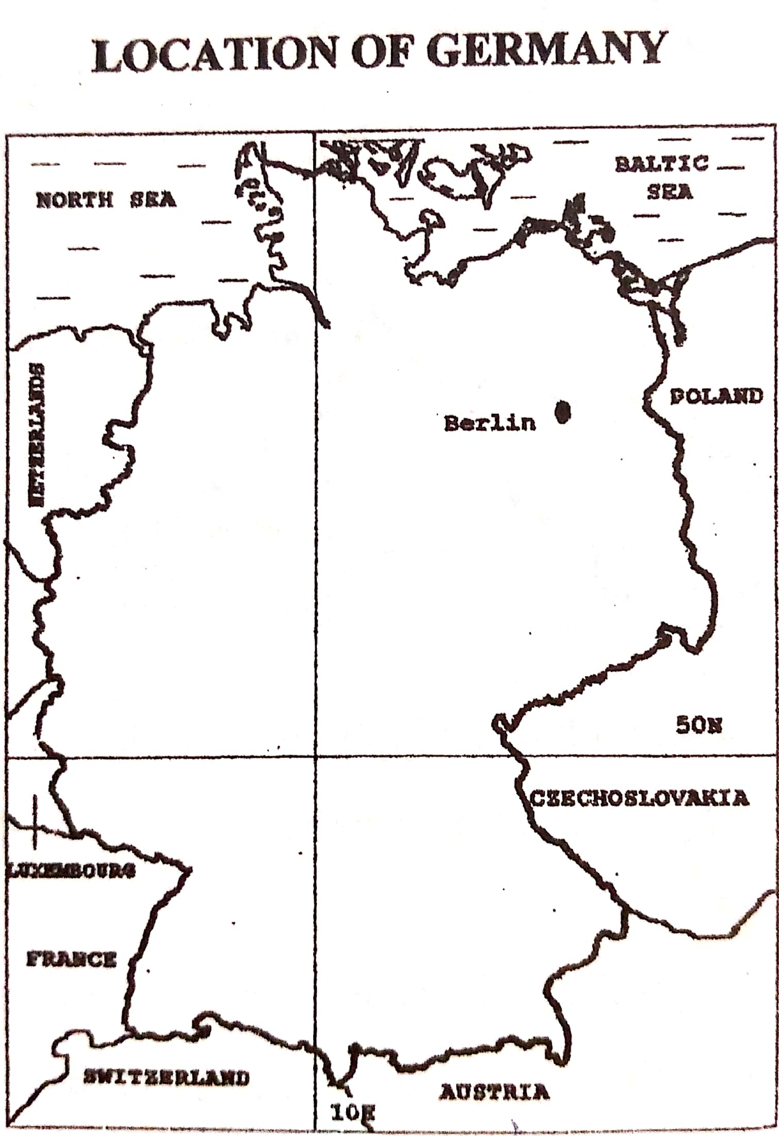

**The main physical divisions of Germany**

Germany is divided into three main physical regions, namely:

* The southern highlands/ Germany Alps
* The central uplands and Rhine gorge
* The northern lowlands / Rhine plain

**The southern highlands**

These occupy much of southern Germany. These highlands are a continuation of the Alps Mountains which originate from Switzerland. The region is made up rocks that have been shaped by glaciation.

**The central uplands**

This is land with an elevation between 200 and 900 m above sea level. It covers much of central Germany and includes the Rhine Rift Valley and the Rhine gorge. The region has greatly been affected by denudation and is characterized by scarps and valleys. Layers of limestone are common. The central upland is rugged, hilly and mountainous. Rhine valley cuts through the western part of the region.

**The northern lowlands**

The region rises from a few meters below sea level to about 200m above sea level. The areas below sea level were originally under the sea but were reclaimed by man. The landscape is generally flat. The area is made up of young rocks that were deposited under the sea before reclamation. Wetlands and marshy plains are seen near the border with Netherlands and along the coast. The north east has largely sandy and only good for pasture and hence used for dairy farming.

**The Rhine Rift Valley**

The Rhine Rift Valley is about 290km long and has a width of between 32 to 42 km. the flat valley is bounded by faults that form the Vosges on the west and Black forest Mountains on the eastern side. The valley bottom contains dry loam and alluvial soils making it productive for agriculture. The valley sides are gently sloping making it suitable for viticulture (growing of vines).

***A sketch map showing the Rhine Rift Valley***

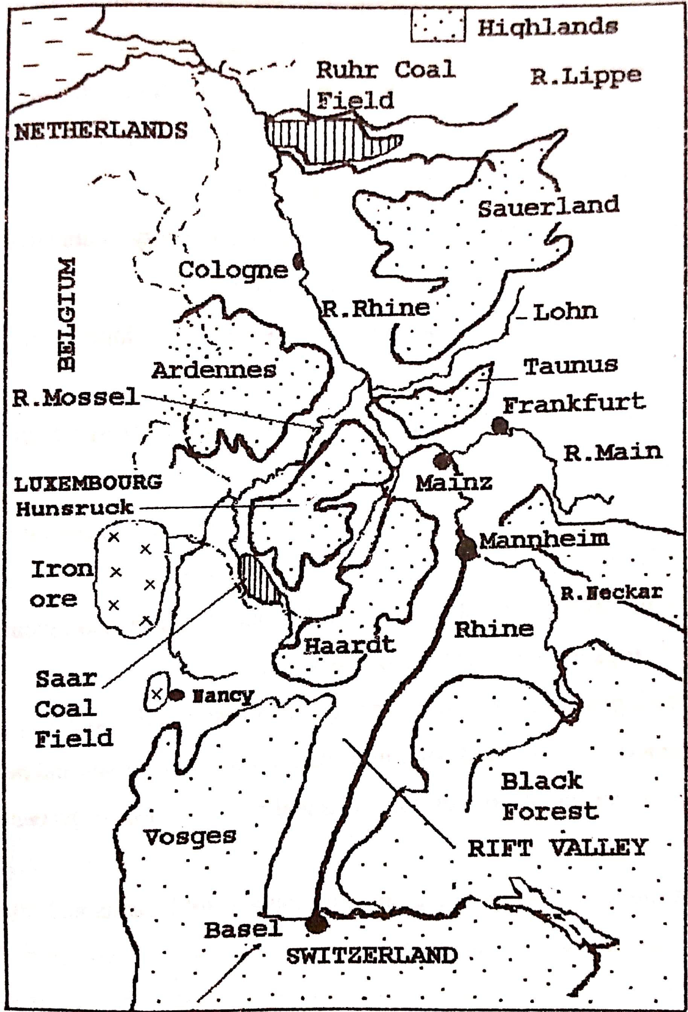

**Formation of the Rhine Rift Valley**

The Rhine Rift Valley was formed as a result of faulting. Tensional forces pull apart the land mass in two different directions; leading to the formation of multiple normal faults in the sedimentary rock strata (rock layers). As tensional forces continue, the fault lines widen, and the middle block sinks/subsides to form a rift valley. The side blocks were left standing thus forming Block Mountains (Vosges and Haardt on the west), Black forest and Odenwald on the east). The rift valley was further shaped by erosion and weathering.

***Illustration of the tensional force theory***

**The Rhine gorge**

A gorge is a deep, narrow, steep sided valley. From the Rhine Rift Valley, the Rhine River enters a gorge which is popularly kanwon as the upper middle Rhine. The Rhine gorge extends for 65km between Koblenz and Bingen in Germany. Due to uplifting, the walls of the gorge were raised to a height of 200 metres along the River. Continued vertical erosion by the Rhine River has further deepened the gorge.

The slopes of the gorge have been terraced where possible for agriculture, in particular viticulture on the south facing slopes.

**Economic activities taking place in the Rhine Rift Valley**

The important economic activities carried out in the Rhine Rift Valley include arable farming, livestock rearing, industrialization, transportation, forestry and lumbering, tourism, etc

**Problems faced by the people in the Rhine rift valley**

* Landslides / mass wasting especially during period of heavy rainfall which destroys life and property.
* Flooding of the Rhine River especially in spring to summer when the snow from the slopes melts and this destroys life, farmlands and property.
* Severe soil erosion on the steep slopes of the Rhine rift valley which limits land productivity.
* It is difficult to construct transport routes due to the steep rift valley sides and this limits accessibility.
* Winters are very cold, and this limits outdoor farming activities
* Forests along the rift valley slopes harbor dangerous wild animals which threaten people.
* Population explosion in some parts of the rift valley leading to overcrowding due to fertile soils.

**Solutions to the above problems**

1. Encouraging terracing and contour ploughing to control soil erosion and landslides.
2. Constant dredging to reduce the effects of flooding.
3. Construction of underground tunnels to increase accessibility/ to avoid the steep slopes.
4. Encouraging the use of glass houses where temperature and humidity are regulated.
5. The use of indoor livestock rearing where the animals are fed on preserved fodder in barns.
6. Spraying warm air during the extremely cold winter conditions.
7. Security barriers like electric fences to reduce attacks from wild animals.
8. Encouraging people to settle in other areas to reduce overcrowding in the Rhine rift valley.

**Agriculture in Germany**

Arable farming is an important landuse in Germany and it involves the growing of crops like vines, wheat, barley, sugar beet, maize, tobacco, hops, asparagus, rapeseed fodder crops etc are grown.

Market gardening involving vegetables like tomatoes, lettuce, asparagus, onions, etc; and fruits like apples, pears, straw berries etc

The Rhine Rift Valley is famous for arable farming in southern Germany.

**Factors favouring arable farming in the Rhine Rift Valley**

1. Presence of deep/ well drained fertile alluivial soils such as in th Rhine Rift Valley which favour the growing of crops.
2. The warm to hot summer temperatures which assists the ripening of grapes. The south and west facing slopes are warmer which is ideal for arable farming.
3. The region is located in a valley well sheltered from strong winds (from the strong cold east winds) by the mountain ranges which enables crop growing to be carried out/ no breaking of stems.
4. Generally flat nature of the valley/ gently sloping landscape which favours cultivation and mechanization.
5. Availability of large sums of capital invested in modern farming such as purchasing farm inputs.
6. Large supply of skilled labour used in modern farming techniques such as irrigation, harvesting.
7. Advanced/ High level of technology employed in farming such as modern irrigation where rainfall is insufficient.
8. High level of research which leads to high yielding crop varieties grown in the Rhine Rift Valley.
9. Presence of a large market for farm products especially in the large urban centres in the Rhine region.
10. The development of many processing industries which provide immediate market for crops under arable farming.
11. Developed/ efficient transport system such as the Rhine River, roads and railways which connect the agricultural regions to markets.
12. Formation of cooperatives which aids joint buying and selling, saving and loan schemes, shared use of expensive equipment and, hence earning high profits.
13. Favourable/ supportive government policy towards arable farming such as undertaking market research and subsidizing small scale farmers.

**Vine growing in the Rhine Rift Valley**

The growing of vines for commercial purposes (viticulture) is a very important activity in the Rhine Rift Valley of especially the western slopes having extensive vineyards. Vines produce fruits called grapes which are used in the making of wine.

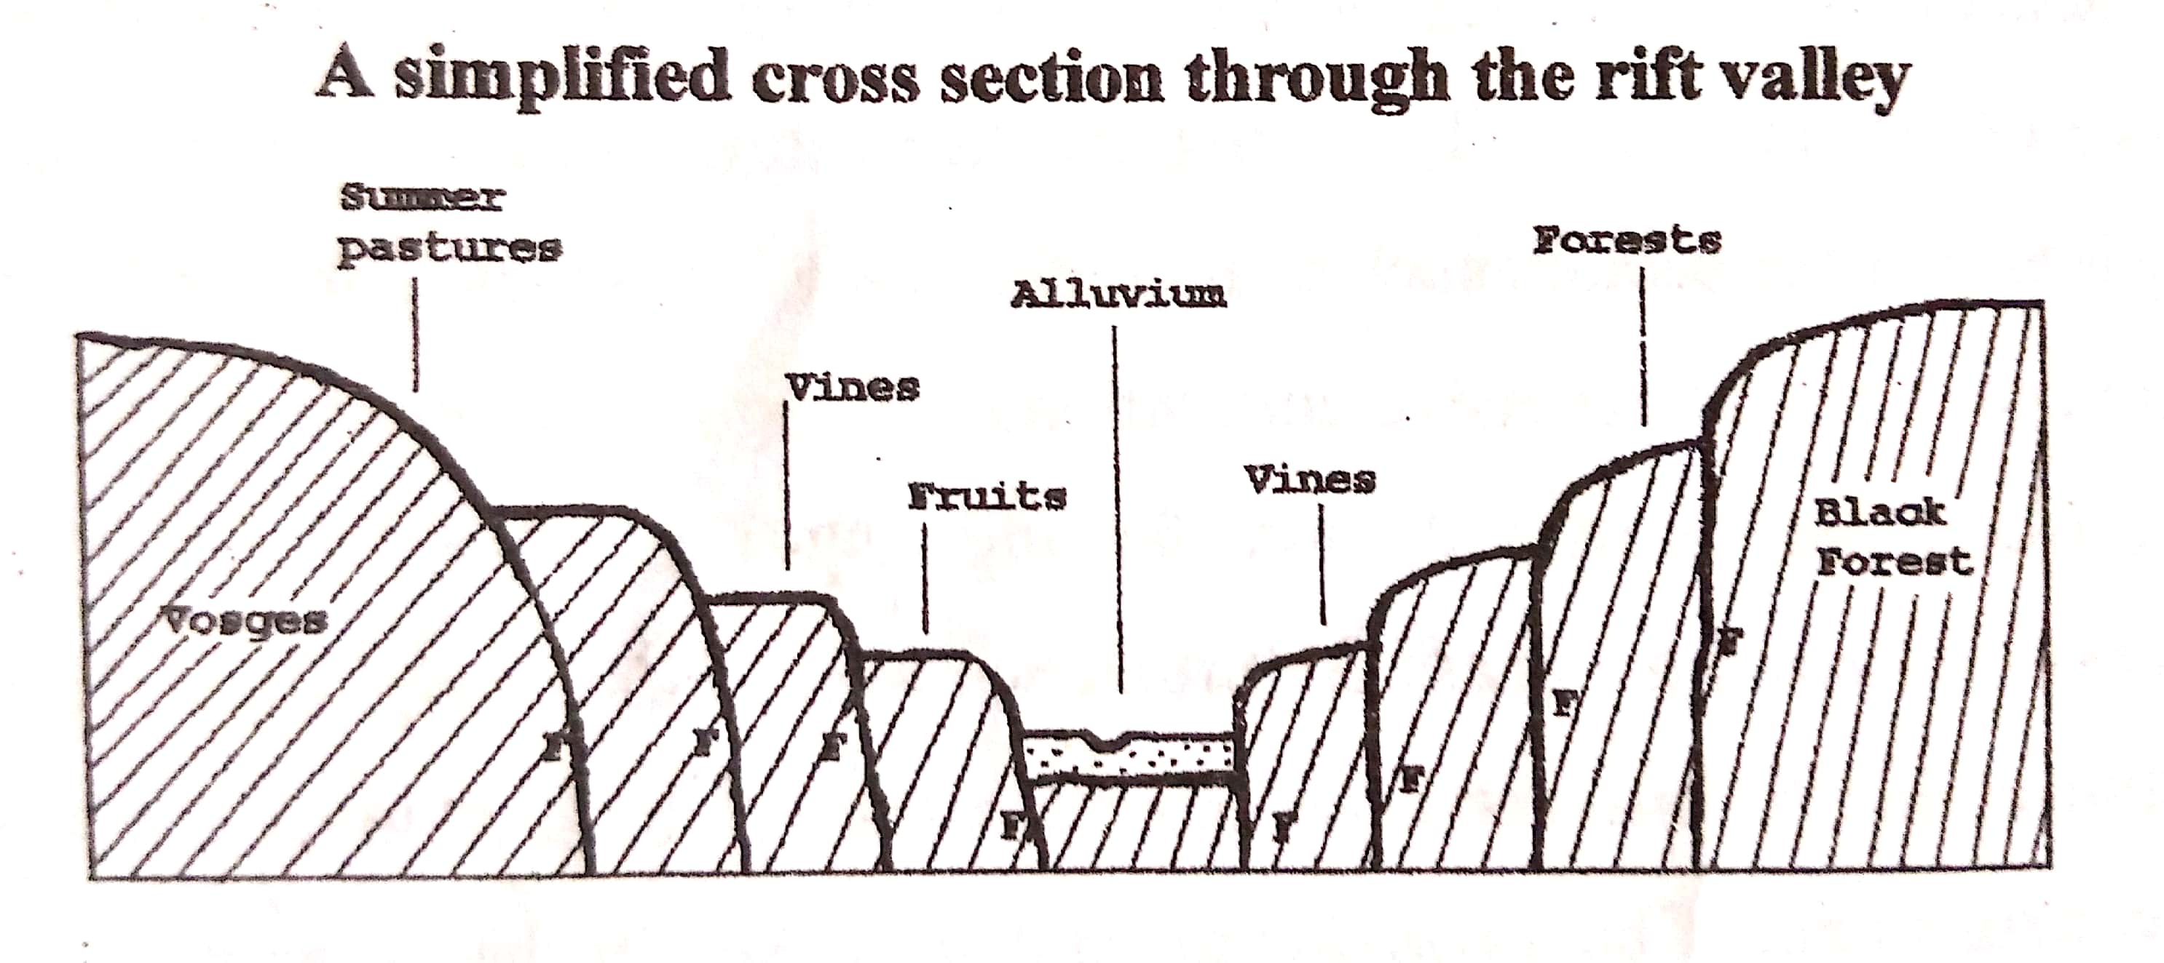

**The vine farmers’ calendar**

|  |  |  |
| --- | --- | --- |
| **SEASON** | **MONTHS** | **ACTIVITIES** |
| Winter | Dec-Feb | * Pruning * Application of fertilizers * Filtering last year’s wine * Booking keeping |
| Spring | Mar-May | * Planting of new vines * Spraying against weeds and pests * Weeding * Fertilizer application * Bottling last year’s wine * Staking of vines to stretch them on the wires to get maximum sunlight |
| Summer | Jun-Aug | * Harvesting * Collecting and sorting and packing * Transport to factories or processing centres * Processing * Marketing |
| Autumn | Sept-Nov | 1. Fermenting juice 2. Packing and bottling 3. Marketing of wine |

**Factors which have favoured vine growing in the Rhine Rift Valley**

**Physical**

1. Presence of fertile alluvial soils deposited by the Rhine River floods which support the growing of vines.
2. Presence of the steady supply of water for irrigation from the Rhine River during the dry period.
3. Moderate /Ample summer rainfall which enables the fruits to grow and mature.
4. The vines are grown on the south facing slopes which are warmer as they receive maximum sunshine that favours vine growing.
5. The gently sloping /generally flat nature of the valley especially on the western parts of the rift valley which facilitates mechanization.
6. Warm sunny summers which often can go above 250c which assists in the ripening of the fruits.
7. The valley is well sheltered from strong winds (from the strong cold east winds) by the mountain ranges which enables vine growing to be carried out/ no breaking of young stems.

**Non-physical factors/Human factors**

1. Presence of a large market especially in the large urban centres and also in the surrounding European countries.
2. Availability of skilled labour force in modern farming such as mechanization, harvesting, irrigation.
3. Modern technology employed in farming such as irrigation systems, use of machines in spraying etc hence high-quality output.
4. Availability of adequate capital to invest in vine growing such as buying machines, fertilizers, irrigation facilities etc
5. The formation of cooperatives which help in acquiring of loans, collective buying of farm inputs and collective selling of farm produce.
6. Intensive/ developed research in vine growing such as application of fertilizers, new varieties etc
7. The development of many processing factories in the region which provide a ready market for the grapes.

**Problems facing the vine growing industry**

1. Pests like moths, red spider, warms which damage the vine plants
2. Diseases for example Peronospera disease, Oidium which destroy the vines
3. The steep slopes also limit the area for cultivation/ the use of machines and also hinder the transportation of grapes in the area.
4. Frost especially during winter and part of spring during the flowering period; and this means reduced yields/ limits flowering.
5. Seasonal flooding of the Rhine River also leads to the destruction of farmlands and thus losses.
6. Soil erosion due to the steep slopes which reduces the fertility of soils leading to poor yields.
7. Soil exhaustion due to intensive cultivation and thus reduced yields.
8. Drought occurs sometimes during the growing period, which in turns limits the output.
9. Shortage of labour especially during the very busy periods of harvesting because skilled labour is attracted to better paying industry instead of working on vineyards. (*Machines cannot be used especially during harvesting because it requires human judgement)*
10. High costs of production are incurred such as expensive fertilizers and pesticides plus spraying facilities.
11. Limited land for farming since there are many activities taking place in the area and this limits farm exapansion.
12. Pollution of the land and water through the use fertilizers and wastes from the industries.
13. Competition for market with other vine producing nations such as south Africa which reduces the profit margin.
14. The growth of weeds which compete with crops for nutrients leading to low output.

**Solutions to the above problems**

1. Practicing irrigation to solve the problem of drought. Irrigation by the use of the Rhine River is being carried out to utilize drier area of the rift valley.
2. Use of organic manure and fertilizers to maintain soil fertility
3. Spraying with chemicals to control pests and diseases. i.e. use of pesticides to improve on the grape output. There is also biological control of pests where possible, by introducing the natural enemies.
4. Use of herbicides and physical removal of weeds to increase production.
5. Attraction of part-time labour especially women during the busy harvesting periods i.e. guest workers used to supplement the available labour force.
6. Building embankments / levees / concrete walls along River Rhine to control silting and flooding.
7. Spraying warm air to raise the temperatures during frost conditions
8. Terracing and contour ploughing to enable cultivation on the steep slopes.
9. Strengthening of regional integration in the EU (European union) for assurance of international markets for wine and this encourages vine growers to increase production.
10. Development of more on-site processing factories to reduce the perishability and hence save transport costs.
11. Emphasis on quality to compete favourably in the international markets.
12. Residues of grapes, skins and seeds are used as manures to reduce pollution from artificial fertilizers.
13. Mechanization where possible to solve labour shortage problems.
14. Attraction of part-time workers during the busy harvesting period. There is also increase in wages to workers to attract more labour to vineyards.
15. Land consolidation to increase the land for vine growing.

**Processing of vines**

* The grapes are picked from the vineyards and put into barrels or cans
* The grapes are loaded onto trucks and taken to processing plants
* The outer skin is removed
* The grape flesh crushed, and juice squeezed into barrels or metal tanks.
* The juice is left to ferment for about 3 months.
* Filtering of the juice follows and finally bottling of the wine.

**The products from vines include**

1. Juice for wines of various types such as champagne, whisky
2. Grapes for canning (eaten in raw form)
3. Residue of grape skins for manure/ fertilizer
4. Residues used in making animal and chicken feeds
5. Currants used for cooking oil, jelly and jams
6. wood fuel from overgrown vine trees

***Currants****-small dried grapes*

The industries associated with the vine growing in the Rhine valley are:

* Wine processing industry
* Manure/ fertilizer industry
* Food processing industry

**Marketing of vines**

Most of the wine produced in the Rhine valley is consumed locally. However, much wine is exported to other countries of Britain, USA, Austria, Switzerland, The Netherlands, Italy and Japan. The Rhine River helps in the exportation of vine production.

***Reasons why vines are not common in east Africa***

1. Hot tropical climate yet vines require cool climate.
2. Inexperienced farmers/ limited skilled labour which discourages vine production.
3. Small market for grape wine in East Africa, which discourages vine production.
4. Shortage of capital to invest in such as a venture and this discourages production.

***Qn. Compare the activities in the Rhine Rift Valley and the East African rift valley***

**The products which farmers in the Rhine Rift Valley obtain from their crops include:**

* White wine from grapes
* Fertilizers from the bi products of wine
* Resins, currants
* Canned fruits such as peaches, grapes, apples etc
* Sugar, jam, canned and fresh vegetables e.g. tomatoes
* Etc

**Livestock industry in Germany**

The livestock industry is also a major source of income to farmers in Germany and therefore utilizes the biggest part of agricultural land. It is carried out on small and medium farms. It involves the rearing of cattle, pigs, goats, sheep and poultry for a number of products like meat/ beef, milk, hides, eggs and feathers.

Beef and dairy cattle are reared especially in the upper slopes and uplands. The harsh climate and infertile soils here are unfavourable for arable farming and therefore used for livestock rearing. Dairy farming is dominant, and the commonly kept breeds are Angler, Hinterwald, Vogelsberg, and Friesians, which are known for high milk production.

The areas known for dairy farming in Germany are the alpine foreland in the south, the Black forest mountain areas and the Elbe River marshland areas. The animals are grazed on open pastures during summer and on preserved fodder in barns during winter. The common fodder crops grown are rye, oats, corn and hay.

**Characteristics of cattle (dairy) farming in Germany**

1. Animals are grazed on open pastures during summers and on preserved fodder during winter
2. Dairy farming is capital intensive such as milking machines and feed towers.
3. It is highly intensive
4. Modern/ scientific methods of cattle breeding and herd management are used.
5. Most dairy farms are near urban centres and thus the costs of marketing are minimized.

**Factors which have favoured the development of the livestock industry in Germany**

1. The cool temperate climate which favours the growth of pasture and fodder crops as well as exotic breeds of animals.
2. The infertile soils on the upper slopes and uplands unfavorable for arable farming and hence utilized for livestock rearing.
3. Availability of large sums of capital to invest in the livestock industry.
4. The presence of ready market by the industrial sector such as hides in making shoes/ bags, and milk for butter, cheese; and also, the foreign market.
5. High level of technology such as milking machines, automatic egg graders, refrigeration services
6. Efficient transport networks such as railway, water for easy transportation of products to the markets.
7. Efficient services of extension workers such as veterinary and agricultural officers who advice to farmers.
8. Formation of various cooperatives which assist in the marketing of livestock products.
9. Intensive / high level of research leading to the development of high yielding breeds of animals
10. The development of various processing industries which offer immediate market for the livestock products.

**Problems facing livestock farming**

1. Diseases such as anthrax, blue tongue mastitis, ketosis which reduce the productivity of the animals.
2. High costs of production due to expensive equipment such as milking machines and this limits the profit margin.
3. Competition from other countries such as Switzerland, Denmark, Netherlands producing livestock products which limits the available market.
4. Shortage of labour since many people are attracted to highly paid industrial sector and this limits production.
5. Limited pastureland due to the EU policies on the environment which require much of the original pasture land in mountainous regions to be replanted with trees.
6. Price fluctuations of milk and milk products on the world market which results into unstable incomes.
7. Extremely cold conditions sometimes in winter which limits farm activities/ limits animals to indoor feeding.
8. Seasonal flooding of Rivers like the Rhine River which limits the transportation of products to the market centres.

**Steps being taken to solve the problems**

1. Mechanization where possible to reduce labour shortage such as milking machines
2. Attraction of migrant labour especially during the busy periods
3. Emphasis on high quality to favourably compete in international markets.
4. strengthening regional integrations such as the European union to widen the market for the agricultural products
5. Carrying out market research to diversify the export markets for livestock products.
6. Strengthening of cooperatives for easy access to loans and marketing of output.
7. Spraying to control pests and diseases
8. Diversification of agriculture to avoid over dependence on animal rearing.
9. Further extension of veterinary services nearer to the farmers to control diseases and recommend better farm practices.

**Importance of agriculture to the economy of Germany**

**(assignment)**

**Coal mining in the Ruhr region**

In Germany the most important coal fields occur in the Ruhr West Phalia region and this accounts for ¾ of Germany’s output and 90% of its reserves.

The coal field is divided into two (2):

* The exposed coal fields
* The concealed coal fields

The exposed coalfields are found south in the Ruhr valley while the concealed coalfields in the north in areas of the Lippe valley and Emscher valley.

The exposed coalfields to the south have the coal bearing rocks on/ near the surface while the concealed coalfields have the coal bearing rocks buried underground.

The exposed coal fields are easily mined compared to the concealed coal fields, because for the latter a lot of work needs to be done to remove the top overlying rock to reach the coal bearing rock.

Open cast method for exposed coal while shaft or underground method for concealed coalfields.

***A sketch map showing the Ruhr coal field of Germany***

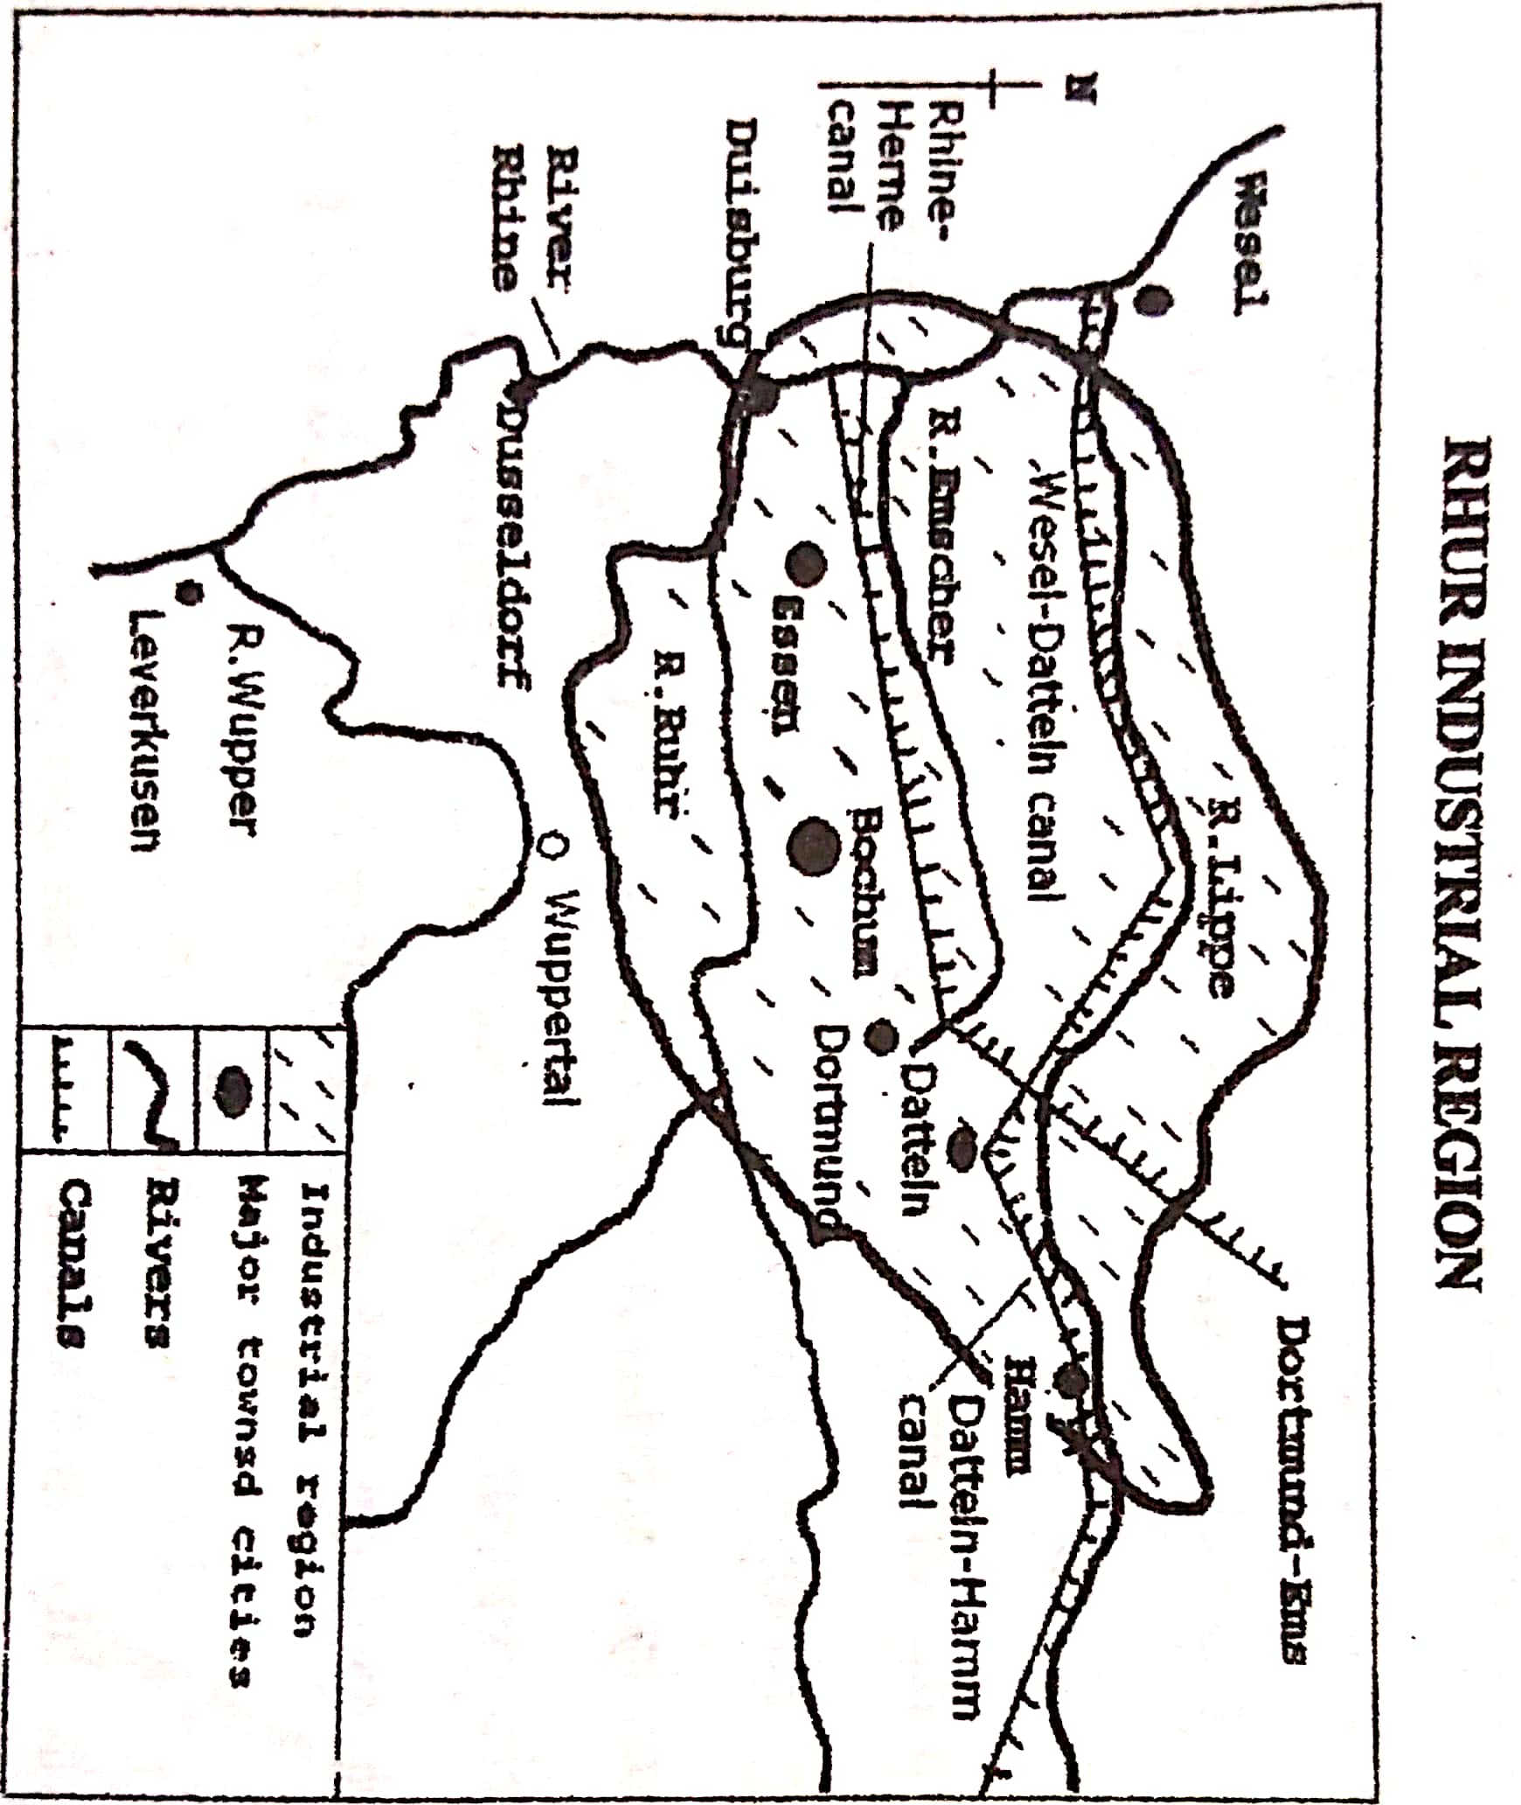

**A cross-section across the Ruhr coalfield**

**Why mining is difficult in concealed coalfield**

1. Highly risky and requires experts to mine otherwise miners may be buried while at work
2. High costs of mining since alot of facilities are needed such as shafts, underground tunnels, miners’ lamps, etc
3. It is time consuming as miners should maintain the size of the pit dug irrespective of the direction of the seams/ coal bearing rocks.
4. Concealed coal occurs in broken seams/ layers

**Note**: The exposed coalfields are getting exhausted and work now is deep in the concealed coal fields which are difficult and expensive.

***Other coalfields in Germany include*** Aachen coalfields *(which is not very important today)*; and the Saar coalfields near the Germany-French border with good coking coal and easy to mine. There are also lignite coal deposits at Cologne and in Bavaria which are mined to provide fuel for thermal electricity generation.

***There are other important minerals in Germany*** such as potash, salt, iron ore, phosphates, copper, lead and zinc.

**Factors which favoured the development of coal mining in Germany**

1. Availability of large mineral deposits/ reserves for example the large coal fields of the Ruhr region has attracted large-scale investment in the mining industry.
2. Presence of different types of coal for example Anthracite coal, Gas coal, coking coal which act as a raw material and energy for industrial development.
3. Some coal deposits are near the surface and thus easy to mine especially in the south of the Ruhr region.
4. Presence of other forms of energy such as petroleum, natural gas and hydro-electric power has also supported mineral exploitation and processing.
5. Well-developed and cheap transport system provided by the Rhine River and its tributaries such as Ruhr, Lippe and Emscher; the Rhine water way is linked with a system of canals to transport coal to industries and markets.
6. Large sums of capital to invest in coal mining which was first provided by the government but later private financiers for mineral exploration, extraction, setting up processing plants.
7. Development in technology in the mining sector such as open-cast mining for exposed coal, adit method for concealed coal. There is intensive research in mining technology such as the use of cranes, excavators etc to support mineral exploitation.
8. Presence of skilled labour employed in mining and mining –related industries such as geologists specializing in mineral exploration/survey, mining engineers, machine operators, managers, drivers—which has increased efficiency in the mining industry.
9. Presence of large market for minerals and mineral products in the Ruhr region, other Germany areas and also exported to Scandinavia, France, Belgium, Italy Switzerland and The Netherlands.
10. Political stability of the country since the Second World War, which also enabled the establishment and maintenance of mineral processing plants.
11. Positive /supportive government policy towards the mining sector such as investing in the mining, providing enabling policies and subsidies such that mining continues in the concealed mines.
12. High level of research in the mining sector which leads to the discovery of more mineral deposits, their quantity and quality. There is also research into the new uses of the minerals.

**Uses of coal**

1. Bituminous coal is used as a source of energy for both domestic and industrial use
2. Anthracite coal burns with great heat and used for heating boilers
3. Coking coal is used especially in the smelting of iron and steel, chemical industries and in tar production.

**Industries associated with coalfields in Germany**

1. Iron and steel industry using coal as fuel
2. Chemical industry using coal as a raw material and as fuel

**Problems facing the Ruhr coal field of Germany**

* Exhaustion of coal in some areas because coal has been mined for many years especially in the exposed fields.
* Increasing costs of mining with increasing depth of the mines especially in the concealed coal deposits. It requires experts and many facilities such as construction of shafts, lamps.
* The closing of mines has resulted into unemployment and retirement of skilled manpower.
* Coal is facing stiff competition from other sources of energy especially petroleum/ oil, which has seriously replaced coal as a major source of power.
* Competition from other coal producing countries such as Saudi Arabia, china, USSR, and Australia which reduces the available market.
* Breakdown of some machines which makes mining expensive and discourages production.
* Opposition from the environmentalists due to pollution from the coal fields, which discourages production.
* Price fluctuations on the world market leading to unstable incomes.
* The shared location of some mineral deposits such as coal with France, causing conflicts.
* The uneconomical deposits of some minerals in some areas, which discourages investment.
* Destruction of landscape and mining accidents leading to loss of life such as due to falling rocks, hence discouraging potential workers.
* Shortage of labour to work in mining activities, which discourages production.
* Remoteness of some areas where minerals occur, which discourages investors.

**Effects of mining on the environment in the Ruhr region of Germany**

* Over exploitation leading to the exhaustion of some mineral deposits.
* The decline of mining and closure of mines is associated with problems of unemployment and declining industry.
* Pollution of the environment in form of noise, dust from the mines and the discharge of toxic wastes, which reduces the quality of life.
* Destruction of vegetation where minerals are being extracted and hence destroying the habitat of wildlife.
* Destruction of the scenic beauty of the landscape/disfiguring of the landscape. It is also associated with soil erosion, and slides and general land degradation.
* Destruction of agricultural land due to large quantities of waste rock debris deposited allover covering the soil.
* Influx/movement of people from rural areas to the mining centres which has also reduced agricultural production.
* Displacement of people to give way for mining, with less or no compensation, hence difficult relocation.
* The growth of urban centres results into many problems such as traffic congestion, high crime rate, drug abuse.
* Emergence of ghost towns where minerals are exhausted and hence the towns abandoned.
* Regional imbalances in development in terms of infrastructure, since the areas without minerals are given less attention by government.
* Mining accidents occur leading to loss of life and property.

**Reasons why there has been a decline in coal production in the Ruhr region**

1. The increased use of natural gas and oil which have replaced the use of coal, hence decline in coal production.
2. The increased use of nuclear power which is more powerful form of energy compared to coal.
3. The rising cost of mining coal especially with the increase in the depth of coal deposits.
4. Exhaustion of some coal fields especially the exposed fields in the south leading the closure of some mines.
5. Improvement in technology which requires less coal to be burnt especially in the iron and steel industries
6. Some coal miners/ workers have abandoned coal mining and taken up better paying jobs in other sectors causing a decline in coal output (shortage of labour to work in the mines).

**Changes in the Ruhr coal field**

Due to the decline in coal mining, several industries were developed in the Ruhr region and these include:

1. Iron and steel industries—producing steel cables, iron bars, motor engines, railway locomotives, containers etc
2. Engineering industries –producing vehicles, engines, generators, turbines, agricultural machinery, electronics, blast furnaces, transformers, batteries, etc
3. Petro-Chemical industries –producing drugs, pharmaceuticals, detergents, dyes, bleaches, plastics, fertilizers, synthetic fibres, acids, cosmetics etc
4. Textile industries-producing cloths, threads, leather products, carpets, etc. These depend on cotton, silk, and linen.
5. Food processing-producing bakery products, wine, brewery products, milk products, canned fruits, etc

**INDUSTRIAL TOWNS IN THE RUHR REGION**

|  |  |
| --- | --- |
| **Town** | **Industries** |
| Duisburg | Iron and steel, engineering, petro-chemical, oil refineries, food processing |
| Dusseldorf | Heavy engineering, petro-chemical, textiles, food processing |
| Dortmund and Bochum | Iron and steel, engineering, brewing, vehicle assembly |
| Essen | Ship building, locomotives, textiles, glass ware, iron and steel, engineering, petro-chemical |
| Wuppertal | Textiles, petro-chemical, carpet making |
| Wolfsburg | Car making, engineering, iron and steel, food processing |
| Leverkusen | Textiles, food processing, chemical |
| Cologne | Car making, food processing, engineering, chemical |

***A sketch map showing the Ruhr West Phalia industrial region***

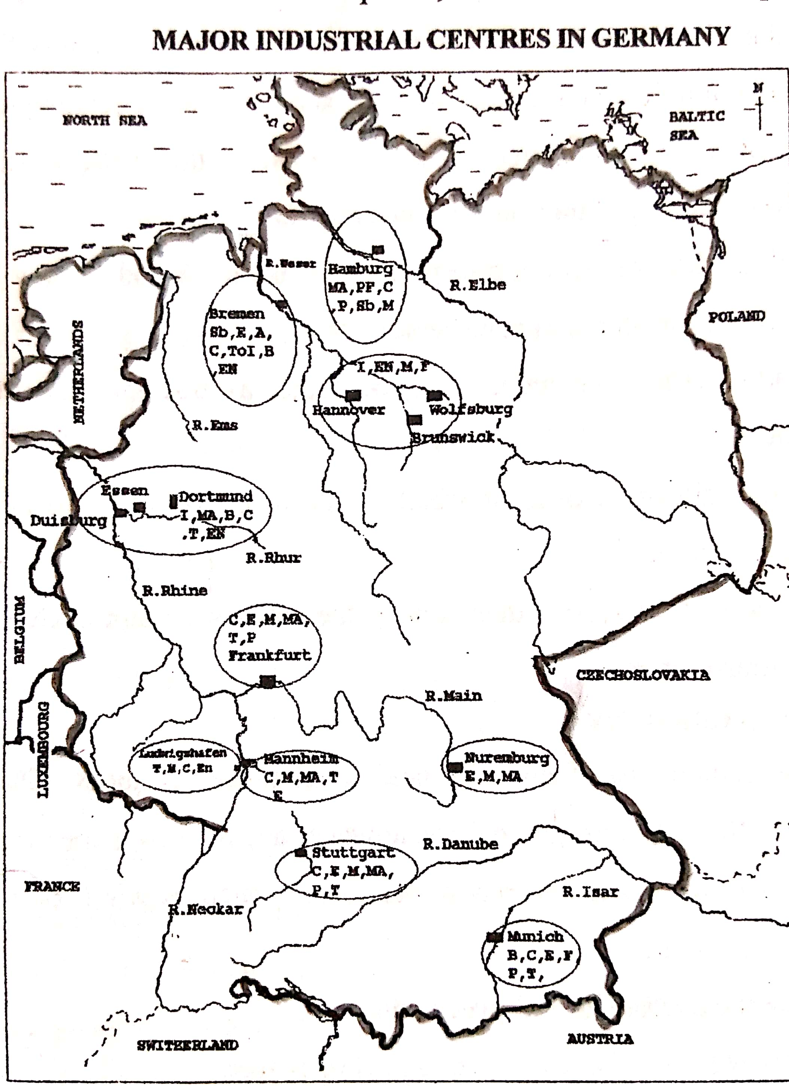

**Factors that favoured Industrial development in the Ruhr region of Germany**

* Availability of a wide variety /large quantities of raw materials used in industries to make goods such as mineral resources, water resources and agricultural materials.
* Availability of various sources of power to run industrial machinery in form of coal, oil, and natural gas.
* Availability of strong capital base/ adequate capital to invest in industrial development provided by the government and private investors.
* Growth of the banking sector which provides capital in form of loans for industrial development.
* Large supply of skilled and unskilled labour to work in industries, hence producing high quality and quantity.
* Well-developed transport system by road, railway, water and air to transport/move inputs and finished goods.
* Presence of a ready/large market for produced goods, both domestic and foreign.
* Availability of large / vast land for industrial establishment and expansion.
* Supportive/positive government policies to promote production for local and foreign market/ carrying out market research/encouraging investors etc.
* High level of technology employed such as automation which improves the quality of output
* High industrial research such as on engineering technology and industrial products; to improve the quality and quantity of output.
* Internal competition between and among industries in the Ruhr region; which leads to high quality production.
* Political stability of the area which has encouraged local and foreign investors in the industrial sector.

**Problems facing industrial development in the Ruhr region**

1. Shortage of some raw materials such as iron ore and coal leading to low output.
2. Competition from other industrial countries such as Netherlands, Japan, china producing similar goods, which limits the export market for output.
3. Competition from imported industrial goods which reduces the local market for the industries.
4. Competition among the industries such as the plastics are competing with steel products, which reduces the market potential.
5. Environmental pollution which reduces the quality of production.
6. Profit repatriation by foreign investors, which reduces re-investment in the industrial sector.
7. Inadequate /Shortage of labour to work in the industrial sector, which discourages production.
8. Shortage of land in the highly industrialized zones, which discourages industrial expansion.
9. High taxes imposed on industrial output and industries by the government, which reduces the level of profits.
10. Congestion at the ports especially along the Rhine waterway causing delays in the delivery of goods.
11. High costs of production such as due high importation costs of raw materials which reduces the profit margin/ leading high prices of final products.
12. Many industries were designed to use coal, but since coal production is reducing, some of them have been forced to close.

**Problems resulting from industrial development in the Ruhr region (Negative effects of the industrial sector)**

1. High rate of profit repatriation due to foreign ownership of many industries and this reduces reinvestment in the economy.
2. Over exploitation of natural resources such as minerals leading to quick depletion/ exhaustion.
3. Destruction of natural landscape such as through leveling land and reclaiming swamps to set up industries.
4. Results into environmental pollution through dumping wastes and emission of gases.
5. Growth of slums due to shortage of accommodation for the many industrial workers, hence the growth of slums and associated problems like poor hygiene.
6. Traffic congestion has resulted in the industrial towns, hence unnecessary delays in the movement of goods and people.
7. Results into high level of unemployment in towns due to high rural urban migration and the high level of mechanization.
8. Destruction of natural vegetation and swamp reclamation due to clearing industrial sites, hence loss of biodiversity/ destruction of habitat for wildlife.
9. Displacement of people to provide room for industrial establishment, hence expensive relocation.
10. Reduces/ limits land for other activities like farming due industrial expansion and urbanization.
11. Destruction of the ozone layer by the industrial gases, leading to global warming.

**Steps to improve the industrial sector in Germany**

1. Encouraging the use of alternative sources of energy such as natural gas, HEP other than coal which pollutes a lot.
2. Importing of raw materials such as iron ore from France and Sweden to minimize domestic shortages.
3. Using of raw material saving technology such as recycling of waste material to minimize raw material shortages.
4. Establishing of related industries which use other industrial bi products as inputs, to increase production,
5. Recycling of industrial products / waste material to minimize raw material shortages.
6. Protecting of local industries from foreign competition by imposing higher taxes on similar goods from abroad.
7. Widening markets through regional cooperation such as Germany is a member of European Union.
8. Treating of industrial wastes to reduce environmental pollution.
9. Anti-pollution laws / strict laws for example involving heavy fines to control pollution have been put by government.
10. Constructing of sub-ways, canals and flyovers to minimize traffic congestion.
11. Encouraging Containerization at the ports to reduce congestion and delays.
12. Adopting automation of industrial activities / more use of machines to minimize labour shortage.
13. Using of migrant labour to minimize labour shortage in the industrial sector.
14. Carrying out market research and advertising to expand market for output.

**Other major industrial regions/ centres in Germany**

Apart from the Ruhr region, other major industrial areas of Germany include:

1. **The middle Rhine industrial area**. This is at the confluence of the Rhine and the main Rivers. Industries include railway engineering, automobile, electronics, chemical, iron and steel, brewing etc. The major centres are Frankfurt, Mainz, Mannheim, and Ludwigshafen.
2. **West Berlin (capital)**. The industries are consumer goods (furniture, luxury articles etc), chemicals, engineering.
3. **Hamburg –Bremen industrial complex**. The industries are shipbuilding, marine engineering.
4. **Hannover –Wolfsburg –Brunswick industrial complex**
5. **Munich**. The industries are brewing, musical instruments, photographic equipment.
6. **Noremburg, Stuttgart, Aachen, Saar Brucken, and centres in East Germany** (like Leipzig, Jena, Dresden, and Strassfurt).

***Contribution of industries to the economy of Germany***

***(Refer to industrialization in the great lakes region of north America)***

**Similarities and differences between the Ruhr and East Africa industries**

**Similarities**

* In both industries are attracted to the sources of raw materials
* In both industries are located near the power sources since power is necessary for running machines
* In both some products are relatively similar
* In both some problems facing industries are similar
* In both industries use experts for the operation

**Differences**

* In East Africa, industries are mainly small-scale while in the Ruhr region industries are mainly large-scale.
* In East Africa industries are mainly labour-intensive (employ more labour than machines) while in the Ruhr industries are mainly capital intensive (much work is done by machines).
* In East Africa industries are largely agro-based (based on agriculture) while in the Ruhr industries are largely based on mineral raw materials.
* There are mainly light industries in East Africa while there are mainly heavy industries in the Ruhr.
* In East Africa, the main source of power for industries is hydroelectricity while in the Ruhr the main source of power for long has been coal (and today it is majorly oil).
* Low level of output is produced in East Africa due to low level of technology while mass production in the Ruhr due to modern technology.
* Low quality of output is largely produced in East Africa while high quality output is largely produced in the Ruhr region.

**Factors for the low level of industrial development in East Africa**

1. Inadequate capital to invest in industries, which discourages production.
2. Inadequate skilled labour to work in the industries, which discourages production.
3. Underdeveloped infrastructure such as poor roads linking raw materials to the industries.
4. Limited market due to the low level of income and the general poverty.
5. Political instabilities in some parts of East Africa which discourages long term investment in industries
6. Shortage of basic raw materials required by industries such as iron ore, coal which reduces production
7. Competition from better and cheaper imported goods from developed countries which reduces the local market.
8. Low level of technology which reduces the quality and quantity of industrial output.
9. Limited industrial research which reduces the quality of products.
10. Corruption and mismanagement of various industries, discouraging production.

**URBANIZATION IN GERMANY**

Germany is highly urbanized with about 80% of the population living in urban areas. The major urbanized region is the Ruhr industrial conurbation.

**THE RUHR CONURBATION/ URBANISATION IN THE RUHR REGION**

A conurbation refers to a large continuous built-up area formed by the joining of several towns/urban centres. OR It is a single urban complex formed by the merging of two or more neighboring urban centers, such that there is no clear distinction between them. Conurbations are formed due to outward expansion of towns.

**The Ruhr conurbation** is the largest industrial complex in Europe. It has developed in the last 100 years into Europe’s biggest iron and steel producer, coal producer, chemical centre and engineering centre. The region is enclosed by Rivers Lippe, Rhine and Wupper.

The major towns within the conurbation include Duisburg, Essen, Dortmund, Bochum, Dusseldorf, Bottrop, Hagen, Dinslaken, Solingen, Wuppertal, Oberhausen, Herne, Recklinghausen, Gelsenkirchen, Witten, Remscheid, Rheinhausen, Leverkusen, Krefeld, Elberfeld.

**Factors for the growth of the Ruhr region as a conurbation**

1. The industrial revolution which led to the setting up of many industries such as engineering, chemical, textile industries providing more jobs and in turn the growth of Ruhr cities.
2. Presence of a variety /valuable mineral resources such as coal, limestone, and iron ore acting as a source of energy and raw material in different industries making mining centers to grow into bigger towns.
3. Availability of large quantities of power in form of coal, natural gas and hydroelectricity which support many urban activities such trade, banking, education, and industry-hence the expansion of the towns.
4. Well-developed transport and communication networks by road, railway, water and air which facilitates the movement of inputs and finished goods and thus increased population concentration.
5. Availability of large water supply for industrial and domestic use provided by Rivers like R.Rhine, and R.Ruhr which supports many urban activities such as industry, recreation, entertainment.
6. Existence of a large and extensive hinterland which provides raw materials for the Ruhr industries such as the Rhine Rift Valley and this increases production and trade in the Ruhr towns.
7. Presence of adequate capital to invest in the region provided by government and private investors for reconstruction/ rehabilitation of industrial plants and other infrastructure.
8. The dense population of the region which has provided labour and provides market for the industrial and other sectors, hence expansion of the Ruhr towns.
9. Availability of large land for expansion of urban activities to the surrounding areas like industry, trade and commerce.
10. Well-developed social and economic facilities which include health facilities, banking, insurance, leading to increased population in the urban centres like Bottrop, and Duisburg.
11. Geographical inertia-where new investments are attracted to the already existing industrial centres to take advantage of the existing infrastructure such as power supply, transport network; and this encourages population concentration in the urban area.
12. Political stability for a long period of time since world war, hence encouraging urban development without disturbances of war.
13. The initiative / creativity of early investors who heavily invested in major industries of the Ruhr region such as Krupp at Essen and Mayer at Bochum.
14. High level of technology employed to develop the urban centres such as engineering to construct canals and storeyed buildings.
15. Positive government policy as promoting trade and attracting investments of large companies from other countries (such as from USA, Britain). The government has also developed waterways, and railways.
16. Strategic location in the centre of Europe, with access to the North Sea and along the Rhine River, which increases the volume of trade in the region.

**CONSEQUENCES/EFFECTS OF the Ruhr conurbation**

**Positive effects (importance of Urbanization)**

1. Creation of more employment opportunities in the urban areas such as in the industrial, business and service sectors leading to increased standards of living.
2. Leads to technological development due to increased investment in various urban activities and this also increases the quality of life.
3. It increases government revenue through imposing taxes on various urban activities such as trade and industry.
4. Stimulates competition in production and this leads to increased innovativeness, thus high-quality output.
5. Results into development of social services such as education, health services in order to support the increasing urban population.
6. Promotes international relationship due to increased number of foreign investors in the region and hence more foreign exchange.
7. Promotes tourism since urban centres and activities are major attractions and thus increased inflow of foreign exchange.
8. The increased population widens the market potential for goods and services produced and this encourages production such as in industry.
9. The increased population increases the labour potential such as skilled labour and this also promotes industrial production.
10. Results into cultural integration and unity due to transmission and diffusion of ideas/information, which in the end leads to balanced regional development.
11. Promotes acquiring of skills which can be used for rural transformation such as by establish small scale industries/projects in the rural areas.

**Negative effects of urbanization in the Ruhr (Problems resulting from the growth of the Ruhr conurbation)**

* Pollution of the environment such as air pollution and water pollution from car fumes, factories. There is also noise pollution from factories and traffic, which reduces the quality of life.
* Expansion of towns results in deforestation/ vegetation destruction such as for settlement, industrial sites and other business activities.
* There is increased swamp reclamation and therefore high rate of flooding in some areas of the expanding towns.
* Expansion of urban activities reduces the land for other activities and leads to the displacement of people who lose their settlement land.
* Over exploitation of natural resources in the surrounding areas such as forest resources, fisheries resources, mineral resources, due to increased demand in the urbanized areas; hence quick exhaustion.
* Urbanization results into unemployment which in turn leads to high crime rate such as gambling, robbery. Increased movement of people to towns does not match with the available job opportunities.
* Strains the social economic infrastructure such as roads, medical facilities, piped water-due to increasing demand by the increasing population. This led to poor service delivery.
* Leads to the growth of slums due to inadequate housing in the urban centres. Slums are characterized by robbery, drug abuse, and easy spread of diseases.
* Results into traffic congestion in the urban areas leading to unnecessary delays in the delivery of goods and services. There is increased number of vessels and commercial vehicles.
* Leads to break down of traditional/ social norms and values because the urban areas become collections of various cultures from many areas.
* Threat of terrorism in the urban areas because terrorists are mostly interested in areas of large population settlement and thus a potential destruction of life and property.

**Solutions to urban problems above**

1. Developing the transport system to reduce traffic congestion in the urbanities for example constructing subways, tunnels, flyovers.
2. Promoting the use of public transport means instead of personal vehicles to control traffic congestion. There is also restricting the movement of certain vehicles into the central business districts such as old vehicles to reduce pollution.
3. Strengthening patrols and police in the urban centers to control the high crime rate.
4. Recycling, treating and proper disposal of waste material to reduce pollution and contribute to a clean environment.
5. Reclamation of swampy grounds to create more room for urban expansion.
6. Setting up /creating more public facilities to such as medical centers, education centers, recreation centers, to match with the rising population.
7. Construction of skyscrapers to solve the problem of land shortage. These buildings usually have all the facilities needed by the people such as shopping, cinema etc
8. Setting up green belts in the urban centres / afforestation to reduce the rate of pollution.

**Forestry in Germany**

There are two main types of forests in Germany:

* Coniferous forests found in the highland region like Black forest, Haardt mountains, Vosges mountains
* Temperate deciduous forests found in the lowland areas. The tree species include beech and oak.

**Factors that have favoured the growth of forests in Germany**

* + - 1. The high altitude which leads to cool temperatures that favor coniferous trees.
      2. The mountainous / steep slopes which cannot easily be put to other uses such as crop growing making forests as the best alternative.
      3. The acidic nature of the soils which h favours the growth of forests especially coniferous trees
      4. The cool temperate climate with rainfall well distributed throughout the year
      5. The policy of afforestation and reforestation leading to extensive forest areas.
      6. Positive government policy of preservation and Conservation of forests due to the need to protect the environment

***S.2 statistics***

1. The table below shows land use in Germany by percentage

|  |  |
| --- | --- |
| **Land use** | **%** |
| Agriculture | 56 |
| Forests | 30 |
| Waste land | 06 |
| Buildings / roads/ railway | 08 |
| Total | 100 |

* Draw a pie chart to show land use in Germany
* (i)Name the types of wasteland in Germany

(ii)What two types of land use are represented by “building”?

* Describe the factors which have favoured the growth of forestry in Germany
* Explain the uses of forests in Germany

2. Study the table below showing the exports of Germany between 1997 and 2003 (000tonnes)

|  |  |
| --- | --- |
| **Year** | **Export volume** |
| 1997 | 16,000 |
| 1998 | 17,000 |
| 1999 | 19,000 |
| 2000 | 18,300 |
| 2001 | 19,000 |
| 2002 | 20,600 |
| 2003 | 21,000 |

1. Draw a line graph to represent the exports of Germany between 1997 and 2003
2. Calculate the percentage change in the volume of exports between 1997 and 2000
3. Describe the trend of exports in Germany between 1997and 2003
4. Name four (4) major exports of Germany

3. Study the table below showing the production of selected commodities in Germany in 2007:

|  |  |
| --- | --- |
| **Commodity** | **000 metric tones** |
| Stone& building materials | 3258 |
| Iron and steel | 3276 |
| Coal | 5118 |
| Chemical | 2511 |
| Food products | 2131 |

1. Draw a bar graph to show the above information
2. Comment on the production of selected commodities as seen in the table and graph above

4. Study the table below showing coal production in the Ruhr region of Germany from 1971 to 1989

|  |  |
| --- | --- |
| **Year** | **Tones** |
| 1971 | 5,000,000 |
| 1974 | 6,500,000 |
| 1977 | 7,600,000 |
| 1980 | 4,700,000 |
| 1983 | 3,300,000 |
| 1986 | 2,000,000 |
| 1989 | 1,500,000 |

1. Draw a line or bar graph to show the above information
2. Describe the trend of coal production as shown above
3. Explain why the production of coal in the Ruhr steady has been declining

5, Study the table below showing the milk yields in the Rhine lands in1995

|  |  |
| --- | --- |
| **Country** | **Milk yields** |
| Belgium | 5,600 |
| Germany | 23,000 |
| Luxembourg | 2,200 |
| The Netherlands | 10,800 |
| Switzerland | 5,900 |

1. Draw a bar graph to portray the information in the table

OR

1. Construct a pie chart/ divided circle to show the relative importance of milk yields in the Rhine lands in 1995.
2. Study the table below showing the number of tourist arrivals in selected countries in 1992

|  |  |
| --- | --- |
| **Country** | **Number of tourists** |
| Belg/ Lux | 1,250,000 |
| Germany | 7,300,000 |
| The Netherlands | 3,900,000 |
| Switzerland | 8,600,000 |
| **Total** | **21,050,000** |

1. Draw a divided circle or bar graph to show the relative importance of the selected countries by the number of tourists
2. Calculate the percentage contribution of each of the selected countries as shown in the table above

**THE RHINE WATERWAY**

The Rhine is the most important waterway in Europe. It navigable for about 800 km from Basel in Switzerland up to the North Sea. It is the principle route from Basel in Switzerland to Rotterdam in Netherlands. It is linked with a system of canals, which improves its transportation capacity; such as Rhine -Rhone canal, Main-Danube canal, the Mosel-Rhine canal, Dortmund Ems.

The Rhine passes through the most industrialized part of the Europe-the Ruhr region and enters the North Sea. It serves 6 Western Europe countries –Switzerland, Germany, France, Netherlands, and Belgium. Its tributaries include Mainz, Lippe, Mosel, and Ruhr.

The upstream traffic/ cargo (imports) includes iron ore, petroleum, cotton, foodstuffs tropical hard wood timber etc While downstream traffic (exports and finished goods) includes watches, chemicals, textiles, machinery, food stuffs

***A sketch map showing the Rhine waterway***

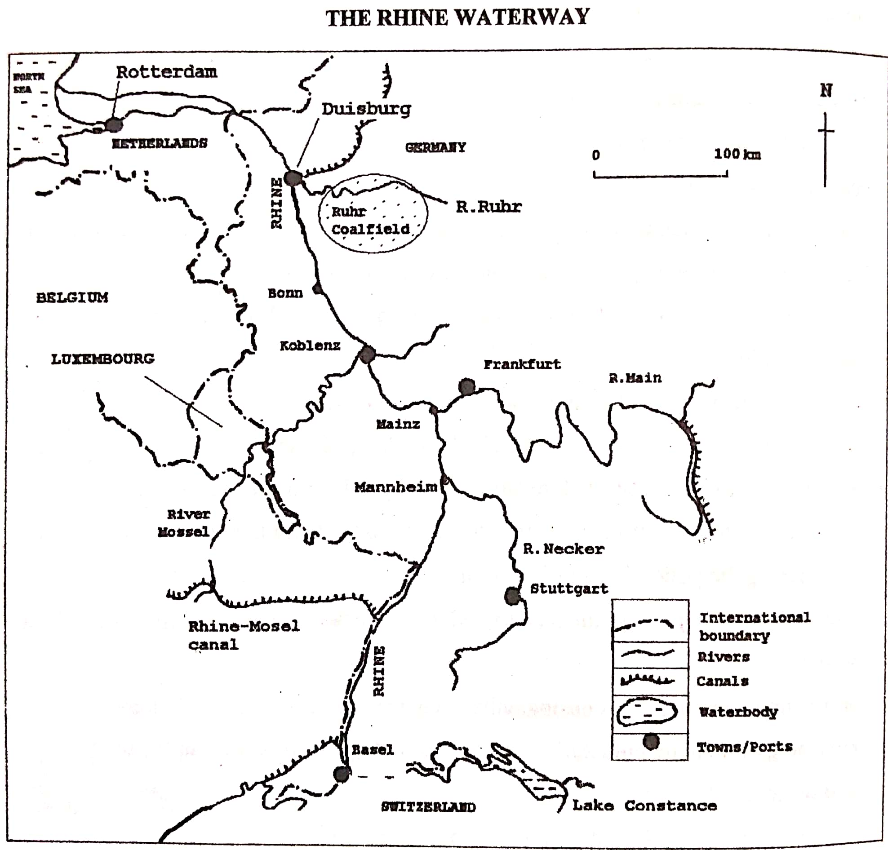

**Factors which have favoured the development of the Rhine waterway**

1. Presence of the Rhine River flowing through the Rhine land countries, hence handling large volumes of cargo.
2. Presence of many tributaries such as Mosel, Ruhr, Lippe, and Emscher which increases the volume of water in the Rhine, hence handling more vessels.
3. The Rhine waterway is linked with a system of canals which improves its transportation capacity. These canals include Dortmund Ems, Lippeseite canal, Main-Danube canal, Mosel-Rhine canal, Rhine -Rhone canal.
4. Strategic location of the Rhine in the centre of Europe which has made the Rhine usable by many vessels from the Rhine land countries.
5. The Rhine flows into the North Sea which is one of the busiest shipping routes in the world, connecting to other international ports, hence more goods handled.
6. Presence of a large productive hinterland such having minerals and rapid urbanization hence handling large volumes of exports and imports.
7. High level of industrial development especially in the Ruhr industrial complex of Germany, which has enabled the Rhine waterway to transport large volume of cargo.
8. The rapid development of Rotterdam port where the Rhine water way enters the North Sea, which has also increased the importance of the Rhine waterway by handling more cargo.
9. The desire to link the Rhine countries which has encouraged the governments to develop the Rhine water way such as by modernizing ports and constructing canals. (Interstate cooperation among the Rhine land countries in developing the waterway).
10. Ice free conditions of the waterway in the lower part of the Rhine, which enables the use of the Rhine water way throughout the year.
11. The Rhine is navigable for a large part from Rotterdam up to Basel which enables it to handle more vessels (For this part it is not interrupted by waterfalls/rapids in its channel)
12. Presence of adequate capital provided by the Rhine land governments, which helped to streamline the River for navigation, and establishing ports.
13. High level of technology used for dredging, straightening and the vessel construction technology.
14. Presence of highly skilled labour force such as engineers, geologists who developed the waterway such as dredging, port construction, canal construction.
15. Relative political stability in the area where the Rhine waterway flows which encourages the use of the waterway throughout the year/ increases the volume of cargo handled.
16. It is the best alternative route for the landlocked countries like Switzerland and Luxembourg found in the heart of Europe.

**Importance of the Rhine waterway**

1. Promotes importing large quantities of commodities for Rhine land countries such as iron ore, coal, crude oil, tropical hard wood timber.
2. Transports large amounts of exports for the Rhine lands such as chemicals, vehicles, machinery, diesel engines, textiles.
3. Promotion of industrial development such as in the Ruhr industrial region of Germany due to the cheap water transport for raw materials and finished goods.
4. Promotion of port and urban development such as Rotterdam port, Basel, Mainz, Frankfurt, Bonn, Essen, Dusseldorf, Leverkusen, and Koblenz.
5. Promotion of mineral exploitation for example coal mining from the Ruhr region, limestone from the Jura region due to cheap water transport.
6. Promotion of tourism development in the Rhine lands since it is a tourist attraction and also provides cheap transport for tourists, hence generating foreign exchange.
7. Provision of employment opportunities to the people such as engineers, hydrologists who monitor the water levels, hence improving the standards of living.
8. Generating of government revenue by taxing the shipping companies and workers’ incomes/ the revenue is used to develop various sectors such health, education.
9. Facilitation of international relationship/ cooperation among the Rhine land countries, which promotes trade relations and economic integration.
10. Diversification of the economy in the Rhine land countries by developing many sources of income / various activities such as mining, agriculture, service sectors.
11. Promotes the development of the agricultural sector due to large demand for food by the population along the waterway.
12. Promoted the development of infrastructure like canals and railway lines linking various areas to the waterway.
13. The waterway minimizes the problem of landlockedness for countries like Switzerland which easily the sea.

**Problems faced by the Rhine Waterway**

* ***Congestion of vessels along the waterway especially at port Rotterdam due to increasing number of vessels,*** causing delays.
* ***The waterway limits the size of vessels used on the route/ some sections are narrow***. The bigger ships cannot sail easily along some sections of the waterway especially the canal sections.
* ***Constant silting of some sections of the Rhine River*** and this calls for continuous dredging which is expensive yet the period of dredging limits the use of the waterway.
* ***The upper course of the waterway has rugged relief*** (from Basel towards the Alps) which makes it unnavigable.
* ***Freezing of the Rhine River during winter season*** especially in the upper course, which limits its use as a waterway.
* ***Pollution problems are associated with the waterway*** such air and water pollution due to oil spills from the moving water vessels, growth of industries along the waterway.
* Smog during winter which limits visibility and thus accidents.
* Flooding of the Rhine River especially in the Rhine delta during heavy rains and due to melting of snow during spring season

**Solutions to the above problems**

1. Containerization to ease loading and unloading hence reducing congestion at the ports
2. Construction of other transport routes like pipelines and railways to reduce congestion on the waterway.
3. Timetabling the arrival and departure of vessels to reduce congestion.
4. Use of strong lights especially in winter to avoid collusion of vessels on the waterway.
5. Regular dredging to deepen and widen the River and canals and control flooding.
6. Use of the radar system that detects the direction, size and speed of approaching vessels at long distance to avoid accidents when there is smog.
7. Building embankments / concrete walls to control flooding.
8. Cooperation among the Rhine land countries to clean up the River and control pollution.
9. Strict laws against industrial wastes to control pollution.

**LUXEMBOURG**

Luxembourg is one of the smallest countries in Europe and the smallest in the Rhine lands. The country has a total land area of 2,586 square kilometers. It is a landlocked country bordered by Belgium, France and Germany.

***A sketch map showing the position, relief and drainage of Luxembourg***

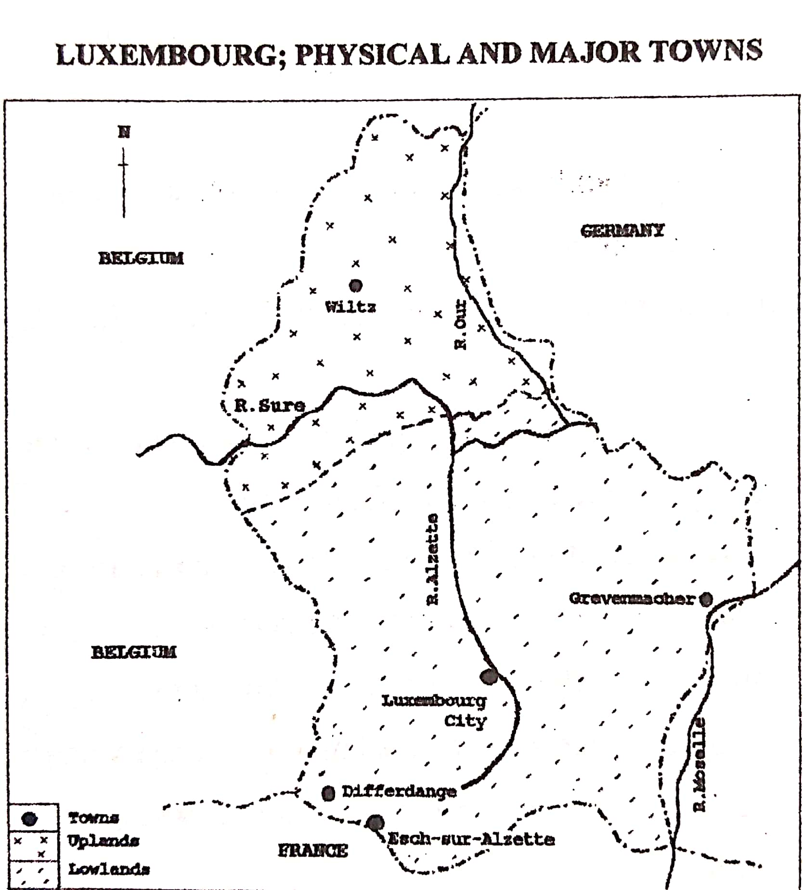

**Relief and drainage**

The country is divided into two main relief regions, that is, the Oesling and Gutland /Bon pays.

**Oesling**

This covers the Northern part of the country and comprises part of the Ardennes Mountains, which is a continuation of the Ardennes Mountains of south Eastern Belgium. This region forms one third of the land area. It is generally a plateau with an average elevation of 450 metres above sea level. The kneiff is the highest point with a height of 560metres above sea level. This highland region is dissected by the deep River valleys of Sure and Clerf. The Oesling is characterized by forested hills and valleys. The soils are generally thin mountain soils and only improved by use of slag fertilizer.

**Gutland / Bon pays**

It is sometimes referred to as ‘Good land’. The region has a more varied topography, with an average elevation of 240 metres above sea level. It forms about two-thirds of the land area. In the centre is the valley of the Alzette River which dissects the region. The Eastern part of the Bon Pays has a sandstone scenery with generally a uniform topography.

**Climate**

The country experiences a modified continental climate characterized by mild winters and cool summers in most of the country. However, the North is much cooler and experiences cold, sometimes severe winter because of altitude. The mean annual temperature is about 100c. Winter temperatures range from -1 to 20c in January and summer temperatures range between 130c and 230c in July. The annual rainfall is about 760mm, with the southwest receiving more rainfall.

**Population**

Luxembourg has a population of over 500,000 and an average population density of about 193 people per square kilometer. This makes Luxembourg one of the most densely populated countries in the world. Most of the population lives in the urban centres in Gutland/Bon pays region especially southern Luxembourg.

Therefore, the southern part of the country is the most densely populated while the Northern part is the most sparsely populated.

***A sketch map showing population distribution in Luxembourg***

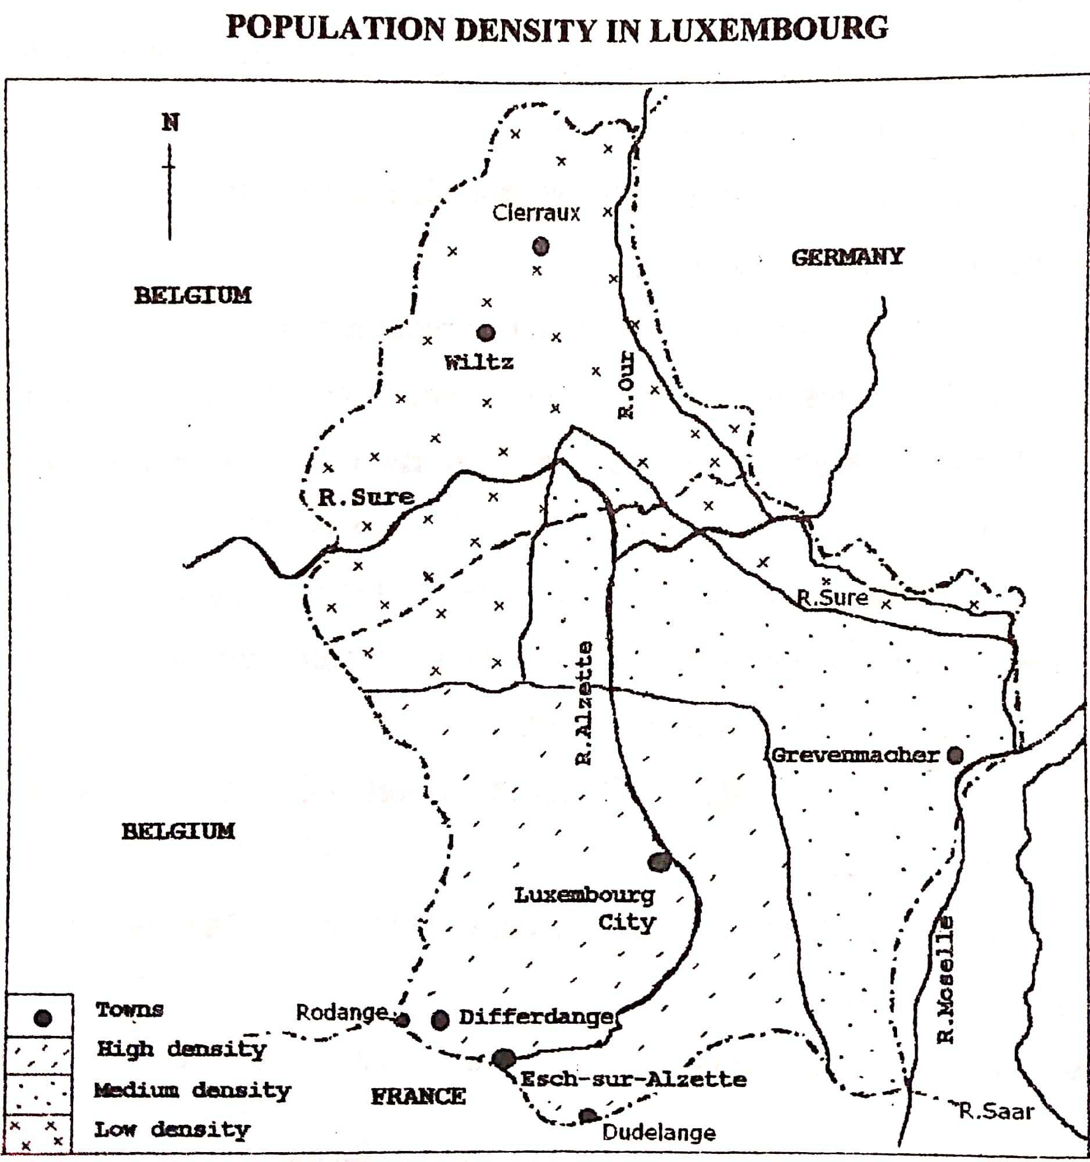

**Factors/conditions influencing population distribution in Luxembourg**

**Physical factors**

1. Climate
2. The south of the country is warmer and with mild winters, hence attracting dense population.
3. The North is cool and winters and sometimes severe winters leading to sparse population.
4. Soils

* Areas with fertile / well drained fertile loess soils promote crop growing hence attracting dense population *(central and southern parts).*
* Areas with thin /infertile soils limit crop growing hence leading to low population density *(particularly the North).*

1. Altitude
2. Areas of low altitude have warm conditions which attract dense population.
3. Areas of high altitude have cool temperatures which attract low population density.
4. Relief

* Areas with rugged relief/ mountainous landscape are inaccessible/ limit construction and mechanization leading to low population density.
* Areas of fairly/ relatively flat relief/ gentle slopes encourage construction and mechanization hence leading to dense population.

1. Vegetation

* Areas with thick vegetation cover hinder transport routes/ are not easy to clear, and thus have low population density.
* Areas of grasslands are easy to clear for various activities such as farming and thus have dense population.

1. Drainage

* Waterlogged areas/ Poorly drained areas/ areas with periodic flooding have low or moderate population density due to problems in cultivation and construction.
* Well-drained areas encourage construction and growing of various crops leading to dense population.

**Human factors/ Non-physical factors**

1. Economic activities such as industry
2. Areas with more economic activities such as mining, industry provide more job /employment opportunities and hence attract dense population.
3. Areas with limited economic activities such as mining and industry have less chances of employment, hence have low population density.
4. Transport and communication routes
5. Areas with developed transport system/ along main roads and coastal areas are easily accessible/ promote economic activities, hence attracting dense population.
6. Areas which are remote / far from main roads are less accessible / limit economic activities leading to sparse population.
7. Duration of population

* Areas of with long history of population attract more opportunities up to today such as trade, jobs; and thus, dense population. This is true with Luxembourg City.
* Areas of relatively recent population have fewer opportunities for development leading to sparse population.

1. Government policy

* Government policy of forest conservation/ nature conservation areas discourages population in such areas leading to sparse population such as some parts of western and Northeastern Luxembourg.
* Government policy of infrastructural development attract population leading to moderate to dense population such as in the urban areas of the south.

**Advantages of high population density**

* Results into increase in market potential/demand for goods and services, which encourages production.
* Increases/ widens the labour force in the area. More people participate in productive activities which promotes the production process. Labour also becomes cheap for investors.
* Increases pressure on government to undertake development programs. The government is encouraged to provide social and economic infrastructure like roads, schools, and hospitals to cater for the high population.
* Promotes investment/setting up of more production units to cater for the requirements of the population. This in turn increases national income.
* Promotes hard work, innovation and invention among the population. The individuals work harder in order to survive in the competitive environment such as through intensive farming methods
* Encourages exploitation of idle resources such as minerals, water resources, in order to sustain the increasing population.
* Reduces the social overhead costs per person in the country. It becomes more economically cheaper to provide social services since they are utilized by many
* Increases the tax potential, thus increasing government revenue for social services like providing health and education services. *(There are more people and activities to tax).*
* Encourages urbanization / growth of towns. Population concentrates in some areas leading to the setting up of transport networks, medical facilities, banking facilities; hence growth of towns.

**Challenges/Problems associated with high population density**

1. Strains the government budget / leads to increase in government expenditure on social services such as education, medical care in the densely populated areas.
2. Increases the level of unemployment; because the rate at which the population increases is higher than the rate of job creation and this leads to increased poverty.
3. Results into over exploitation of natural resources like minerals, water resources. This leads to quick exhaustion and denies the future generations a chance to use them.
4. It leads to increase in cost of living due to high competition for the scarce resources / goods and services.
5. It increases pressure on land/ shortage of land for population and cultivation. This leads to land conflicts and land fragmentation. This has made the country less self-sufficient in food production.
6. Leads to reduced productivity of land. The over-use of land for cultivation leads to a decline in its productive value and thus lower yields.
7. Leads to the growth of slums and associated problems like high crime rate, poor housing/ accommodation, poor health facilities, alcoholism, drug abuse.
8. Leads to overcrowding which results into easy spread of diseases. There is crowding of social public places such as schools, health centres.
9. Results into environmental degradation such as through pollution, deforestation and swamp reclamation.

**Possible solutions to the above problems**

1. Gazetting some parts of the country as nature conservation parks to protect the environment
2. Promoting hygiene standards to guard against the spread of diseases.
3. Development of more natural resources such as soils, power, forests to support the bigger numbers of people.
4. Agricultural modernization/ Ensure higher foods supplies /yields from the existing farmland such as through agricultural research, farm technology, swamp reclamation etc.
5. Encourage out-migration to relieve population pressure.
6. Discourage rural-urban migration through putting up more social services in the rural areas such as modern schools, high grade hospitals.
7. Exportation of labour force such as expatriates to other countries (export skilled labour which is unemployed).
8. Population control policies / legislations should be undertaken to limit large families such as one child per family policy, marriage age legislation.
9. Setting up repopulation schemes for the people from the densely populated areas.
10. Encourage vertical expansion of cities/ towns using storeyed buildings/ skyscrapers.

**Urbanization in Luxembourg**

The major urban centres in Luxembourg are Luxembourg city (capital), Diekirch city, Dudelange, Differdange, Mertert, Echternach, Esch-sur-Alzette, Ettlebruck among others.

**Luxembourg City**

Luxembourg City is the capital city of Luxembourg. It is located at the confluence of the Alzette and Petrusse Rivers in the south of the country. The city is built on a land area of 51.46 km2. It has a population of about 100,000 people.

The city is one of the wealthiest cities in the world; having developed into a baking and administrative centre of Europe. Luxembourg City is the seat of many institutions of the European Union such as the European parliament’s secretariat, the European court of justice, the European court of auditors and the European investment bank.

**Factors for the growth and development of Luxembourg City**

1. Generally flat topography encouraging the construction of urban facilities such as buildings and transport systems.
2. Presence of a rich and productive hinterland which increases the activities in the city such as trade and commerce.
3. The development of many industries in the area such as electronics, computer, textiles which has increased the volume of cargo handled by the port.
4. High level of technology which has enabled the development of the city such as engineering technology in construction, and containerization at the port.
5. Availability of large sums of capital to invest in the modernization of the city such as putting up commercial buildings.
6. Political stability of the region, which has enabled the city to expand without any disturbance of war.
7. Improvement in transport systems linking the city to the large hinterland for example roads and railways linking to the interior, which has also increased economic activity in the city.
8. Supportive government policy for example the need to develop the city into the regional capital of Luxembourg.
9. Large/ abundant supply of skilled labour in the area to carry out modern construction and development of urban facilities.
10. Earlier settlement also helped in its growth because they were hard working.
11. Abundant water supply necessary for various human activities in the city such as trade, industry.

**Problems facing Luxembourg City**

1. There is traffic congestion causing delays in the delivery of goods and services.
2. Maintenance of the city is extremely expensive such as water supply, sewage disposal, law and order. This is due to overcrowding.
3. Pollution of the environment especially due to toxic gases and wastes from industries such as petro-chemical industries.
4. Unemployment problems due to high rural urban migration/ high population in the city. This leads to social evils like theft and robbery.
5. Shortage of land for expansion of the port due to many activities carried out in the city.
6. Population explosion/ increase has led to inadequate housing resulting into slum growth.
7. Overcrowding of people leading to easy spread of diseases and high crime rate.
8. High cost of living due to high population total such as high rental charges.

**Solutions to the above problems**

1. Vertical expansion on the city by building skyscrapers to minimize problems of limited land for expansion.
2. Recycling and treatment of industrial wastes to reduce pollution.
3. Strengthening the police force to fight crime.
4. Construction of underground tunnels to reduce congestion and expansion of railway lines in lowlands.
5. Planned housing to control the development of slums. In addition, government encouraging private and public companies to construct decent houses for rent to limiting the emergence of slums.
6. Development of more industries due to the wide market to reduce unemployment.
7. Anti-pollution laws put in place such as non-importation of used vehicles and condemnation of old vehicles. Also, bicycles are being promoted as a means of transport in the city, hence limiting car use.
8. Discouraging illegal immigrants with strict laws to control the population explosion.

**Agriculture in Luxembourg**

Agriculture contributes only a small percentage of the GDP of Luxembourg, but it is still an important sector of the economy. They practice mixed farming i.e. both arable and dairy farming although dairy farming is dominant.

Under arable farming, there is viticulture, forestry and animal feed crops. The main crops are barley, oats, potatoes, wheat, beetroot, rye fruits and grapes (for wine production). The main farming areas are located in the bon pays and around the floodplains of the Moselle River, in the southeast of the country. Although the climate is conducive for crop growth, the poor/marginal soils limits agricultural land. About 42% of the land is arable, with 1% used for permanent crops. About 60% of the nation’s farms are smaller than 50 hectares.

**Viticulture**

The growing of vines is one of the major activities in agriculture. Large vineyards are located in the Moselle River valley especially on the south facing slopes, while the North facing slopes are left to forests. The vineyards produce 15million litres of wine annually.

**Factors favouring vine growing in Luxembourg**

* The presence fertile soils in the Moselle River valley suitable for growing a variety of vine types. Also, the chalk or slate-based soils of the south facing slopes are good for the varieties of vines required for table wines.
* The suitable micro-climate provides enough sunshine necessary for the ripening of the grapes and good for summer grape harvesting.
* The gradient of the River valley slopes ensures the presence of well-drained soils that are suitable for vines.
* The long vine growing culture, which has given the vine growers a wide experience in vine growing.
* The Moselle valley is sheltered from winter Easterly winds that bring coldness, making the area free from frost. The valley is also sheltered from the strong winds that could blow away the pollen and reducing the yield.
* The formation of several cooperatives which undertake vine growing, processing and marketing.

**Problems facing vine growing in the Moselle valley**

1. The steep slopes limits mechanization and this leads to the challenge of labour shortage and hence limiting the quality of produce.
2. Sometimes the winters are too cold and there is frost. This damage the crops leading to losses.
3. Pests and diseases which leads to low quality and quantity of output.
4. Shortage of land for expansion of the vineyards. This is because the southern part has a high population density.
5. Etc.

**Livestock farming**

Livestock production accounts for about 80% of the agricultural profits in Luxembourg especially dairy farming. However, the number of livestock farms has been reducing over the past decades. Livestock farms are majorly concentrated in the North although dairy farming is spread throughout the country.

Cattle rearing has increased in importance in the recent times while sheep and pig rearing have been declining. There is an increase in dairy products and the production of corn as livestock feed. Still every dairy farm has an arable unit where fodder, mainly corn is grown.

The livestock products include dairy products and meat. Luxembourg is self-sufficient in meat production and exports about 40%.

**INDUSTRIALISATION IN LUXEMBOURG**

Luxembourg is a major industrialized country in the world and the main industries are iron and steel, food processing, rubber and plastic production, engineering and chemical industries. Since the 1980s the government has tried to diversify the industrial sector by encouraging several industries.

***Iron and steel industry***

Since the industrial revolution of the 19th century through the 1970s, the steel industry was the backbone of Luxembourg’s economy. The industry produces high quality products such as galvanized metal sheet and metal wire. The older blast furnaces have been replaced with sophisticated electric furnaces and modernization continues. The major steelmaker is Arcellor-Mittal Company. The iron and steel industry in Luxembourg today contribute approximately 11%of the overall economy. The major iron and steel centres include: Rodange, Dudelange, and Esch-sur-Alzette.

***Chemical industry***

This uses raw materials like oil, natural gas, air, water, metals and minerals in different products. The products include industrial chemicals, pharmaceuticals, agricultural chemicals, plastics, petro-chemicals, etc. the major chemical company is the Du Pont Company operating a plant producing polyester filaments and another plant producing photographic films.

**The wine making industry**

This is based in the south-East of the country which is the main vine producing area. This industry dates as far back as the Ancient roman times, which is about 2000 years ago. Most of the wine is exported to countries like Belgium, Germany and the rest consumed locally. Wine production is dominated by several cooperatives.

**Factors favouring the development of the industrial sector in Luxembourg**

* The existence large quantities of raw materials such as iron ore deposits in Dudelange in the southwest supporting the iron and steel industry. There are also imports of iron ore from France and Sweden.
* The large sums of capital to invest in the industrial sector such as acquiring the necessary machinery in industry.
* The supportive government policy towards the industrial sector such as encouraging large companies in various industries. The government offers investment incentives such as tax reductions, offering industrial sites.
* Political stability of the country which has created a conducive environment for the development of industries and, hence encouraging various industrial investors.
* Well-developed transport and communication network which enables the transportation of raw materials to industries and finished goods to markets. *(River Moselle transports bulky raw materials like coal and petroleum).*
* Strategic location of the country in the centre of Europe hence giving it easy access to the wide European market
* Presence of skilled and multi-lingual labour to work in the industrial sector from within and outside the country.
* Availability of large quantities of power especially hydroelectricity to run machines in the industries.

**Challenges/ Problems facing the industrial sector in Luxembourg (refer)**

1. Shortage of raw materials such as the exhaustion and closure of most iron ore mines, which has made companies to resort to importing raw materials.
2. Stiff competition for market from other industrial countries like Netherlands, Germany and France, which limits the available market and profits.
3. Shortage of skilled labour and this has necessitated the use of migrant labour.
4. High costs of production such as due to high costs of mining given the increasing depth of the ores.
5. Small home market for the manufactured goods due to the small population.
6. Industrial pollution which reduces the quality of goods produced.

**Solutions to the above problems (refer)**

1. Importation of raw materials to increase industrial output such as iron ore from France.
2. Recycling of waste materials to reduce the demand for raw materials
3. Adopting raw material saving techniques in order to produce small but high-value goods.
4. Emphasis on the production of high-quality goods to control the competition. Some industries have also opened plants in other parts of the world, targeting the market there.
5. Use of modern and efficient machinery to reduce the cost of production.
6. Carrying out market research / survey to increase the exportation of the goods produced.

**BELGIUM**

Belgium is a small country in North-west Europe. It covers an area of 30,528 km2 making it one of the smallest countries in Europe and the second smallest in the Rhine lands. It bordered by the North Sea to the west, the Netherlands to the North, Germany and Luxembourg to the East and France to the south.

**Relief**

The land is divided into three major relief regions based on elevation and topography. These relief regions include the coastal plain, the Flanders plain and central plateau, and the Ardennes uplands.

***A sketch map showing the relief regions of Belgium***

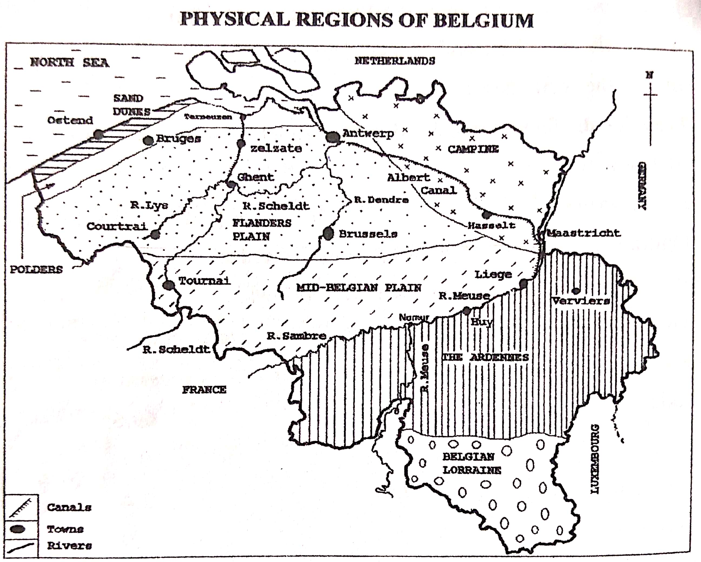

**The coastal plain**

This is a generally flat area consisting mainly of **sand dunes and polders**. It has some small hills in the south and the highest point is 159metres above sea level. The sand dune coast is a broad sandy beach about 2 km wide. The sand dunes are used for sheep pastures and the coastline is also used for seaside resorts and fishing activities.

The Belgian polders are not below sea level. They are reclaimed from low-lying marsh lands.

**The Flanders plain and Central plateau**

The Flanders region is relatively flat with soils based on clay, sand, and river alluvium. The soils have been largely improved by man and intensive cultivation is going on.

The central plateau (mid-Belgium plain) is fairly raised with an average elevation of 200 metres above sea level. It is characterized by low hills and loamy soils. Due to fertile soils it is the most productive region in the country.

**The Ardennes uplands**

These uplands are thickly forested (coniferous trees), rugged and rocky with caves and gorges, rolling hills old mountains. These uplands range between 350 and 500m in height above sea level but with some places rising over 650metres above sea level. The region has steep sided valleys carved by the Sambre and the Meuse Rivers. Dairy farming takes place in the valleys.

**Drainage**

The **Scheldt** and the **Meuse** are the two great rivers of Belgium. Both rivers have their origin in France, traverse Belgium and enter the sea of Holland. Both rivers are navigable throughout their entire length, they are a source of water for domestic and industrial purposes, used for recreational purposes etc.

**Climate**

The country has a cool temperate climate with mild winters and warm summers. Due to the influence of the sea, the climate experienced in largely maritime with precipitation throughout the year. The temperature is coolest in January at 30c and hottest in July at 180c. The rainfall varies from east to west but generally moderate. However, the Ardennes are much cooler all the year and have heavy rainfall of about 1200mm.

**Population**

Belgium has a population of about 11 million, and due to its small area, it has a high population density of over 340 people per square km-one of the highest in Europe.

**Agriculture in Belgium**

Agriculture is an important economic activity in Belgium, and it is carried out in about half of the country’s total land area. For long there have been many small farms, most of which are family owned. Both arable and livestock farming take place. However, the number of family-owned farms is reducing due to the low income derived unlike other sectors of the economy. Today large agribusiness farms are replacing small family-owned farms. This is largely because of the increasing costs of agricultural production and hence unmanageable by small scale farmers.

***A sketch map showing Belgium’s agriculture***

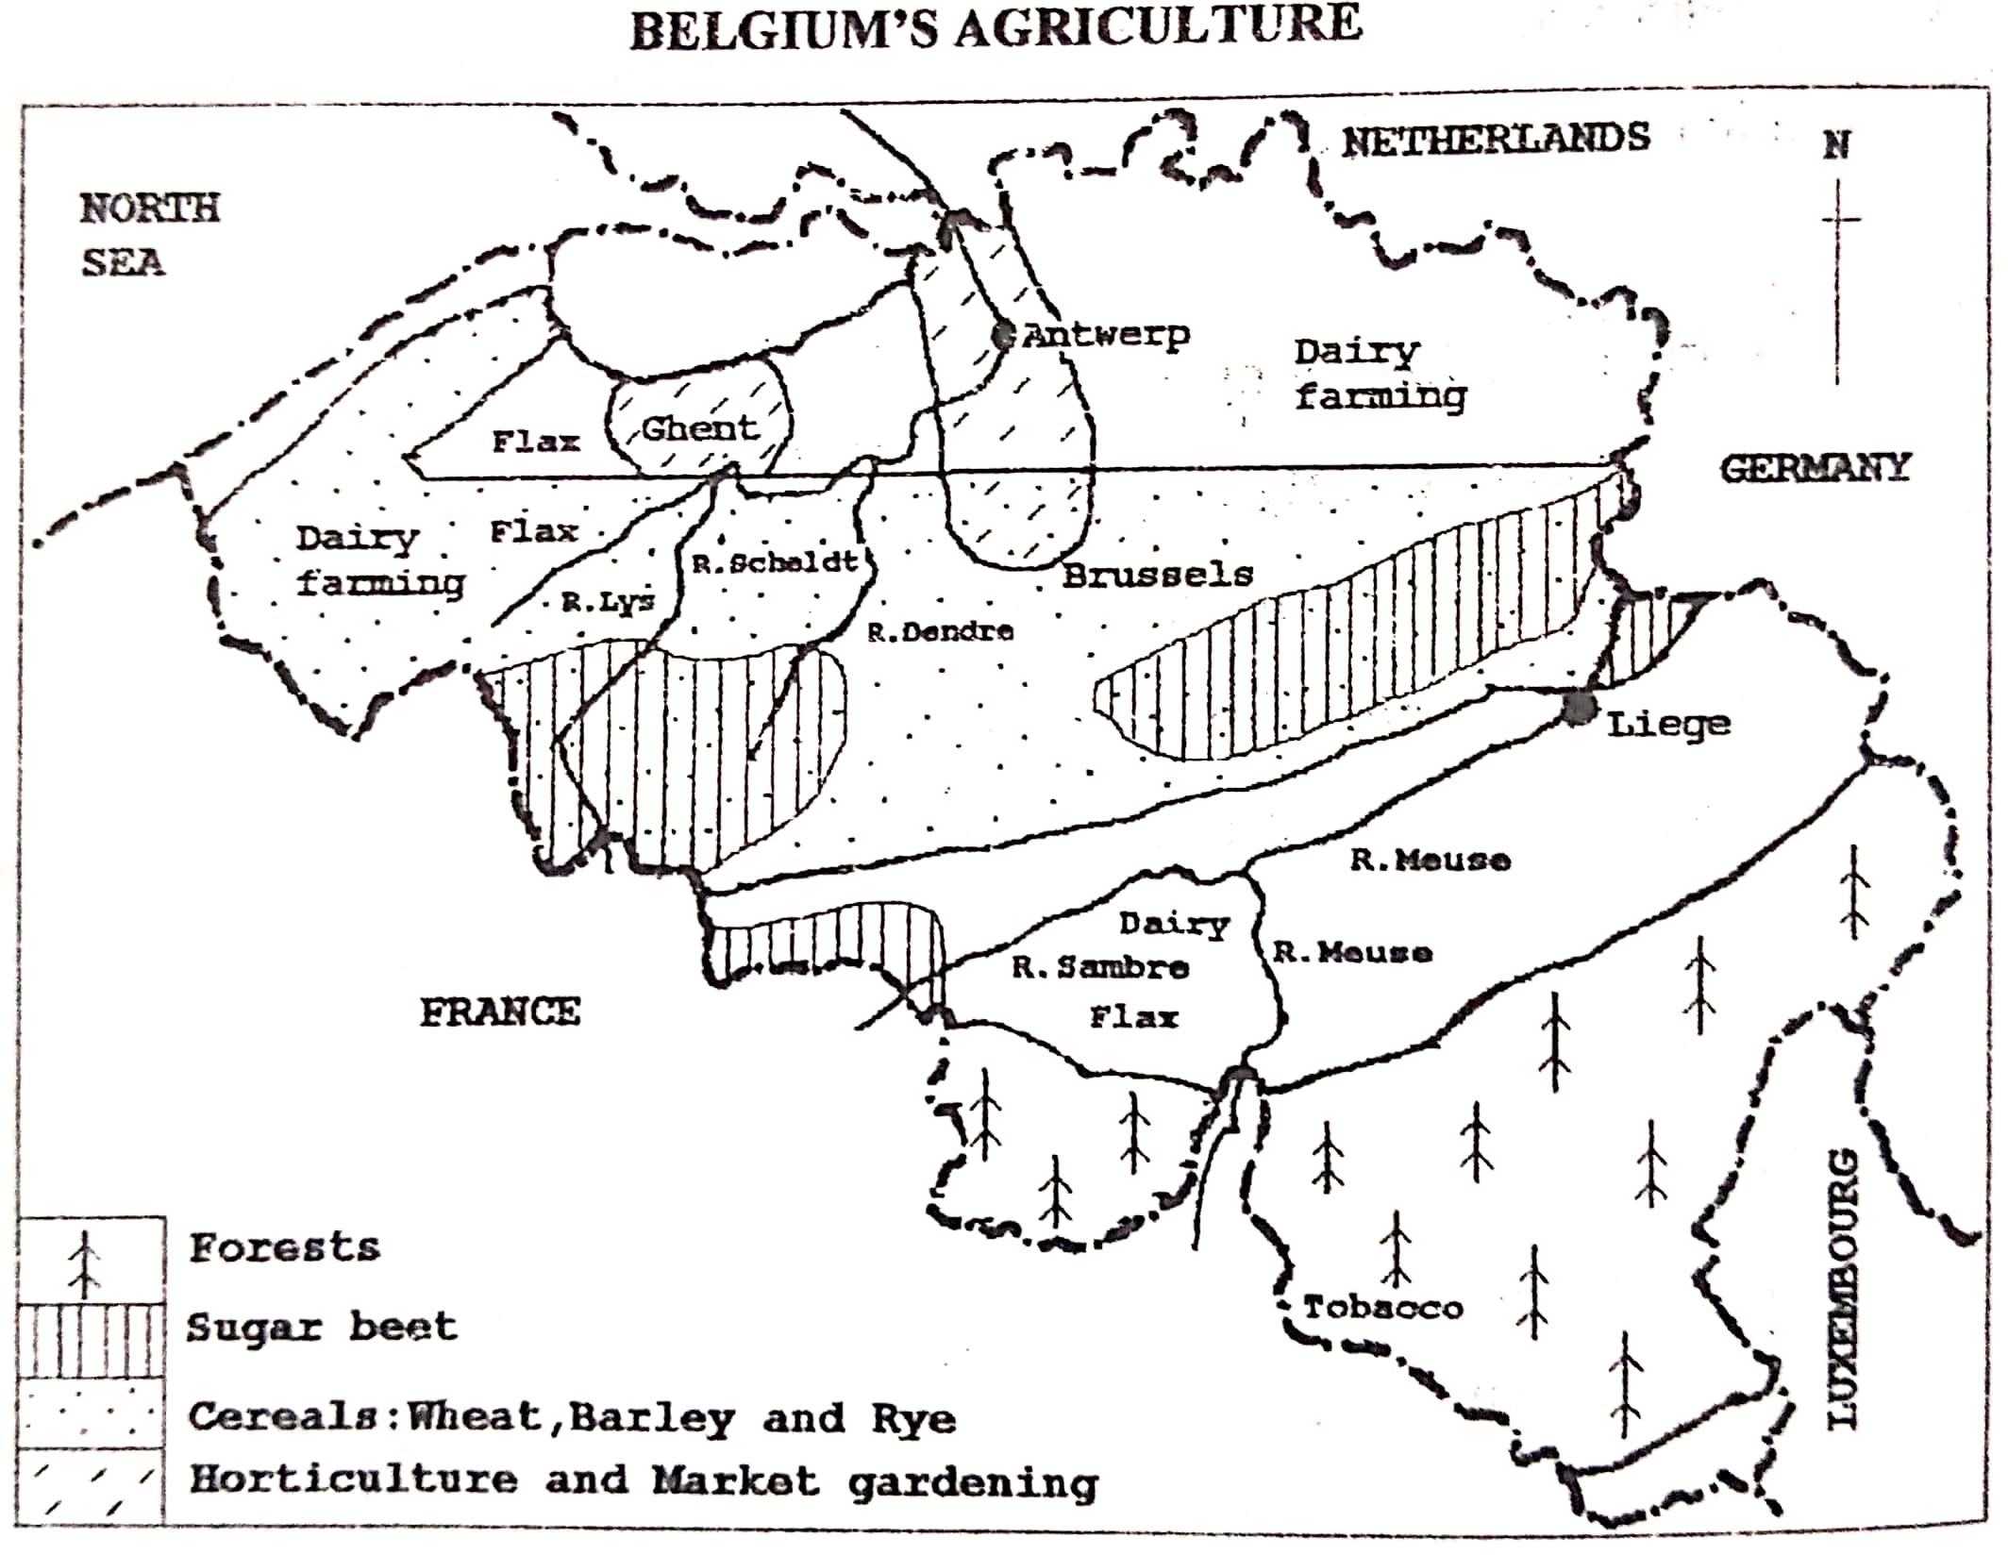

**Arable farming**

Arable farming covers about 27% of the land area. The major crops grown include cereals—wheat, barley, oats, rye, maize, ; others important crops are sugar beet, potatoes, tobacco, beans, peas, flax, hops *(for beer making)*; horticulture—growing of fresh vegetables, and fruits. Fruits grown include apples, pears, strawberries, orchards and grapes. The vegetables include tomatoes, onions, lettuce, etc Arable farming is famous in Flanders and central plateau, although livestock rearing is also common. Farm work is done by family members and occasionally by hired labour.

Arable farming is carried out using modern means. For example, machines are used to plough, sow and harvest, and fertilizers are also used. Many farms undertake to process their produce, and this has led to high degree of specialization in farms.

**Note**: Market gardening is naturally important in Belgium.

**Factors favoring arable farming in Belgium**

1. The relatively flat landscape of Northern and western Belgium which allows the cultivation and use of machines in farming.
2. The temperate climate with ample rainfall to allow a variety of crops to grow naturally. The temperate climate is characterized by warm summers and mild winters.
3. Presence of fertile loamy and clay soils/ fertile loess soils which have supported growing a variety of crops for long such a cereal, sugar beet and fruits.
4. Accessibility to the Rhine River which is a major waterway to the markets for crop and animal output.
5. Availability of large sums of capital to invest in arable farming such as use of tractors, combine harvesters, glass houses, fertilizers etc
6. Presence of a large market for agricultural output such as the large urban population in the country. The country is also located in the heart of Europe and thus a ready foreign market available.
7. Presence of highly developed transport network such as water, railway, road and air to transport farm inputs and farm output. The Rhine is the most important waterway.
8. Well developed technology which has enabled farmers to increase production on the farms such as use of fertilizers, tractors on the farms, glass houses used for some crops.
9. The favourable/positive government policy towards farming such as protecting and promoting local farmers, giving them subsidies. The government has also reclaimed more land from the swamps and marshes to increase arable farming.
10. Availability of skilled labour to work in the agricultural sector such as applying fertilizers, construction and maintenance of glass houses leading to high quality and quantity of production.
11. The formation of various cooperatives which have improved the buying of farm inputs and the marketing of the output.
12. The development of many agro-based industries in the country which offer immediate market for farm produce such as canning industries for peas and beans, beer industries for hops, fruit canning industries.
13. Developed/Intensive research carried in farming leading to the development of high yielding and fast maturing crop varieties.

**Problems facing arable farmers in Belgium**

1. High/ increasing cost of production such as buying machinery, use of fertilizers, use of glass houses; which has made many smallholding farmers to reduce production.
2. Still many consumers are demanding for organic farm products and hence the process of conversion takes time and is very expensive, leading to loss of income.
3. Stiff competition from other countries in Europe due to the requirement by the European Union that all member countries must remove trade tariffs, hence limiting protection of local farmers.
4. Soil exhaustion due to continuous cultivation, hence low quality of yields.
5. Presence of infertile soils in some areas such as sandy soils of the Campine and Ardennes, which discourages crop growing.
6. Pests and diseases which attack the crops and reduce the quantity and quality yields. The most common pests are aphids and nematodes.
7. Labour shortage on the farms due to better paying jobs elsewhere such as in industry and service sector; hence limiting farm production.
8. Sometimes the winters are too cold/ winter frost damages the crops leading to losses (does not allow the crops to grow).
9. Shortage of land for expansion of the farms such as due to a high population density in parts of the Flanders area. *(there is also competition for land between arable farming and animal rearing)*
10. The mountainous terrain/ landscape of the Eastern part of Belgium and the Ardennes, which make the soils thin and thus not supporting crop farming. It also limits mechanization of farming.
11. Flooding of waters from the rivers especially in the low-lying coastal areas which destroys farmlands. *(Sea incursions in the low-lying coastal areas).*
12. Salination of soils from the sea waters especially for the coastal areas, hence low production.

**Steps taken to improve arable farming in Belgium**

1. The government has come in to subsidize the farmers for them to catch up with the increasing costs of production.
2. Farmers have tried to produce high quality produce which can compete favourably with other farmers elsewhere.
3. Promoting organic farming which consumers are increasingly demanding although their price is a bit higher.
4. Use of fertilizers and organic farming to control soil exhaustion. Organic farming relies on crop rotation, manure/ compost manure.
5. Spraying using of chemicals to control pests and diseases.
6. Biological pest control is also used, and this involves the reduction of pests by introducing their natural enemies (predators/ parasitoids) and this is environmentally friendly.
7. Emphasis on mechanization to solve the problem of labour shortage in farm activities such as harvesting, sorting, packing.
8. Adopting the growing of crops in glass houses and growing crops which are resistant to cold temperatures, hence farming throughout the year.
9. Reclamation of more land from the marshes and swamps to increase arable farming.
10. Carrying out intensive farming which requires small land areas and ensures high yields.
11. Building dykes to protect farmlands from flooding.
12. Introduction/carrying out of mixed farming to allow interdependence between arable farming and animal rearing.

**Livestock farming**

Livestock farming / production dominates the Belgian agriculture and it accounts for 65% of the farms. The livestock reared include **cattle (especially dairy cattle), pigs**, poultry, sheep, and turkeys. Cattle and pigs are the main stock in Belgium. Livestock farming is done all over the country, but cattle rearing is dominant in the North where the soils are sandy and in the mountainous East where soils are very thin due to steep and rugged terrain. Therefore, the major areas are:

1. the sandy plains of the Flanders and
2. the northern flanks of the Ardennes.

Dairy farming is practiced producing milk and other milk products.

**Factors favouring livestock farming in Belgium**

1. Presence of thin and infertile soils in the Ardennes Mountains which do not support crop growing and thus leaving land for animal rearing.
2. The sparse population in the rugged mountains that has left large land for animal rearing.
3. The cool temperate climate which favours the rearing of the exotic breeds of animals.
4. Presence of a variety of fodder crops such as hay, oats, and rye used to feed the animals.
5. Availability of adequate capital from credit banks to invest in dairy farming such as construction of shelters for in-door grazing and carrying out research.
6. Presence of large market both domestic and foreign for the animal products.
7. Well-developed transport network to transport farm inputs and farm produce.
8. High level of technology such as the use of electric milking machines leading to high quality and quantity of output.
9. Increased research in animal rearing such as on fodder crops, artificial insemination.
10. The development of processing industries to handle dairy products which also expands the market.
11. The formation of cooperatives which help in buying of farm inputs, selling of farm output and carrying out research.

**Problems facing dairy farming in Belgium**

* Winter temperatures are too cold to allow full-scale farming activities such as they do not allow outdoor grazing of animals.
* Stiff competition from other European countries, which has reduced the market available for the animal products.
* The EU requirement to liberalize the economy has reduced the country’s subsidies to the local farmers.
* Diseases which affect livestock and thus limiting the quality and quantity of output.
* The general trend of falling prices of farm products affecting Europe, making livestock production less profitable since many farmers fail to meet production costs.
* Price fluctuation of milk on the world market which discourages farmers/ leads to unstable incomes.
* High costs of production such as artificial insemination and this reduces the profit margin.
* Shortage of labour to work on the dairy farms due to the small population.
* Rugged relief in the Ardennes, which also limits the movement of animal to some areas for grazing / limits the construction of transport routes.

**Solutions to the above problems**

* Government us of subsidies to offset the high costs of production.
* Spraying with chemicals to control pests and diseases.
* Formation and strengthening of cooperatives to enable the farmers to get loans to invest in animal rearing and to readily secure market for the produce.
* Diversification of markets through research to minimize competition from other countries.
* Emphasize high quality production through specialization to minimize competition from other countries.
* Use of alternative means of transport such as air transport to reduce delays along the Rhine River.
* Mechanization of animal rearing to minimize labour shortage

**Mining in Belgium**

The major minerals of Belgium are coal, stone for building purposes, limestone for cement making, sand for glass making.

The metallic minerals like iron ore, lead and zinc are now nearly exhausted yet they used to be very important. Belgium shares with France and Luxembourg large quantities of iron ore of Lorraine, although its share is very small.

The Belgian **coal deposits** occur in two main basins:

1. The southern basin which lies in the ***Sambre-Meuse trough/ valley***
2. The northern basin in the province of Limburg which is commonly known as the ***Campine field (the Kempenland)***

**INDUSTRIALIZATION IN BELGIUM**

Belgium was the first to undergo the industrial revolution from the early 1800s. The major manufacturing industries include textiles and footwear, food processing, tobacco products, engineering (metallurgy, metal works, machine making), iron and steel, paper and printing, glass and chemical industries.

**The major industrial centres in Belgium**

**The main industries in Belgium include;**

1. **Engineering-**electrical appliances, machinery, machine tools, motor vehicle, diesel engines
2. **Chemical based** originally on coal but later changed to oil. The products include plastics, synthetic rubber, nylon, detergents, pharmaceuticals, explosives, etc.
3. **Textile-**all materials like cotton, jute, and synthetic fibres are imported except for flax grown at home and used to make linen cloth.
4. **Iron and steel-**originally developed around the old coal mining areas of the Sambre-Meuse basin, but new ones have developed along the coast such as at Zelzatte.

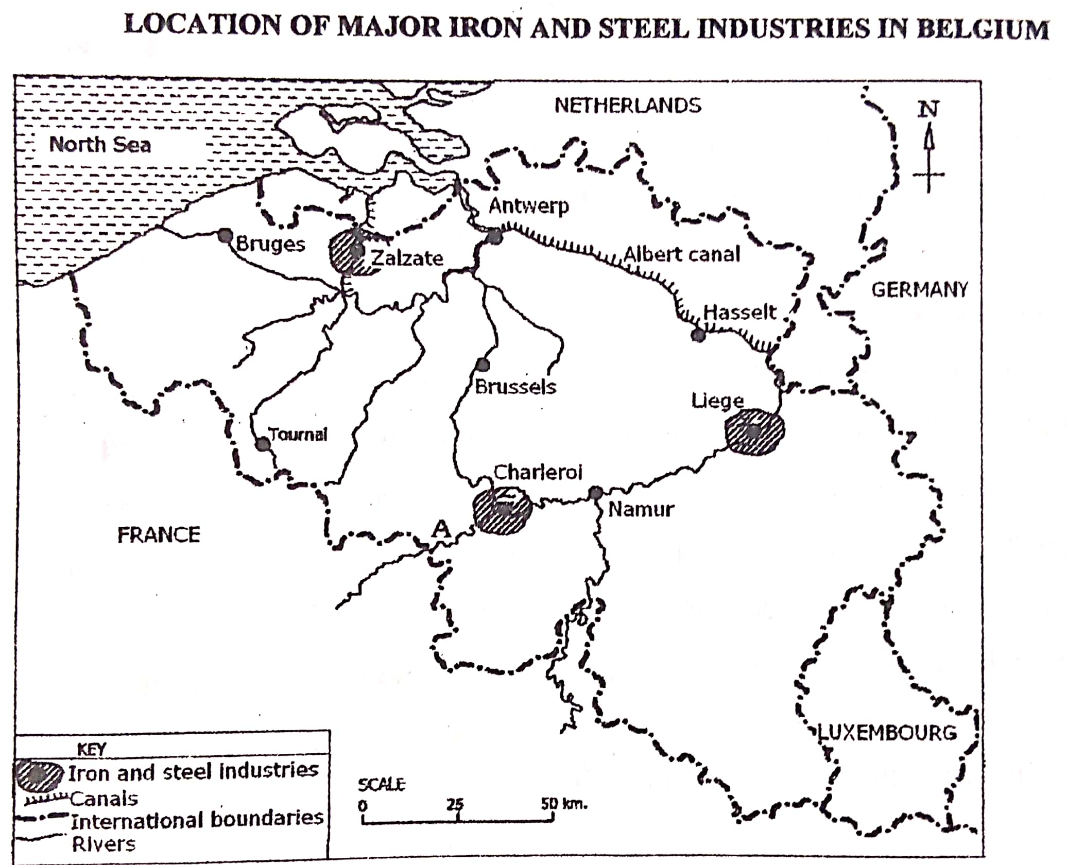

1. **Non-ferrous metal industry—**makes materials used in electronics, aeronautical and space industry. For example, the copper refining plant at Antwerp.
2. **Glass making, diamond cutting etc.**

The major industrial centres are Antwerp, Brussels, Ghent, Charleroi and liege. Other industrial areas are Kortrijk and the North East.

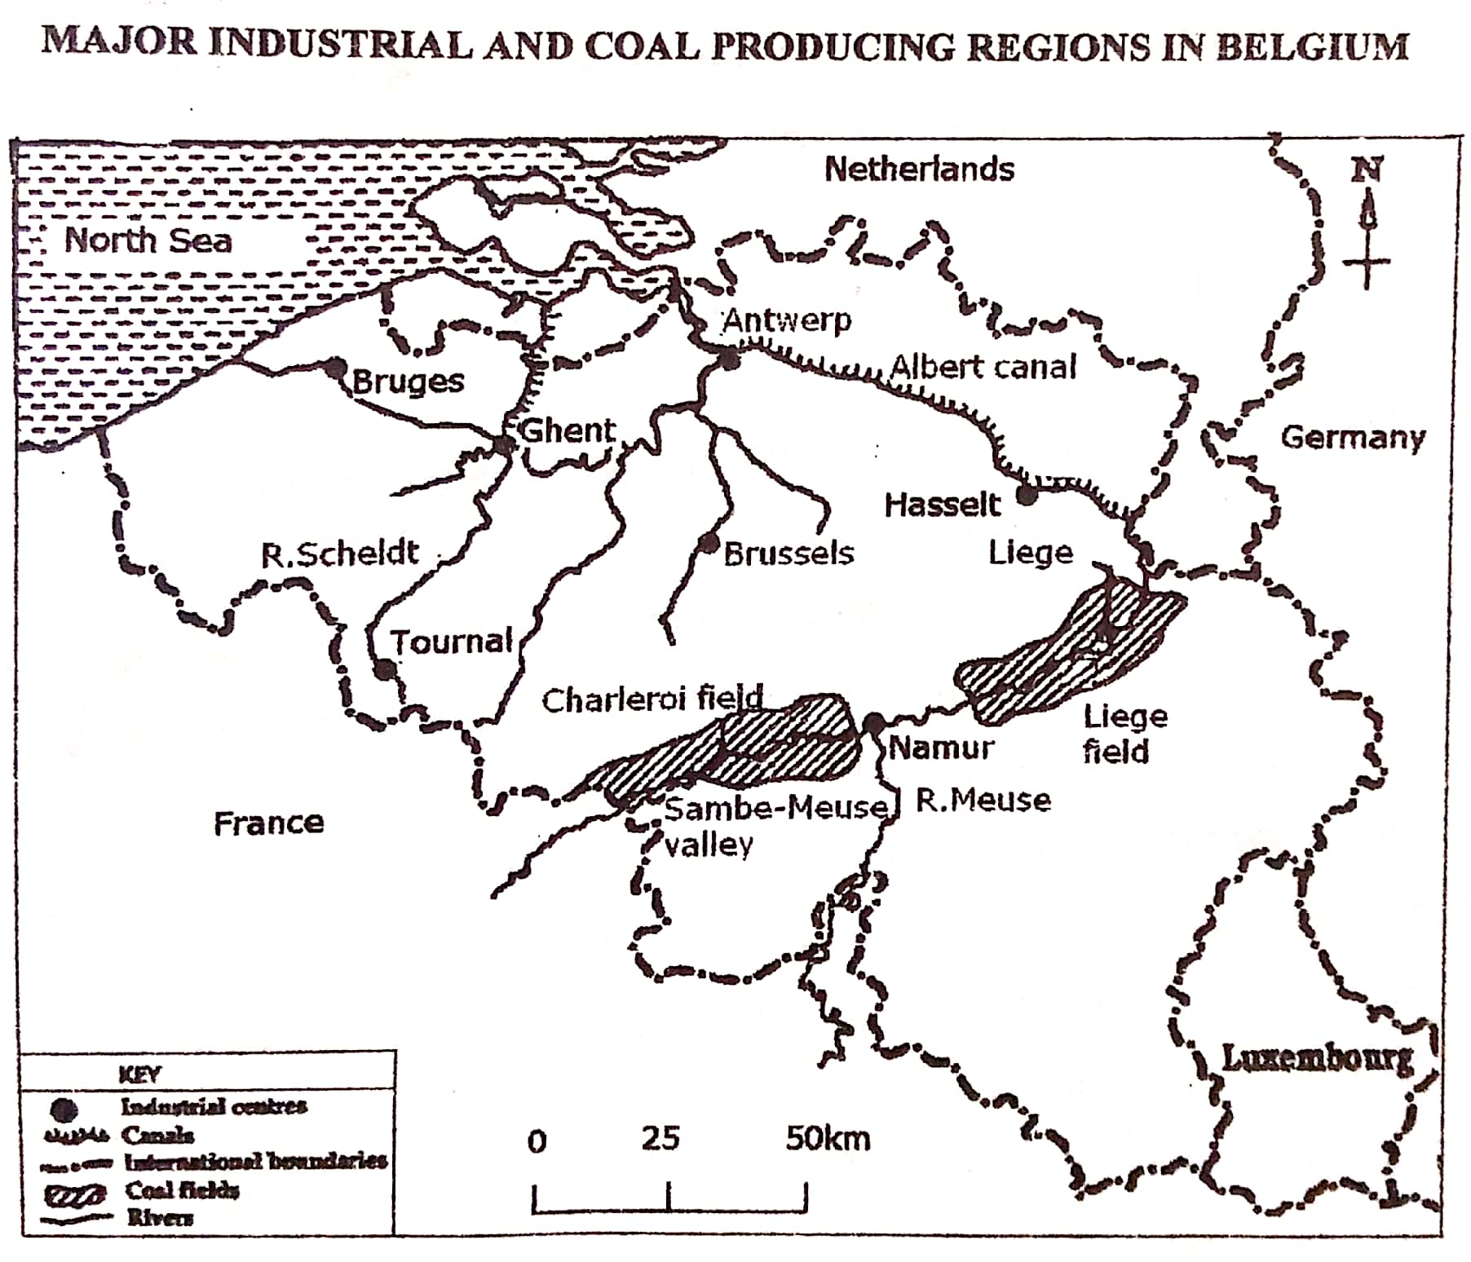

**Table showing the main industries in the various industrial centres of Belgium.**

|  |  |
| --- | --- |
| **Centre** | **Main industries** |
| Antwerp | Oil refineries, Chemical industries, engineering, motor vehicle assembly, ship building and ship repair, diamond cutting, electronics |
| Brussels | Food processing, brewing, car making, engineering, electronics, chemicals, printing and publishing, furniture, textiles, telecommunications, and aircraft construction. |
| Ghent | Food processing, paper, printing and publishing, textiles, leather, machinery, oil refineries, chemical |
| Liege | Iron and steel, Engineering, armaments, chemical, glass, rubber goods, electronics, cutlery, food processing |
| Charleroi | Engineering, iron and steel, glass making, machinery, food processing |

Note: Other industrial centres are; Bruges, La Louviere, Felouy, Zelzatte, Mons, and Mol.

**Factors for the growth and development of industries in Belgium**

1. Presence of abundant raw materials for example coal and iron ore in the Meuse valley, limestone, dolomite, silica sand and agricultural materials which lead to steady supply of industrial goods.
2. Availability of large supply of fresh water from the various Rivers used as a raw material and for cooling machines.
3. Presence of cheap transport network such as River Scheldt, Rhine waterway for importation of bulky raw materials such as iron ore, Ruhr coal, crude oil, agricultural raw materials; and also export finished goods.
4. Presence of a variety of energy sources such as nuclear power, coal deposits in the Sambre-Meuse valley, and imported oil to run machines in the industries.
5. Modern technology employed in industry such as automation of processes hence increasing the quality and quantity of output.
6. Presence of a wide / large market for the products in Belgium and other European countries.
7. Strategic location of Belgium in the centre of Europe surrounded by rich countries such as Italy, France, Germany and thus easy access to a large market in all directions.
8. The spread of the industrial revolution in Europe which involved transforming economies from agricultural into industrial ones, and hence the setting of various industries in Belgium.
9. Supportive/ positive government policy such as encouraging foreign investors using tax incentives. There are many US and Japanese companies in Belgian industry.
10. Availability of large sums of capital from local and foreign investors to set up and manage the industries such as Ford and Volvo, General Motors and Leyland in the motor industry.
11. Presence of skilled labour such as engineers, factory managers, accountants, researchers to work in the industrial sector leading to high quality production.
12. Presence of gazette land for industrial establishment and expansion in the industrial zones.

**Problems facing the industrial sector in Belgium**

* Shortage of some raw materials such as exhaustion of coal and iron ore mines in the Eastern part of the country which limits industrial production *(leading to expensive importation of the materials).*
* High costs of production such as due to dependence on some imported oil and natural gas. Also, high costs of mining coal and iron ore due to increasing depth, which reduces the level of profits.
* Stiff competition for market from industrial countries which limits the market available.
* Shortage of skilled labour especially engineers which discourages production.
* Industrial pollution which reduces the quality of the produced goods and increases the costs of operation.
* Limited home market for the produced goods, which discourages production.
* Shortage of land in the industrialized towns which discourages the expansion of various industries.
* Price fluctuation on the world market leading to unstable incomes and, hence discouraging further investment.

**Steps taken to develop the industrial sector in Belgium**

1. Many companies have resorted to importing raw materials from areas of abundance to control raw material shortage.
2. Adopting raw material saving technology such as recycling to increase industrial production.
3. Emphasizing the production of high-quality products to compete favourably with other countries. Still some industries have opened plants in other parts of the world, targeting the market there.
4. Carrying out market research/ advertisement for the industrial sector to acquire market beyond Western Europe.
5. Using of migrant labour from other countries like Spain and France to increase industrial production.
6. Human resource development i.e. training more workers to equip them with the required modern industrial skills to increase the quality and quantity of output.
7. Encouraging mechanization/ automation to control labour shortage in the industries.
8. Emphasis on treating of industrial wastes to increase the quality of output although it increases the costs of production.
9. Improvement of port facilities at Antwerp to ease importation of raw materials and export of manufactured goods.
10. Relocation of some industries to less congested areas to access land for expansion.
11. Creation of industrial linkage, both forward and backward linkages to avail raw materials and market for industrial goods.
12. Encouraging international cooperation for efficient use of the shared resources such as iron ore shared with France; and extension of markets.

**The Iron and steel industry**

Steel and metal goods account for a large percentage of Belgian exports. Iron and steel developed rapidly in Liege, Mons and Chaleroi. Other centres are Zelzate, Clabecq, and La Louviere. High-grade iron ore is got from Brazil and West Africa despite the low-grade reserves of northern Lorraine and Luxembourg.

**Factors which favoured the growth of the iron and steel industry in Belgium**

* + - * 1. The presence of large coal reserves in the Sambre-Meuse valley and Campine areas as the major sources of energy.
        2. Presence of iron ore deposits in the Sambre-Meuse valley together with large quantities of cheap imported iron ore from France, Sweden and Luxembourg used in the iron and steel industries.
        3. The importation of high-grade iron ore from Brazil and West Africa used in the iron and steel industries.
        4. Availability of adequate capital to invest in the iron and steel industry such as from foreign investors.
        5. Availability of a large market for the iron and steel products basically in the countries of Western Europe such as Holland, Germany.
        6. Well-developed transport routes especially cheap river and canal transport via the North Sea to transport coal, iron ore to the industries.
        7. Large supply of water for use in the iron and steel industry from rivers like Sambre—Meuse, Scheldt.
        8. (*refer to industry in Belgium above)*

**Problems facing the iron and steel industry in Belgium**

1. Depletion of iron ore and coal deposits in the Sambre-Meuse valley which undermines industrial production.
2. Over dependence on imported raw materials which causes occasional shortages and low profits.
3. Increased costs of coal mining which reduces the level of profits.
4. High costs of transporting raw materials from the coast to the interior which also reduces the profit margin.
5. Pollution of the environment which increases the costs of operation.
6. Low grade iron ore from the Lorraine fields resulting into expensive importation such as from Brazil and West Africa.
7. Competition from other countries producing the same products which reduces the available market.
8. High costs of land due to competition with other forms of land use.
9. Etc.

**Solutions to the above problems**

1. Shifting of the Sambre-Meuse iron and steel industries to the coastal region of the North Sea of Zelzate to reduce transport costs.
2. Importation of high-grade iron ore from Brazil, Liberia and Mauritania.
3. Emphasis on production of high-quality products to minimize competition.
4. Reduction of mining costs through the importation of raw materials which are cheaper.
5. Improvement in port facilities at Antwerp to ease importation of raw materials and exportation of manufactured goods.
6. Etc.

**Forestry in Belgium**

The highlands of Ardennes are mainly used for forestry, and the forests are mainly coniferous. They protect the land from soil erosion, landslides, important sources of timber, and tourist attraction. However, the forests are slowly being reduced in size due to the following reasons:

* Frequent fire outbreaks especially in summer
* Pests and diseases which affect the trees
* Pollution affecting the trees
* Competition for land with other land uses such as arable farming; which lead to the clearance of forests.

**Guiding questions:**

1. Study the table below showing land use in Belgium and answer the questions that follow:

|  |  |
| --- | --- |
| **Land use type** | **Land area (000ha)** |
| Arable | 939 |
| Permanent pasture | 732 |
| Forests | 601 |
| Built-up / waste land | 779 |
| **Total** | **3051** |

(i)Calculate the percentage of land area under each of the above land use types

(ii)Draw a pie chart to show the relative importance of the land use types above.

Identiy the:

(i) most dominant

(ii) least dominant land use type in Belgium

Describe the factors which have favoured the development of arable land use type in Belgium

Explain the problems facing any one of the following land use types in Belgium:

–arable

–forests

**Urbanization in Belgium**

Urbanization refers to a situation where there is increasing population concentration in towns. *There is a continuous shift of the population from rural areas to towns/ cities, and the resultant growth and expansion of urban areas.*

The major urban centres include Brussels, Antwerp, Ghent, Charleroi, Liege, Bruges, and Namur.

* + - 1. **Brussels city**

Brussels is the capital city of Belgium. It is located in the Senne River, a tributary of Scheldt River. Brussels is the country’s largest urban with a population of about 1.8 million people and having a high population density. The city is situated on a generally flat landscape of an elevation of 14 metres above sea level. It is built on an area of 16.4km2. It is one of the oldest cities in Belgium.

**Factors for the development of Brussels as an urban centre**

1. Its strategic location on the banks of River Senne made it connected to trade in the region by the waterway. The River also provides water for the large population.
2. Brussels’ central position and being the capital city of Belgium made the government to develop it, by modernizing urban infrastructure.
3. Generally flat topography/ relatively flat landscape encouraging the construction of industries and transport systems.
4. The area has a cool climate and not prone to heavy snow fall in winter; which attracts many people to settle there.
5. The development of many industries in the area such as engineering, textiles, chemical, food processing which has increased the volume of trade.
6. High level of technology which has enabled the construction of the city/ port such as constructing canals, roads and modern buildings.
7. Availability of large sums of capital to invest in the modernization of the town such as building commercial buildings.
8. Availability of various power sources such as oil and hydroelectricity to develop the various urban activities.
9. Political stability of the region for a long period which has enabled the city to expand without any disturbance of war.
10. Well-developed transport and communication systems connecting to various parts of the country such as canals, roads and railways for easy movement of goods and people.
11. Large supply of skilled labour in the area to carry out modern construction and development of the city.
12. Availability of large supply of water from river Senne for use in the various urban activities such as cooking, industry, recreation.
13. Supportive/ positive government policy of developing the city such as by urban planning, encouraging investors in various activities.
14. Brussels’ position as the headquarters of international organizations such as such as the European Union (EU) and North Atlantic Treaty Organization (NATO); which has led to increase in infrastructural development.

**Functions of Brussels city**

* It is a Commercial centre with many businesses, insurance companies and commercial banks.
* It is a Manufacturing/industrial centre with many industries such as chemical, textiles, food processing.
* It is an administrative centre as a capital city and with many offices
* It is a residential centre with a large population settlement.
* It is a transport/communications centre with roads, airport, and other transport systems.
* It is an educational and research centre with many schools, colleges and universities
* It is a tourist centre with various attractions such as modern buildings, museums, the Grand Palace.
* It is an entertainment centre with theatres, dance halls and amusement parks.
* It is a recreation centre with many resort places

**Problems facing Brussels city**

1. Traffic congestion in the city causing unnecessary delays.
2. Maintenance of the city is extremely expensive such as water supply, sewage disposal, law and order. This is due to overcrowding.
3. Pollution of the environment especially due to toxic gases and wastes from industries such as chemical industries and vehicles.
4. Unemployment problems due to high rural urban migration and high population in the city. This leads to social evils like theft and robbery.
5. Shortage of land for expansion of the city due to many activities carried out in the city.
6. Population explosion/ increase has led to inadequate housing resulting into slum growth.
7. Overcrowding of people leading to easy spread of diseases and high crime rate.
8. High cost of living due to high population in the city, hence poor standards of living to some people.
9. Rampant discrimination against people of foreign origin leading to social conflicts/ misunderstandings and crime.

**Solutions to the above problems**

* + - 1. Treating industrial wastes before disposal into water to reduce pollution.
      2. Anti-pollution laws have been put in place such as non-importation of used vehicles and condemnation of old vehicles. Also, bicycles are being promoted as a means of transport in the city, hence limiting car use.
      3. A foreigners’ office was established to register all foreigners and ensure their settlement in Brussels, by advising them on better integration.
      4. Discouraging illegal immigrants with strict laws to control the population explosion.
      5. Vertical expansion of the city to minimize the problems of limited space (use of skyscrapers/ storeyed buildings).
      6. Police has been strengthened to be more alert against crime among citizens.
      7. Construction of more small-scale industries to fight unemployment.
      8. Encourage people to search for jobs in other areas to reduce unemployment and overcrowding.
      9. Government has encouraged private and public companies to construct decent houses for rent to limiting the emergence of slums.

1. **Antwerp**

This is the second largest city after Brussels. It lies mainly at the right bank of River Scheldt and about 90km from the North Sea. Antwerp is Belgium’s leading port which handles over 90% of Belgium’s own traffic and serving northern France, Luxembourg and other neighbouring parts.

Antwerp now ranks third in importance, following Rotterdam and New York.

**Factors which have favoured the growth and development of Antwerp**

* The city has a direct route to the North Sea which enables both ocean going ships and barges to transport large volumes of cargo. *(it is also the terminus of the albert canal from liege providing a useful waterway link with the Sambre-Meuse industrial region)*
* *Well developed transport system with road and railway and air links enabling easy movement of people and goods in the city.
* Its position as a port *(the third largest in the world after Rotterdam and New York)* handling large volumes of imports and exports.
* Relatively flat landscape favouring easy construction of buildings and transport routes.
* Availability of land for expansion through draining marshland adjacent to the port.
* Presence of large and productive hinterland serving Belgium, Luxembourg and northern France which increases industry and trade in Antwerp.
* Large supply of water from river Scheldt to support the various urban activities such as trade, industry.
* The development of many/ various industries in the city such as chemical, electronics, motor vehicle assembly, oil refineries which increases the jobs available and thus attracts a large population.
* Availability of large sums of capital to invest in the area such as investment by large foreign companies from USA, Britain, and Germany in various activities / industries.
* Etc.

**Note:** The main imports handled by Antwerp port are ores, petroleum, foodstuffs, timber, and coal. The exports handled are mainly manufactured goods like steel, chemicals, glass, textiles etc.

**LAND RECLAMATION AND AGRICULTURAL DEVELOPMENT IN THE NETHERLANDS**

The Netherlands is popularly known as Holland and it derives its name from the word “hollow land”. It is one of the countries of the Rhine lands. It is bordered by the North Sea in the north and west, Belgium in the south, and Germany in the east. The country covers a total land area of 41,526km2, making it equivalent to 2% of East Africa or 17% of the total area of Uganda. over 45% of the land area is below sea level.

**Physical geography**

**Relief**

The country is mostly low-lying. The elevation of the land ranges between 7 meters below sea level and 322 meters above sea level. About 45% of the total land area is below sea level. Most of the country is very flat, except for low hills in the extreme southeast and in the central parts. The country is generally composed of young rocks, which were formed by the processes of glaciations, River deposition and sea deposition.

The areas below sea level comprise of the territory mostly in the west. This land was reclaimed from the sea from the 13th century and is guarded by sand dunes and dykes. These units are called the polders.

**Climate**

The Netherlands lies in the temperate zone of the northern hemisphere. The climate is influenced by North Sea and the warm north Atlantic drift. It experiences a mild climate with cool summers and mild winters. *(The average temperature fluctuates between 20c January and 170c July. However extreme temperatures may occur at times).* Rainfall is evenly distributed throughout the year and about 800mm of rainfall is received in a year.

**Population**

The people of the Netherlands are called the Dutch and their language is also Dutch. The population of the country is estimated to be 17million and it is the second most populated country in the Rhine lands. It is the most densely populated country in Europe and obviously the Rhine lands, having a population density of about 400 people per km2. Most of the population lives in urban areas and the biggest city is Amsterdam in the western part of the country.

**Reasons why Netherlands is densely populated**

* + - * Its low-lying relief makes settlement easy.
      * Relatively high population growth of about 1.6% per year.
      * The small land size yet the population is high.
      * Presence of fertile soils due to glacial, River and wave deposition in the area which favours farming and attracts many people.
      * Cool summers and mild winters which attract many people for settlement.
      * Strategic location near the North Sea and the mouth of the Rhine River which are some of the busiest waterways in the world.
      * Early trade and commercial activities which also attracted many people.

**Land reclamation in Netherlands**

More than half of the total land area has been reclaimed from the sea and the River floodplains. Land reclamation has been done for many years. The process of reclaiming land from the sea or Rivers is called polderization and the reclaimed land is called a polder.

**A polder** is a low-lying land reclaimed area enclosed by dykes that protect it against higher water levels outside the area.

A dyke is a strong concrete wall constructed to protect a reclaimed area against higher water levels outside the area.

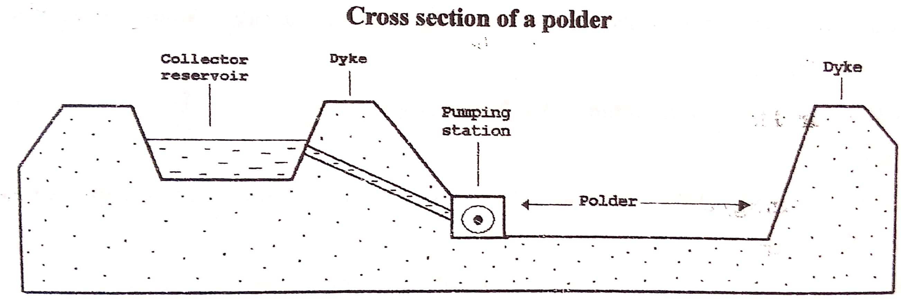

**Why the Dutch had to reclaim land**

1. Much of the land in the western and northern part is below sea level and therefore is was necessary to protect it from the sea water.
2. The need to create more land to settle the excess population.
3. The western and northern parts were heavily settled and thus the need to protect the population from constant North Sea tides.
4. The need to create more land for farming to provide food for the high population.
5. The need to control the frequent floods from the North Sea.
6. The need to create recreation grounds such as beaches to develop the tourism sector.
7. To protect the soil from salination because wave deposition.
8. The need to improve transport and shorten the distance on the coastline especially along the Rhine delta region.

**Factors which have favoured land reclamation in the Netherlands**

1. Increased demand for land for settlement and cultivation due the ever-increasing population.
2. Availability of adequate capital provided by the Dutch government and the rich merchants in Holland to invest in land reclamation such as constructing dykes and canals.
3. The long experience of the Dutch people in land reclamation since the 14th century.
4. High level of engineering skills / technology employed in land reclamation such as building dykes and canals.
5. The need to improve the quality of the existing land in the Netherlands which also encourages the Dutch to continuously reclaim land.
6. The need to protect the land from flooding due to strong waves from the North Sea.
7. Availability of skilled labour to work in land reclamation such as engineers, geologists, and hydrologists.
8. Favourable government policy towards polderization such as funding the projects of polderization.

**Uses of reclaimed land**

1. Arable farming involving growing of crops such as rye, oats, barley and wheat.
2. Animal rearing. Some parts of the polders are used for rearing animals especially dairy farming. Fodder crops are also grown to feed the animals.
3. Settlement. Due to the high population residential areas are created and cities have been developed.
4. Industry and commerce. Part of the reclaimed land is used for industrial activities and commercial purposes.
5. Tourism and recreation. Recreation areas have been set up on the polders, yet other tourists are attracted to the technology used in polderization.
6. Communication –many roads, railways and airports connecting the polders and other parts of Netherlands.
7. Forestry. some parts on the polders have been gazetted for forest conservation.
8. Provision of fresh water for the people especially using the man-made lakes and River canals.

**Process of land reclamation/ formation of a polder**

* The area to be reclaimed is surrounded by a very expensive barrier known as a dyke made of concrete.
* Ditches or trenches are dug within the polder to drain out all the trapped water
* The seawater is pumped out of the enclosed area into the open sea using diesel engines.
* Rainwater can fall into the enclosed area to dissolve all the salts from the polder and this takes about 4 years.
* Bamboo shoots and rids are fixed into the enclosed area to help in the absorbing/ draining the salty water.
* Fertilizers and sand are added to the reclaimed land, which is deep ploughed and ready for use.

**Problems faced in the utilization of the polders**

1. Salination of the soil due to underground seepage of sea water which has reduced the productivity of the land for agriculture.
2. Flooding resulting from damage of dykes and snow melting leading to increased water volume, destroying life and property.
3. Presence of infertile soils in many areas of the polders due to wave deposition which discourages farming
4. Excessive waterlogging especially on polders where a lot of rainwater is received, discouraging economic activities.
5. High rental charges of land due to the high costs of land reclamation and maintenance of polders
6. Shortage of fresh water especially in periods of prolonged drought.
7. Constant maintenance of polders is very expensive, hence high costs of production.

**Solutions to the above problems**

1. Construction of dam projects to control flooding such as in the Zuider Zee scheme.
2. The salt content is dissolved in rainwater and constantly pumped out of the polders to create better land for farming.
3. Use of fertilizers and manure where the soils are infertile.
4. Pumping excess water out of the polders using windmills and diesel engines to reduce water logging.
5. Growing of high value crops to offset the high costs of utilizing the polders.
6. Construction of manmade lakes to provide fresh water and act as reservoir such as lake ljssel/ Yssel
7. Construction of stronger dykes to control flooding
8. Government has set up a body called Delta plan tom be in charge of maintaining the polders.

**PROJECTS OF LAND RECLAMATION**

There are two major projects in land reclamation, and these are:

1. The Zuider Zee project
2. The Delta Plan

Note: other reclamation projects are Haarlem, Zeeland, Groningen, and Friesland.

**Zuider Zee project**

This is a huge area North of Netherlands and is the major achievement in land reclamation. (the project was intended to drain a large area of land engulfed by the sea and this area known as the lake Yssel).

The work started in 1916, involved construction of a 30km barrier dam, and todate 5 different polders have been completed:

* North East polder (49,000 hectares)
* East Flevoland polder (55,000 hectares)
* South Flevoland polder or south East polder (44,000 hectares)
* Markerwaard polder (61,000 hectares)
* Wieringermeer polder /North west polder (20,000 hectares)

**Aims of the Zuider Zee project**

* To provide land for settlement due to the increasing population.
* To create land for farming to feed the increasing population
* To increase the supply of fresh water by constructing dams
* To create more land for industrialization
* To make the area a tourist attraction
* To urbanize the region and protect Amsterdam a very vital seaport and largest city of The Netherlands.
* To improve transport and encourage trade and commerce in the area.
* To increase the area for recreational grounds.

***A sketch map of the Zuider Zee reclamation scheme***

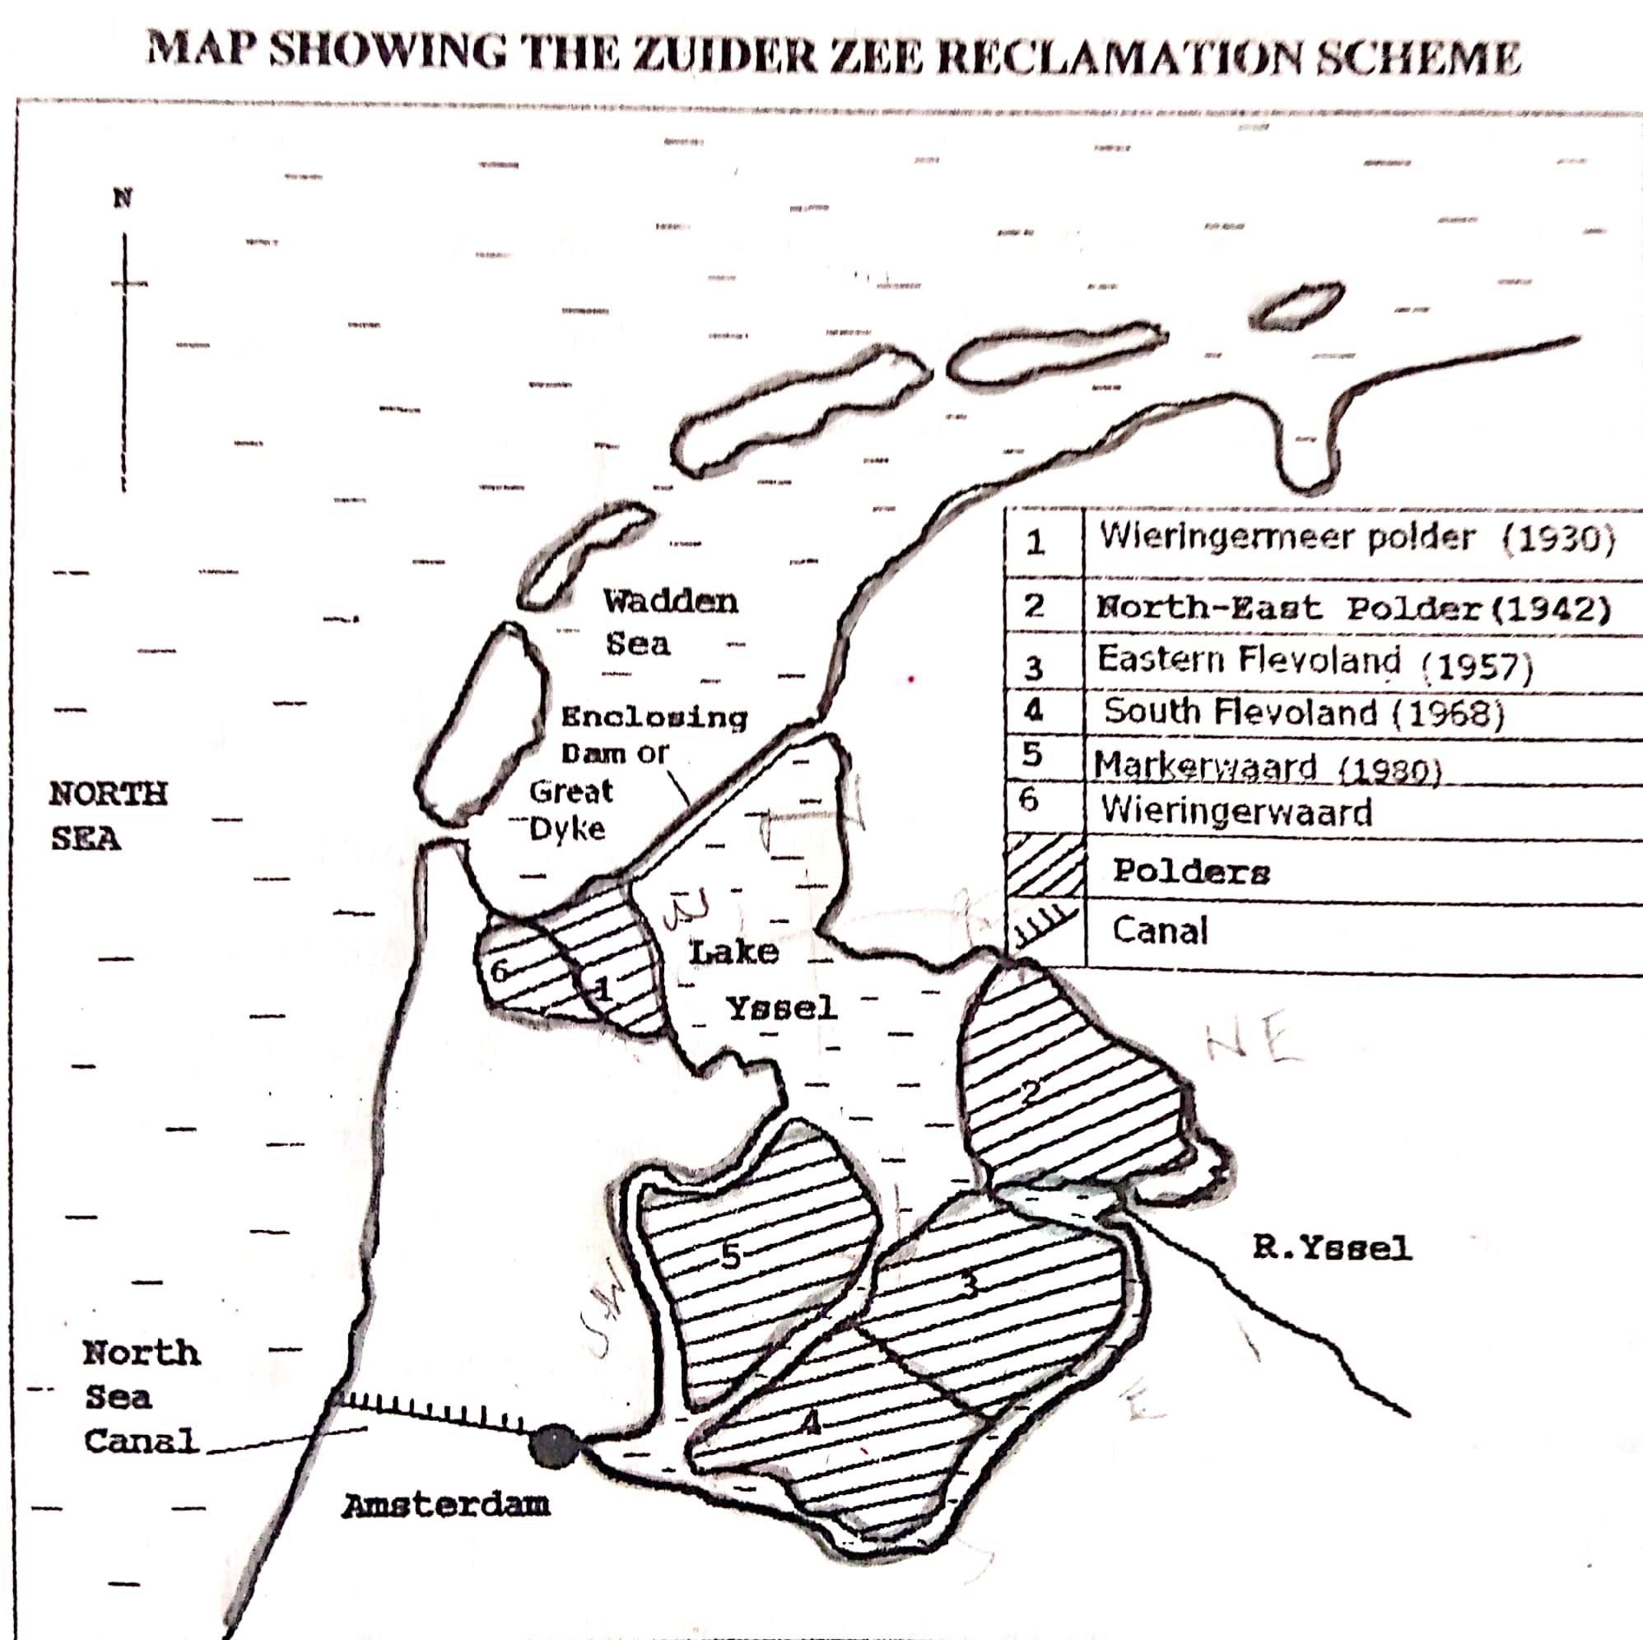

***Benefits of the Zuider Zee scheme***

* It led to the creation of freshwater lakes in the interior known as Lake Yssel, providing water for the provinces of North Holland and Friesland.
* The area has got better drainage system especially after the completion of the North Sea canal, hence more land use.
* Floods were controlled in the area, hence increased activity in the region.
* Lake Yssel has reduced the salt content/ salination in the surrounding land hence making it more suitable/ productive for farming.
* The project has generated employment opportunities to many people especially in agriculture and industry. This in turn improves the standards of living.
* Agricultural production has increased within the polders and this has favoured the growth of agro-based industries.
* The polders are imported tourist attractions, and this generates foreign exchange.
* The Zuider Zee project has encouraged acquiring of skills in polderization and research in crop farming by the Dutch people.
* The road distance between North Holland and Friesland has been shortened due to construction of the 30km barrier dam.
* Attraction of population into an area which previously has been lowly populated, hence urbanization and trade.

**The Delta plan**

This is the region which lies in the Rhine delta and it is drained by Rivers like Rhine, Meuse (mass), Scheldt and Waal.

The delta plan was an attempt by the government to control severe floods in the Rhine delta area, among other aims.

**Aims/ purposes of the delta plan**

(Refer to the Zuider Zee project)

**Benefits of the delta plan**

(Refer to the Zuider Zee project)

**Problems faced by the delta plan and Zuider Zee schemes**

(Refer to the general problems faced in using/ utilizing polders)

**Solutions to the above problems**

(Refer to the general solutions already given)

**LAND USE IN THE NETHERLANDS**

|  |  |
| --- | --- |
| Land use type | Land area (000 ha) |
| Arable | 977 |
| Permanent pasture | 1291 |
| Forest | 288 |
| Built up/ Wasteland | 805 |
| TOTAL | 3361 |

**Note:**

1. Arable land –used for marketing gardening involving the growing of crops such as fruits, vegetables, flowers.
2. Permanent pasture-occupies the largest area and mainly used for dairy farming with exotic breeds like Friesians, new jersey and Guernsey.
3. Forests-used for lumbering especially soft wood species like pines.
4. Built-up/wasteland—used for settlement purposes. It used for urban centres, industrialization, residential houses, transport and communication lines.

**Reasons why a large land area is under pasture**

1. The soils are infertile and saline hence cannot favour crop growing but growth of pastures.
2. Grass helps to improve on soil fertility of the reclaimed land from the sea; hence a large area is left under pasture.
3. The temperate climate favours dairy farming more than crop growing.
4. The area is generally flat hence easy movement of animals and paddocking.
5. The Dutch government encourages specialization in dairy farming or ranching.
6. Dutch farmers are predominantly known for animal rearing than crop growing.

**A SKETCH MAP OF NETHERLANDS SHOWING MAJOR TOWNS, RIVERS, PORTS, MINERALS AND NEIGHBOURING COUNTRIES**

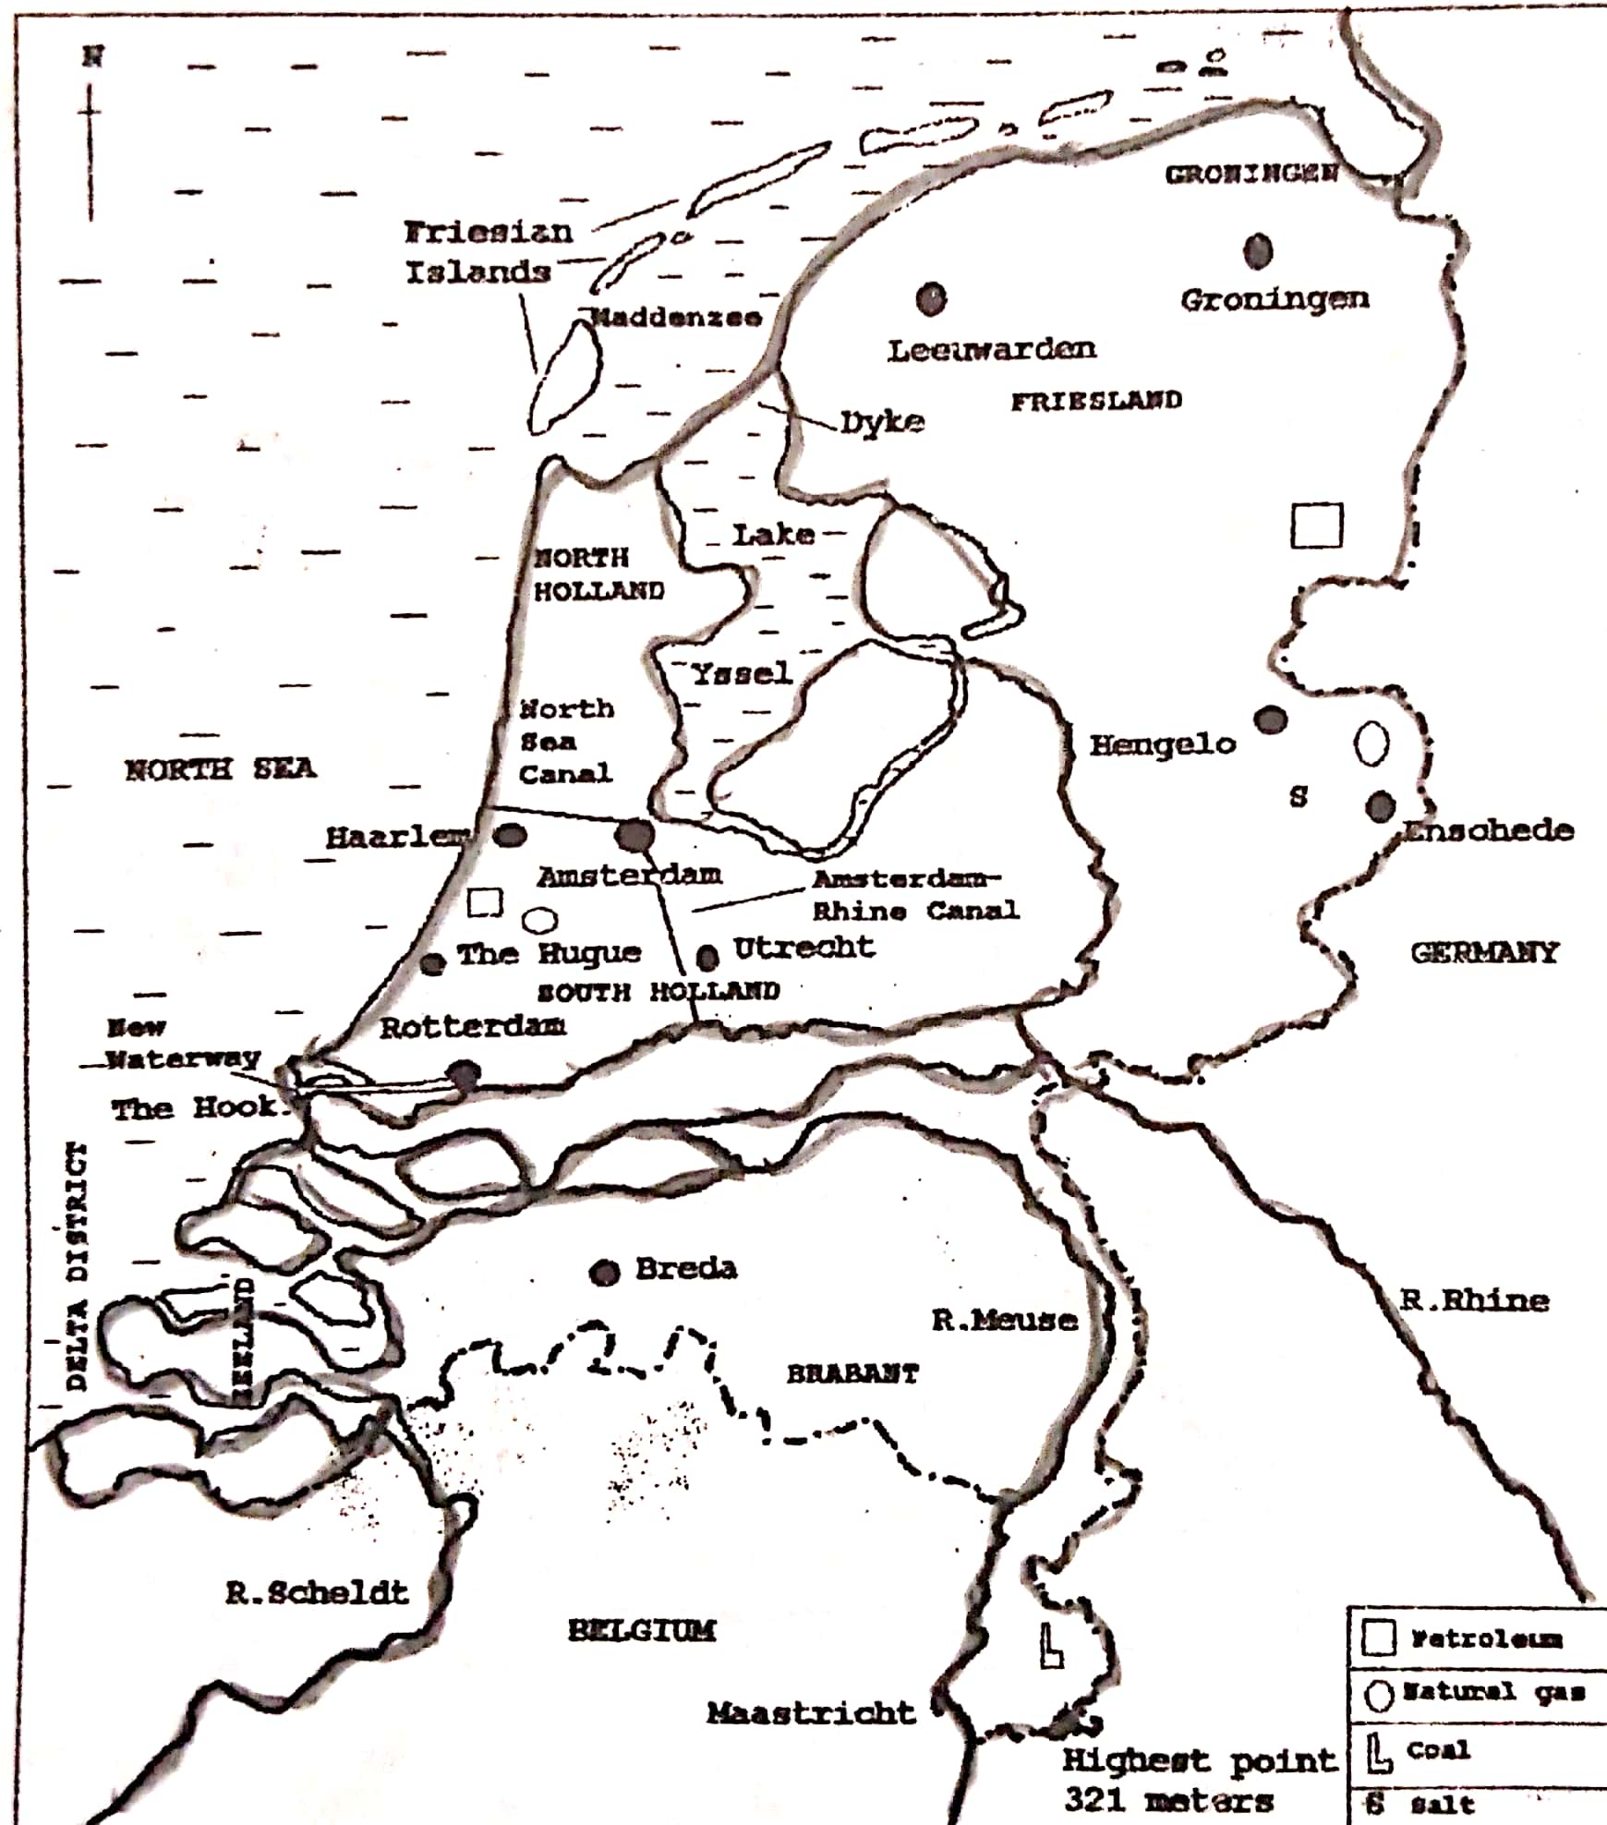

**AGRICULTURE IN NETHERLANDS**

The characteristics of agriculture in Netherlands include:

* Intensive in nature
* Highly organized farming
* Farming is scientifically managed
* High yields per unit area
* Careful government supervision
* Much output is exported.

**Types of farming in Netherlands**

The major types of farming include:

1. Arable farming
2. Mixed farming
3. Market gardening
4. Horticulture
5. **Arable farming**

Arable farming is mainly practiced on fertile, well drained sea clay land found in the North and south west of the country. This mainly involves cereals, potatoes, and sugar beet.

1. Cereals such as wheat, rye, oats, and barley.
2. Potatoes-both for humans and stock feeds.
3. Sugar beet-supplying sugar, cattle cake (from crushed vegetable matter) and leaves used as stock feed.
4. **Mixed farming**

Refers to the growing of crops and rearing of livestock. This is mainly practiced in the East and south of Netherlands.

* Livestock rearing includes rearing of cattle for beef and beef products, milk and milk products, pigs and poultry
* Fodder crops are grown to feed the livestock. The products of livestock are cheese, milk, butter
* Other Crops grown include tomatoes, cereals, potatoes, sugar beet, lettuce, melons.

1. **Market gardening**

This is a form of farming involving the growing of vegetables, fruits and flowers for sale in the major urban centres. The products from market gardening include tomatoes, cabbage, onions, cucumber, mushrooms, fruits and flowers.

**Characteristics of market gardening**

1. Most farms are small in size not exceeding 10 acres (intensive farming)
2. The farms are located near and in the urban centres.
3. Perishable crops are mainly grown
4. Use of scientific methods such as applying fertilizers.
5. A variety of crops are grown on the same field (intercropping)
6. Crop rowing takes place throughout the year.
7. The famers involved are highly skilled
8. The farms are highly mechanized
9. Most crops are grown for sale.
10. Industrial processing of crops is done.

**Conditions which favour market gardening in the Netherlands**

1. Relatively flat landscape which allows the use of machines like tractors on the farms and also allowing irrigation under gravity flow.
2. Large supply of fresh water for irrigation from Rivers like Rhine and Meuse.
3. Political stability of the region which has favoured investment in the market garden farms.
4. Abundant/Large supply of skilled labour to work on the market gardens.
5. Modern technology employed on the farms such as glass houses used during winter for growing crops and these help in regulating temperature.
6. Presence of modern/ well developed transport network by railway, road, air, for easy marketing and distribution of crops to market centres.
7. Large sums of capital to invest in market gardens such as purchasing farm machinery, chemicals, and fertilizers.
8. Ready market for farm produce within the urban centres of Netherlands (Rotterdam, The Hague, Utrecht) and other countries.
9. Improved/ increased research in order to develop high yielding crop varieties and those which are disease resistant.
10. Supportive/ positive government policy towards market gardening through giving tax incentives and encouraging farm research.
11. Formation of cooperatives has also supported market gardening through buying of farm inputs cheaply and carrying out market research.
12. Land shortage leading to maximum utilization of land under intensive methods of which market gardening is suitable.
13. Geographical location of the polders (Netherlands) in the centre of Europe / developed countries which offers a large market.
14. **Horticulture**

Refers to the growing of vegetables, fruits and flowers for sale. Dutch horticulture is categorized into the following:

1. Floriculture
2. Vegetable growing
3. Fruit growing
4. **Floriculture**

Refers to the cultivation of flowers. The traditional area for flower growing is Aalsmeer near Amsterdam. Flowers are used in house decoration, offices and hospitals, as well as occasions. Flowers have high demand all over Europe, high technology of growing like under glass houses. Flowers are cut in the morning and sold the same day in most large European cities.

1. **Vegetable growing**

The most important region for vegetable growing is the south Holland glass district—which is divided into two production centres of Westland and the Kring. On the province of North Brabant, the most important producing area is Breda.

Vegetables grown include carrots, lettuce, tomatoes, cauliflowers, cucumbers, endives, spinach, leeks, and melons.

1. **Fruit growing**

The most important region is the province of Guelderland (between Rivers Rhine, Waal and Meuse. The main fruits grown include apples, pears, plums, cherries.

1. **Animal rearing in Netherlands**

Dairy farming takes the lead with mainly Black Friesian and white Friesian breeds. The major breeding districts are the provinces of Friesland, North Holland, South Holland and Drenthe.

The products from dairy farming include butter, cheese, powder milk, skimmed milk. Over half the production of each commodity is exported.

**Characteristics of Dutch animal rearing**

1. Concentrates on producing milk and milk products (dairy farming)
2. It is highly mechanized such as electric milking machines
3. Use of improved dairy cattle such as Friesians
4. Intensive use of available land
5. High use of fodder crops (such as hay) and manufactured cattle feeds
6. Cattle farming is scientifically managed
7. Use of highly skilled and specialized labour
8. Produces very high output (dairy cattle are very productive per animal)
9. Cattle herds and farms are small
10. A large percentage of Dutch milk is processed in cooperative societies (over 85%).

***Note:*** *Dutch dairy cattle are amongst the highest in the world. The cattle are kept indoor throughout winter. Barns, food stores, cattle sheds and milking parlors are scientifically managed for maximum mechanization. Food and water are automatically distributed to cattle pens.*

**Conditions which have favoured animal rearing in Netherlands**

**Physical**

1. The cool temperate climate of the country. It has a mild climate with cool summers and mild winters-which favours the high milk yielding Friesian cattle.
2. Presence of fertile clay and peat soils which are moist favouring the growth of pastures and other fodder crops (such as hay,).
3. Availability of a wide extensive land area especially in the polders to enable animal rearing and growing of pastures to feed the livestock.
4. The generally flat landscape on the polders also favours extensive mechanization of dairy farming activities.
5. Presence of high breed animals such as the Black and white Friesians which have very high milk yields.
6. Presence of fresh water supply from Lake Yssel for animal use especially during the drought periods. Water is also supplied by Rivers like Meuse and Rhine.

**Human**

1. Availability of large sums of capital to develop dairy farming which was provided by the credit banks to invest in dairy farming especially on the polders. There is also government financing of polderization.
2. High levels of technology employed such as use of automatic milking machines, carefully designed food stores, cattle sheds and milk parlors.
3. Presence of a large market for dairy products, both local and foreign. The large urban centres like The Hague, Amsterdam, Utrecht, Rotterdam, and Groningen. Also, the developed countries like Germany, Britain and Belgium.
4. Presence of a developed transport system in the Netherlands by canals, Rivers, land to facilitate the marketing of produce and the distribution of farm implements.
5. Presence of skilled labour force such as managers of the dairy farms- who organize the dairy farming activities like feeding, milking, and milk handling to ensure high quality production.
6. The development of cooperative societies which help farmers in the buying and selling of dairy products, carrying out research.
7. Constant research regarding dairy farming in form of improving the animal breeds, the animal fodder grasses, manufacture of animal feeds,
8. Favourable/supportive government policy towards dairy farming for example carrying out research and giving advice to the farmers.

**Problems facing agricultural sector in the Netherlands (polders)**

1. River flooding leading to the destruction of farmlands.
2. Shortage of fresh water during drought periods.
3. Salination of soils due to underground seepage of water from salty sea waters. This reduces the productivity of the land and calls for continuous use of fertilizers and manures to enrich the soils for pasture growth. Too much use of fertilizers in turn pollutes the soils.
4. Over production of animal products, leading to a fall in prices.
5. High costs of production especially during winter, because the cattle are kept in-door throughout winter.
6. High land rent on the polders which is costly to the farmers. This in turn promotes intensive dairying on the polders.
7. The infertile sandy soils in a large area less fitting for farming practices such as pasture growth.
8. Excessive water logging and high costs of pumping out of excess water from the polders.
9. Inadequate labour supply which limits production.
10. Sea incursions.

**Steps taken to solve the above problems**

1. Use of fertilizers and manures to improve soil fertility
2. Building of dykes or concrete walls to control flooding
3. Exportation of excess products to the other countries to reduce wastage.
4. Emphasizing high quality production for high prices, hence offsetting high costs of production.
5. Continuous pumping out of excess water from the polders.
6. Mechanization to reduce the problem of limited labour
7. Subsidizing the farmers to enable them to compete favourably with other producing countries
8. Carrying out intensive farming to offset the high land rent.
9. Reclamation of more land from the sea and Rivers to increase agricultural land.
10. Creation of freshwater lakes to supply water required for farming activities.
11. Use of glass houses where humidity and temperature are artificially controlled.

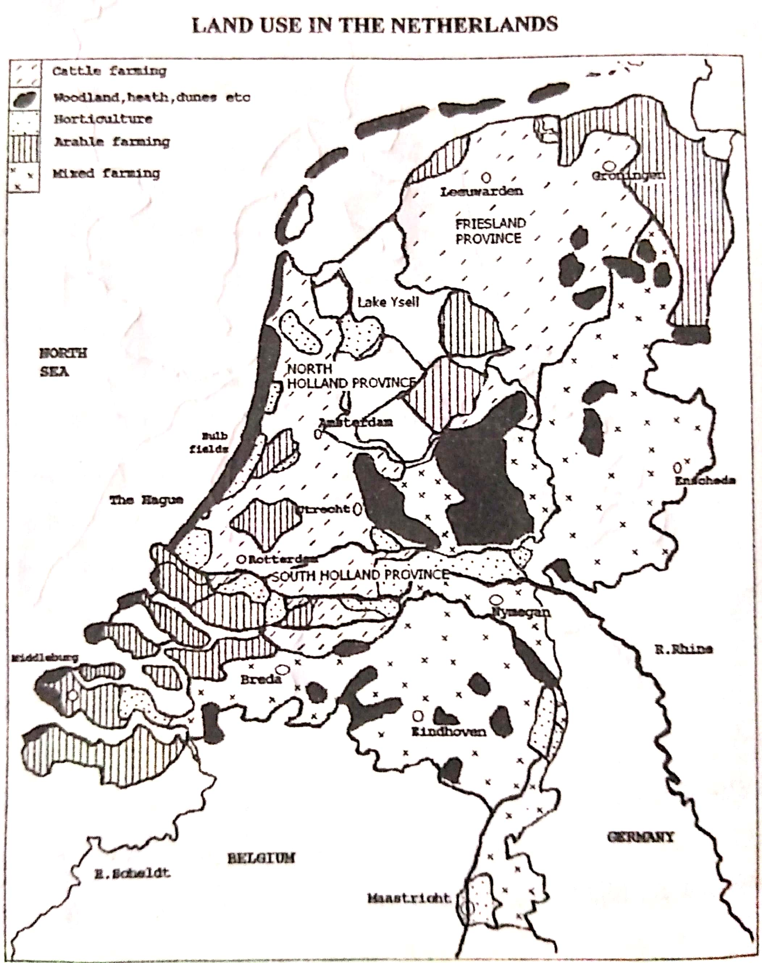

**Guiding questions:**

1. The table below shows land use on the ljssellmeer polders:

|  |  |  |  |  |
| --- | --- | --- | --- | --- |
| Period | Wieringermeer | N. E Polder | Eastern Flevoland | South flevoland |
| Amount of: |  |  |  |  |
| Farmland | 87% | 87% | 70% | 50% |
| Residential land | 1% | 1% | 8% | 18% |
| Woodland & recreation | 3% | 5% | 16% | 25% |
| Canals, dykes, &roads | 9% | 7% | 6% | 7%s |

1. Construct a pie graph to show the details of agricultural land use on wieringermeer
2. Which crops are grown for:

(i) human use

(ii) animal feed

1. The table below shows the types of farming on the Dutch polders

|  |  |  |
| --- | --- | --- |
| Types of farming | Percentage of polder | Degrees |
| Arable farming | 53 | 191 |
| Market gardening | 07 |  |
| Orchards | 05 | 18 |
| Mixed farming | 35 |  |
| Total |  |  |

* Calculate the degrees to complete the table
* Draw a pie chart to show the relative importance of the different types of farming on the Dutch polders.

1. The below shows landuse in the Netherlands

|  |  |
| --- | --- |
| **Landuse type** | **Total land area in hectares** |
| Arable farming | 880,000 |
| Horticulture | 150,000 |
| Pastures | 1,605,000 |
| Wood and wasteland | 625,000 |
| Others | 560,000 |
| **Total** | **3820,000** |

1. Draw a bar graph to show the relative importance of the landuse types in the Netherlands
2. State the landuse which occupies:

(i) Largest area

(ii)Smallest area

1. Calculate the percentage of land under farmland
2. Study the table below showing the agricultural exports of the Netherlands in percentage:

|  |  |
| --- | --- |
| **Type** | **Percentage** |
| Meat and meat products | 22 |
| Dairy products | 34 |
| Horticultural products | 20 |
| Cereals | 08 |
| Others | 16 |
| **Total** | **100** |

1. Draw a pie graph to show the relative importance of the agricultural exports of the Netherlands
2. State any three facts shown by the pie graph in (a) above
3. Identify any 4 dairy products in Netherlands
4. The table below shows the commodities which passed through Rotterdam port in 1998:

|  |  |  |
| --- | --- | --- |
| Commodity | Tonnage | Percentage |
| Mineral oils | 315.0 | 74.0 |
| Ore | 39.0 | 9.1 |
| Cereals | 9.5 | 2.2 |
| Coal | 7.8 | 1.8 |
| Fertilizers | 7.5 | 1.7 |
| Other goods | 46.5 | 11.2 |
| Total | 425.3 | 100 |

1. Calculate the tonnage of:

(i) Mineral oils

(ii) Ore

(iii) Coal

1. Draw a divided circle to show the commodities Rotterdam handled in1998

**INDUSTRIALIZATION IN THE NETHERLANDS**

Major industrial centres in Holland

|  |  |
| --- | --- |
| TOWN | MAJOR INDUSTRIES |
| Amsterdam | * Ship building * Printing and publishing * Automobiles * Glass making * Sugar refining * Petro-chemical * Food processing |
| Rotterdam | * Ship building * Petro-chemical * Sugar refining * Food processing * Oil refining * Marine engineering |
| Eindhoven | 1. Electronics 2. Engineering 3. Food processing 4. Textiles |
| Groningen | 1. Sugar refining 2. Furniture making 3. Bicycle making 4. Cigarette making 5. Printing and publishing |
| Breda | * Soft drinks and beer * Metal goods * Sugar refining * Chemical |

Note: Other important industrial centres are Tilburg, Hengelo, The Hague, Utrecht, and Enscheda.

**Problems facing Netherlands’ industrial sector**

1. Shortage of some raw materials such as iron ore leading to low output.
2. Competition from other industrial countries which limits the export markets for output.
3. Competition from imported industrial goods which limits the local market for the industries.
4. Environmental pollution which reduces the quality of production.
5. Profit repatriation by foreign investors, which limits re-investment in the industrial sector.
6. Inadequate /Shortage of labour to work in the industrial sector, which limits production.
7. Shortage of land for industrial expansion in the highly industrialized zones.
8. High taxes imposed on industrial output and industries by the government.
9. Congestion at the ports especially at port Rotterdam causing delays in the delivery of goods.
10. High costs of production such as due high importation costs of raw materials which reduces the profit margin/ leading high prices of final products

**GROWTH OF MAJOR TOWNS IN NETHERLANDS**

**1. Rotterdam port**

Rotterdam is an international port and it is the largest port in the world. It is the busiest port in Europe, and it is situated at the mouth of the Rhine River as the River enters the North Sea.

**Factors that have favoured the location and growth of Rotterdam port**

**Physical factors**

* Presence of deep waters at the entreport enabling big/large ships to anchor easily.
* Presence of a well sheltered natural harbor that enables large vessels to anchor at the site (enables the port to handle all types of vessels).
* The low tidal range which allows easy shipping/anchoring of vessels to the coastline of the North Sea. Therefore, ships easily come and go at any time.
* Generally flat topography of Rotterdam encouraging the construction of port facilities such as buildings and transport systems.
* Ice-free conditions all year round thus enabling the use of the port throughout the year, leading to the growth and expansion.
* Strategic geographical location of Rotterdam at the North Sea which gives it easy accessibility to foreign markets. (It is also located at the mouth of the Rhine River and in the center of Europe).

**Other factors**

* Presence of a rich and productive hinterland comprising of countries like Switzerland, Germany, Belgium, Luxembourg and Holland which increases the cargo handled by the port.
* The development of many industries in the area such as shipbuilding, marine engineering, oil refining which has increased the volume of cargo handled by the port.
* High level of technology which has enabled the construction of the New Waterway, construction of Europort and canals, containerization at the port.
* The construction of a deep water channel called the New water way, linking the port to the North Sea which made the port usable by very large vessels *(and also enabled Rotterdam to become more of a transit port for bulky goods to the interior).*
* Availability of large sums of capital to invest in the modernization of the port such as construction of canals.
* The long period of existence of the port for over 600 years which has also favoured its continued expansion/development.
* Political stability of the region, which has enabled the port to expand without any disturbance of war. The area has been stable since the Second World War.
* Improvement in transport systems linking the port to the large hinterland for example roads and railways linking to the interior which has also increased the volume of cargo handled by Rotterdam port.
* Supportive government policy for example the need to open the region to easily access markets for the manufactured goods; and greatly financing the modernization of the port.
* Large supply of skilled labour in the area to carry out modern construction and development of the port.

Note: More so major developments have taken place on the banks of the waterway, most important being the construction of Europort (5000 hectares large).

**Note:** Most of imports handled by Rotterdam port consist of bulky goods/ basically raw materials such as:

1. Petroleum/ oil
2. Coal
3. Iron ore
4. Grains
5. Cotton
6. Coffee
7. Tropical timber
8. etc

However, the major exports / seaboard goods are manufactured goods and foodstuffs such as:

1. General merchandise
2. Automobiles
3. Machinery
4. Fertilizers
5. Chemicals
6. Electrical appliances
7. Textiles
8. Etc

**Transit port**-a port where goods going to other countries are handled.

OR It is a port which handles imports and exports of the country’s further inland.

**Hinterland of Rotterdam port**

A hinterland Refers to a region which serves and is served by a port. The countries which make up the hinterland of Rotterdam include:

1. Holland/ The Netherlands
2. Germany
3. Switzerland
4. Belgium
5. Luxembourg
6. Northern France.

**Functions of Rotterdam port**

**(Refer back to other ports and cities earlier studied)**

**Importance/ contribution of Rotterdam port and city**

* Rotterdam port has promoted trade between the Rhine lands and the rest of the world because it is a major entreport.
* Promotion of industrial development such as in the Ruhr industrial region of Germany due to handling raw materials and finished goods.
* Promotion of urban development such as expansion of Rotterdam city and other towns in the region (The Hague, Utrecht, Mainz, Frankfurt, Bonn, Leverkusen, and Koblenz.
* Promotion of mineral exploitation for example coal mining from the Ruhr region, limestone from the Jura region due to cheap water transport.
* Promotion of tourism development since it is a tourist attraction, hence generating foreign exchange.
* Provision of employment opportunities to many people such as engineers, hydrologists who monitor the water levels, hence improving the standards of living.
* Generating of government revenue by taxing the shipping companies and workers’ incomes/ the revenue is used to develop various sectors such health, education.
* Facilitation of international relationship/ cooperation among the Rhine land countries such as Switzerland, Netherlands and Germany which promotes trade relations and economic integration.
* Diversification of the economy in the Rhine land countries by developing many sources of income / various activities such as mining, agriculture, service sectors.
* Promotes the development of the agricultural sector due to large demand for food by the population along the waterway.
* Promoted the development of infrastructure like canals and railway lines linking various areas to the port.

**Problems facing Rotterdam port and city**

1. There is congestion of vessels since it is one of the busiest ports in the world causing delays.
2. Maintenance of the city is extremely expensive such as water supply, sewage disposal, law and order. This is due to overcrowding.
3. Pollution of the environment especially due to toxic gases and wastes from industries such as oil refineries, petro-chemical industries, automobile industries.
4. Silting of the River canals /new Maas River and the New Waterway which necessitates constant dredging which costly.
5. Sometimes the port experiences flooding since it below sea level, which interferes with the shipping of vessels.
6. Some sections of the port experience winter freezing which at times interferes with port activities such inconveniencing shipping schedules.
7. Narrowness and shallowness. There is still work to be done to expand the port and to deepen it in order to accommodate even larger vessels.
8. Risks of fire hazards due to presence of oil tanks all over the port.
9. Unemployment problems due to high rural urban migration and high population in the city. This leads to social evils like theft and robbery.
10. Shortage of land for expansion of the port due to many activities carried out around the port.
11. Population increase has led to inadequate housing resulting into slum growth.
12. Overcrowding of people leading to easy spread of diseases and high crime rate.
13. Risk of fire due to the presence of many oil tankers all over the port.

**Solution to the above problems**

* + - 1. Reclamation of land from the sea to create more room for expansion.
      2. Vertical expansion of the port to minimize the problems of limited space (use of skyscrapers).
      3. Containerization to ensure fast handling and dispatch of cargo.
      4. Industrialists have advised to build elsewhere away from the concentrated area of Rotterdam.
      5. Treating industrial wastes before disposal into water to reduce pollution.
      6. Industrial fumes have been exposed high up in the atmosphere by very long chimneys.
      7. Regular dredging to reduce the effects of silting.
      8. Greenbelts have been created in the city to reduce CO2  from the atmosphere and in turn produce O2  which is in short supply.
      9. Police has been strengthened to be more alert against crime among citizens, although it is still a challenge.

1. **AMSTERDAM PORT/ CITY**

Amsterdam is the largest city of the Netherlands, located in the province of north Holland. It is situated on the banks of Amstel River. The name Amsterdam is derived from the Amstellerdam-which is a dam on the Amstel River.

Amsterdam town began as a small fishing and trading village. It developed as a trans-shipment point due to the break in navigation of the Amstel River.

**Factors for the growth of Amsterdam**

* Amsterdam’s position as the capital city of Netherlands which made the government to develop it by constructing canals and other infrastructure.
* Generally flat topography/ landscape encouraging the construction of industries and transport systems.
* Construction of the North Sea canal which has ensured steady water supply for the city.
* Strategic geographical location of Amsterdam near the North Sea, which gives it easy accessibility to foreign markets. *(the city is also strategically located on the banks of the Amstel River and hence the fishing industry attracted many fishermen to settle there)*
* The development of many industries in the area such as engineering, textiles, chemical, food processing which has attracted more workers and also increased the volume of trade.
* High level of technology which has enabled the construction of the city/ port such as constructing canals, modern buildings.
* Availability of large sums of capital to invest in the modernization of the town such as building commercial buildings.
* Availability of various power sources such as oil and hydroelectricity to develop the various urban activities.
* Political stability of the region for a long period which has enabled the city to expand without any disturbance of war.
* Well-developed transport and communication systems such as River Amstel, canals, roads and railways for easy movement of goods and people.
* Supportive/ positive government policy of developing the city and port such as by constructing canals, encouraging local and foreign investors in various activities.
* Large supply of skilled labour in the area to carry out modern construction and development of the city.
* Her port status which has ensured business throughout the year handling imports and exports.

**Functions of Amsterdam city/ port**

* It is a Commercial centre with many businesses, insurance companies
* It is a Manufacturing/industrial centre with many industries such as chemical, textiles, shipbuilding.
* It is an administrative centre with many offices e.g. it is the capital city of the Netherlands
* It is a residential centre with a large population settlement.
* It is a communications centre with canals, and other transport systems.
* It is an educational centre with many schools, colleges and universities
* It is a tourist centre since it has museums, canals, industries etc
* It is an entertainment centre
* It is a recreation centre with many resort places
* It is a port with container terminals and other cargo handling services

**Problems facing Amsterdam port/ city**

* + - 1. Limited land for expansion
      2. The city is prone to flooding because it is located below sea level.
      3. Pollution of the environment such as air pollution from vehicles and industries.
      4. High crime rates such as drug abuse due to unemployment.
      5. etc

**Solutions to the above problems**

* Reclamation of more land to extend the city land
* Encouraging upward expansion of the city using storeyed buildings.
* Construction of strong barriers/ dykes to control the danger of flooding.
* Recycling of material is encouraged to reduce solid waste and also limiting car use in the city to reduce emission of fumes.
* Strengthening authorities such as the police and governing departments to fight against crime. The community policing policy is also encouraged.
* Etc

**“GOD ABOVE ALL”**